**1 Pikes Hill, Gales Green, SO43 7AS**

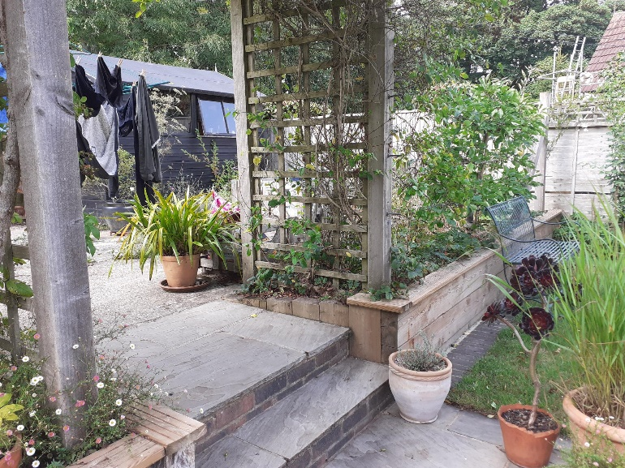Site for proposed garden studio

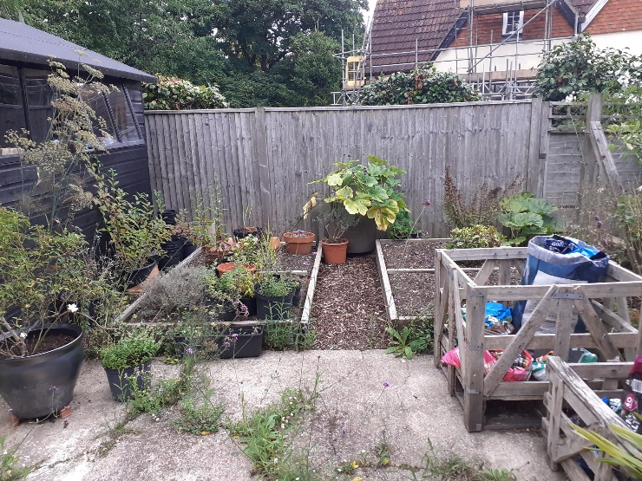approach via steps from garden

approach via steps from garden

Proposed site

View opposite proposed site

Ash tree on Gales Green as per attached tree plan