4-Front Architecture
East View 82 Pitt Street Eckington Sheffield S21 4EZ
architecture.4front@gmail.com

Project 4FA203

Proposed Alteration to Entrance Porch & demolition of existing garage and erection of Carport

At

Ragnall House,
Ragnall,
Newark,
Notts,
NG22 0UR

For

Mr Jason Oakes & Mrs Susan Oakes

Planning Reference number: 19/00763/HSE

With reference to Planning Application Reference number: 19/00763/HSE, please find submitted the discharge of conditions application for conditions 3

Condition 3

- With regard to the facing materials the bricks to be used shall be the demolished bricks, cleaned up and reused, please see photo below.

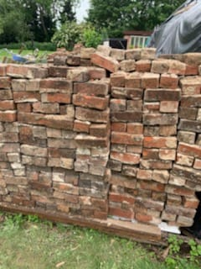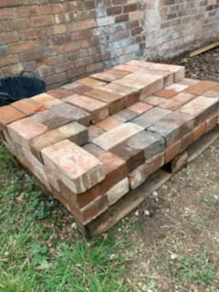

- The timber will be natural Oak from a Local Saw Mill.

- The roof tiles will match the existing dwelling

I trust all is correct, but should you require any further information then please do not hesitate to contact me.

Yours,

A.J.Cresswell MCIOB,Bsc.hons

