Heritage Statement - Crimsworth Farm

This Heritage Statement relates to the following property; Crimsworth Farm, Pecket Well, Hebden Bridge, HX7 8RB

The property is a Grade II listed semi-detached cottage from around the mid 1700s. The construction is typical for properties of this time; solid stone walls, pitched roof covered by roof tiles. A picture of the front elevation is provided below for information.

Crimsworth Farm
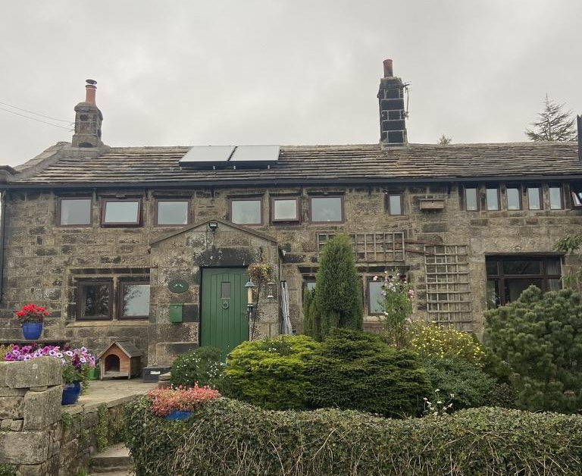

The proposal is to paint the front door and windows of the property from the existing mismatching green door and brown windows to Farrow & Ball ‘Off-Black’. This is a charcoal grey colour used by various houses and businesses around the area, that matches various features of the building such as guttering and doorframes, as well as tones and patinas in the stonework.

The existing finish is cracking, allowing water ingress and is in need of urgent repair. This work will also improve the aesthetic of the property on the outside elevation, making a cleaner and more presentable view of the property.

With best wishes,

Jack Wallington and Christopher Lyon Anderson
Crimsworth Farm
Pecket Well
Hebden Bridge
HX7 8RB

