THE SCHOOL HOUSE, 64, UTTOXETER ROAD, HILL RIDWARE, STAFFORDSHIRE
Design, Access and Heritage Statement to accompany proposed for internal dry-lining and insulation.
This statement is submitted in line with paragraph 194 of the National Planning Policy Framework 2021, which says:
“In determining applications, local planning authorities should require an applicant to describe the significance of any heritage assets affected, including any contribution made by their setting. The level of detail should be proportionate to the assets’ importance and no more than is sufficient to understand the potential impact of the proposal on their significance. As a minimum the relevant historic environment record should have been consulted and the heritage assets assessed using appropriate expertise where necessary. Where a site on which development is proposed includes, or has the potential to include, heritage assets with archaeological interest, local planning authorities should require developers to submit an appropriate desk-based assessment and, where necessary, a field evaluation.”
The heritage asset in question is the School House, a Grade II listed building now divided in two. The southern part, no. 64a, is now known as “Wisteria Cottage”, and is not affected by the present proposal.
The house was first listed on 5/10/1987, and the list description is as follows:
“House. Mid C18. Red brick; plain tile roof with raised verges; brick ridge stack and integral end stack. Two storeys with dentilled eaves band. Three window front: casements with segmental heads, the left hand ground floor window is taller than the others. Gabled porch to left of centre.”
The house has the appearance of a former farmhouse, the earliest brickwork being at the parlour end to the south, now part of “Wisteria Cottage”.
The north end appears to have been the kitchen end of the farmhouse but, at some point prior to 1838, was adapted as a school. The adaptation was primitively done by removing the internal walls and first floor structure at this end of the building, and making a full-height window in the front elevation.
At the time of the Mavesyn Ridware tithe map (1838) and schedule, the property was already a house and school belonging to the Mavesyn Ridware Church Estate. Could it have been among the property purchased with a generous bequest left by Daniel Sandford, a former Rector, in 1779?
By comparing the 25” Ordnance Survey sheets of 1880-2, 1900 and 1921, it appears that the backward extension of the room in a new piece of building was done in at least two stages, though there seems no obvious evidence of that in the fabric today.
By 1902, the Education Department was pressing for £200 worth of improvements, which were put in hand in 1902-3. The “Lichfield Mercury” of 30/1/1903 noted that:
“The much needed improvement in the school accommodation at Hill Ridware has now been completed. The school has been considerably enlarged and otherwise renovated. For the purpose of raising funds towards the liquidation of the debt incurred, a tea and dance were held on December 26th. The secretary has just submitted a statement of accounts, which shows a balance in hand of £3 11s 2. The amount has been placed to the fund for the enlargement of the school.”
This seems to have been the last expansion of the school before it closed, and presumably involved the east end of the present building.
Unsurprisingly, the school still got an unfavourable report in December 1907 from His Majesty’s Inspector who noted that:
“The main room is very narrow, badly lighted and ill ventilated and is wedged in between the Teacher’s House on one side and some farm buildings on the other. I understand that at times there is a most offensive smell from some neighbouring premises.”
The school was eventually superseded and was sold off in 1986. A first floor has since been reinstated in the front part of the schoolroom, and the large window has been replaced with separate ground and first floor windows, which it will originally have had. The farm buildings on the north side have been cleared away.
The significance of the building is:
- as a former farmhouse, evidencing the usual piecemeal development of farmhouses, and
- as an example of how educational facilities might be provided in an ad-hoc manner in small rural communities before formal standards were set.
THE PROPOSAL AND ITS IMPACT
The school house is built of nine-inch brickwork without so much as an internal coat of plaster (see appended photographs), and the building has no insulation except for loose-lay insulation above the first floor ceilings in the section nearest the road.
The applicant has a series of potential ecological measures in mind, but wishes to make a start by insulating the internal surfaces of the exterior walls, as noted on the plan and elevations. Pre-application advice has already confirmed that “internal insulation of the old school room would not be an issue as long as it is sensitive to the listed building”, and there is obvious public benefit in making the historic building stock suitable for continued use into the future.
The proposed means of implementation are theoretically reversible and comprise:
- Batten out walls with 2” x 1” battens ready to take plasterboards.
- Fix breathable TYVEK style membrane to battens.
- Screw insulation-backed plasterboards to battens.
- Screw insulation-backed plasterboards to existing roof rafters.
- Plaster skim all plasterboarded ceiling & wall areas.
Where there are roof voids, additional thicknesses of loose-lay insulating material will be installed, which do not require listed building consent.
Where relevant, window linings and window boards will be extended forward to accommodate the extra wall thickness, and the existing patterns of architraves and skirtings will be reinstated on the new surfaces.
There are buildings of such sensitivity that plastering bare brick surfaces could have an adverse impact on significance. However, in this case I concur with the conservation officer that the sensitivity of the building is not so high that the proposed interventions would be harmful.
Philip Heath BA IHBC, November, 2022.

PHOTOGRAPHS
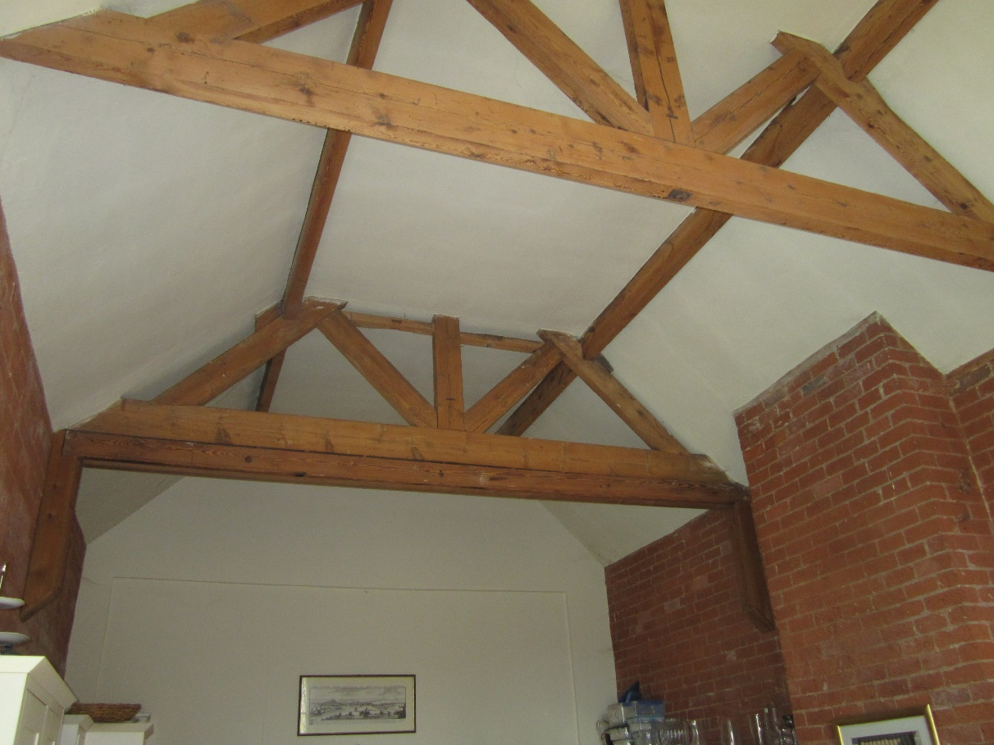
School room looking west. The kingpost trusses will remain exposed.
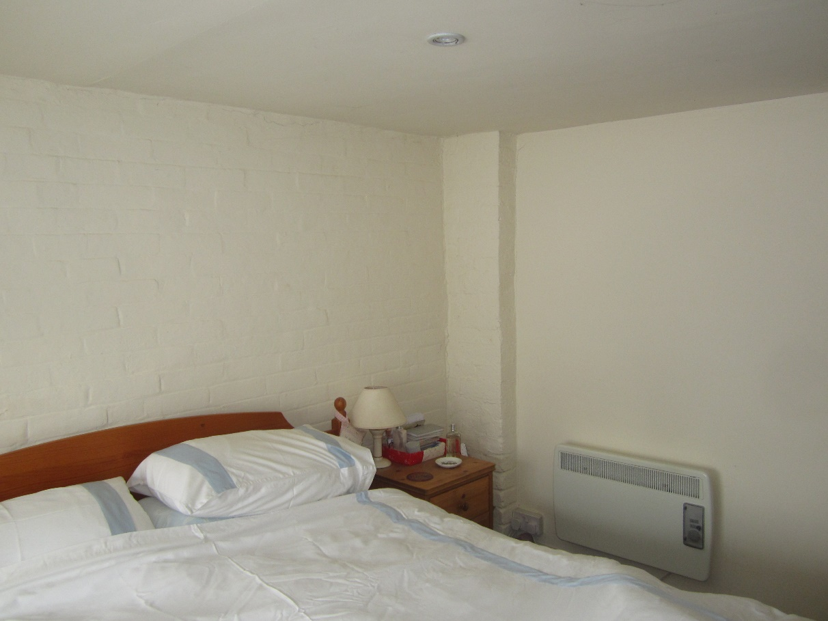
Unplastered exterior wall in an upstairs bedroom.

“Lichfield Mercury” 25/7/1902.
As quoted in ridwarehistorysociety.com
Email Helen Livingston to applicant, 18/10/22.

