architectural design and planning limited
proposed change of use of barn to dwelling

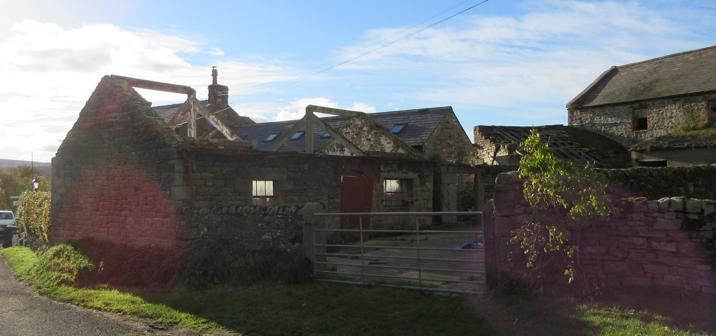

WOODHOUSE FARM LAMBLEY NORTHUMBERLAND NE49 0NX

planning statement

Introduction

Woodhouse Farm consists of a farmhouse outwith the ownership of the applicant and two agricultural building previously barn and byre now redundant. The site is within a small cluster of buildings, both residential and agricultural, within the general countryside.

The site is approximately 685 metres to the North East from the village of Coanwood in the Parish of Haltwhistle. Access to the site is from an existing private road used by the site.

The proposals are within the existing curtilage and land ownership of the applicant.

Previous Planning Application

Northumberland County Council 16/01955/AGTRES

Delegated report 16 August 2016

The application was submitted under the requirements of Class Q of Schedule 2, Part 3 of the Town and Country Planning (General Permitted Development), Order 2015 in relation to the change of use of agricultural buildings.

The provisions of Class Q state that the change constitutes permitted development with a number of exceptions, none of which applied in this case.

Consultees responses

Highways, no objection

Public Protection, falls below risk appetite

LLFA no objection subject to a condition and informative

Ecology no objection subject to a condition and informative

Objections none

1/.
Class Q
Appraisal The proposal has been assessed against the criteria as set out in Class Q; those applicable to the change of use are summarised in the report
Conclusion
The submitted details indicate that the proposal can be constructed under permitted development in line with The Town and Country Planning (General Permitted Development) Order (2015) for the reasons outlined in the report.

It also states that:-
Prior approval in relation to the design or external appearance of the building is not required.

But then it states that :-
The development hereby permitted shall not be carried out otherwise than in complete accordance with the approved plans. The approved plans for this development are: 1. Proposed combined plan – Woodhouse Farm – WHF/08/PPE&PBP/03 2. Site location plan – Woodhouse Farm – WHF/08/LP/01

The report has been studied in detail so that the detailed design would comply with the recommendations and to ensure that the works were in compliance with planning law.

There is no condition or informative relative to the commencement or completion of the works within the report, normally planning permission are issued with the condition that the works must commence, (not be complete), within three years of the decision notice.

However on the legislation gov website it states the following :-
Conditions Class Q
Q2 (3) Development under Class Q is permitted subject to the condition that development under Class Q(a), and under Class Q(b), if any, must be completed within a period of 3 years starting with the prior approval date.

Building works

Building work commenced within three years of the date of the delegated report which included the re-roofing of the barn, installation of roof-flights, rainwater goods and fascia and soffits.
In 2021 new plans were drawn up by Architectural Design and Planning Limited in accordance with client instructions to provide an improved layout, include a family bathroom and better relationship between the bedrooms and circulation space.
The plans also included a small extension to house a porch and a utility room which would include the hot water cylinder for the heating and hot water which were not in the previous scheme.
As Class Q would not allow for the extension a householder application was submitted but this was withdrawn as the planning officer advised that either a) a full application would be required or b) the conversion to a dwelling be carried out and then a householder application could be made.
2/.
As the applicant wished to progress the works, and his builder had availability, it was agreed that the works would be carried out in accordance with the Class Q and when the property had been converted to a dwelling then a householder application would be made.
The householder application was withdrawn and the application fee refunded. The building regulation application was approved and the building inspector has made a number of site inspections and has been helpful in addressing the issue of underpinning walls and means of escape.
Access and parking
Presently the parking of vehicles is outside the curtilage of the site on the access road. It is proposed to create two parking spaces within the curtilage. The farm gate will be removed and the access has good visibility onto the access road.
Protected habitats and species
At and barn owl survey was carried out by Ruth Haddon in the summer of 2015 and the mitigation measures recommend in the report have been incorporated into the scheme. The report covered the two single storey buildings which are the subject of this application and also the adjacent buildings which were the subject of the Class Q application.
Whilst some evidence was found in the two storey building there was no evidence of bats or bat potential in the single storey building which is the subject of this application.
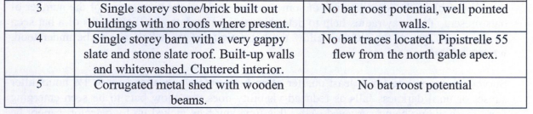
Extract from the report of summer 2015
There was no work to the roof carried out to the eaves or roof or any pointing carried out during the bat hibernation period. The roof to the barn had been completed before 2021 and at that time there was no roof on the byre. The roof to the byre has since been completed and no evidence of bats has been found. Consequently it can be assumed that there has been no access for bats to roost in the roofs which had no bat traces or bat roost potential.
Services
The property is serviced by mains electricity, mains water and a mains combined sewer system. At present there is no heating or hot water to the property.
It is proposed that the electricity and mains water supplies will be installed into the dwelling during conversion. The new and altered bathroom provisions will discharge to the main combined sewer system.
3/.

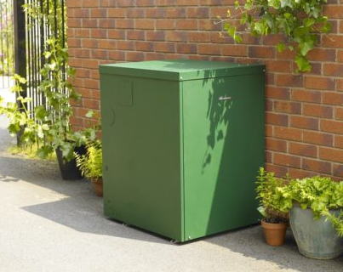

It is proposed to provide heating and hot water by an external oil fired boiler, with nearby bunded oil storage tank, to the dwelling. This would involve the installation of under floor heating to the ground floor of the converted dwelling.

flood risk assessment
The site is not in a flood risk zone.

fenestration

The West elevation.

The existing window openings will be retained and reused for the new windows which will be traditional sliding sash style double glazed windows in white upvc.

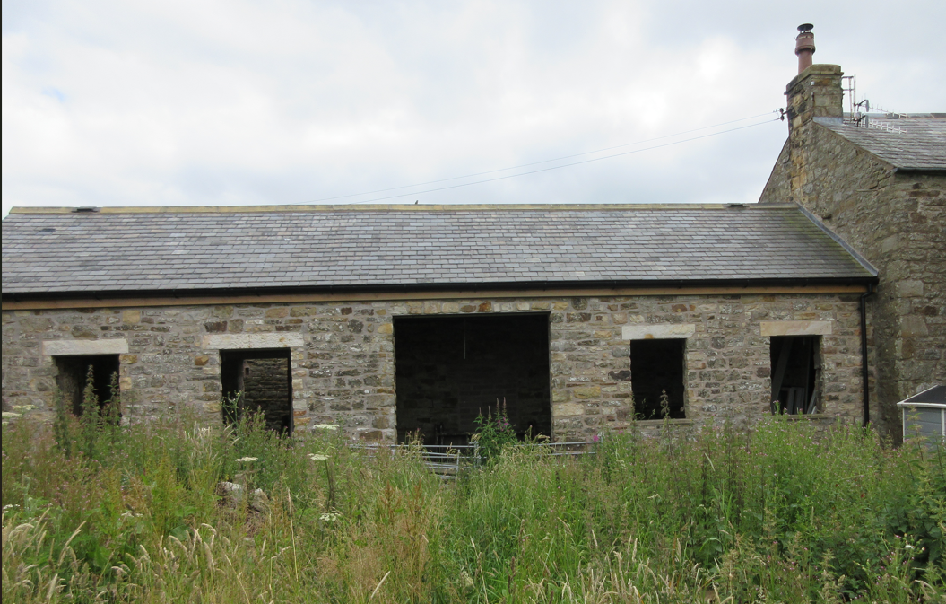

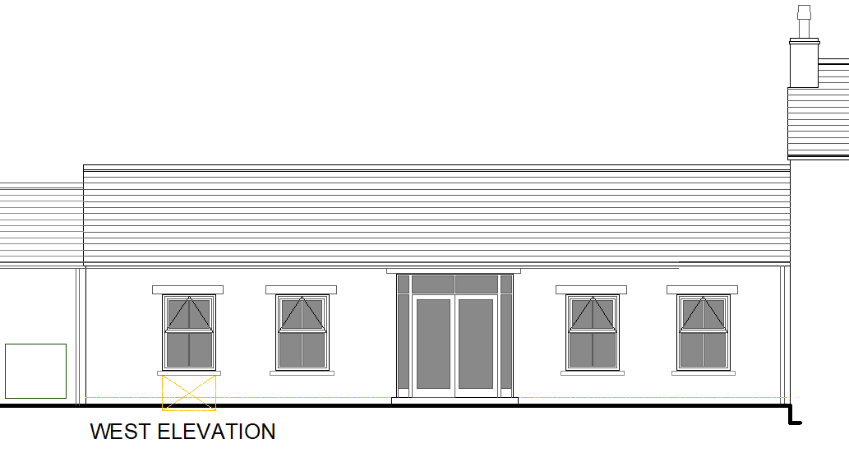

4/.

The North elevation

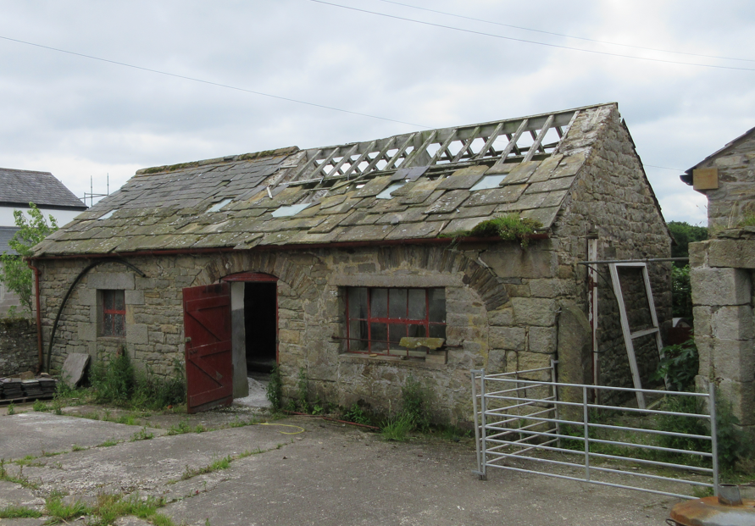

The previous stone arches, which would have been doorways into the byer, had been partly destroyed in the past, a timber door and two metal framed windows of inappropraite design had been installed.

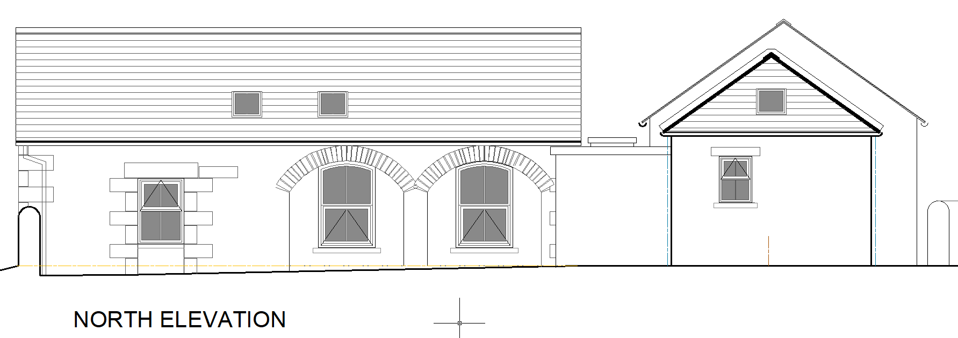

In the poposal the former arches are to be reinstated and infilled with stone set back from the face of the main elevation and windows of traditional vertical sliding sash windows be installed.

Whilst it is appreacited that the previous scheme submitted with the Class Q application included filling the full arch with framed glazing. That fenestration related to the large bedroom 2 and the partition wall was at an odd angle to avoid the opening. The revised scheme makes better use of space available with better proportion bedrooms, family bathroom and ensuite which in turn relates to the windows on this scheme.

During the works the arches have been reformed to bring back the charcater of the building which had been destropyed previously. This has enhanced the elevation and saved a key part of the building’s heritage.

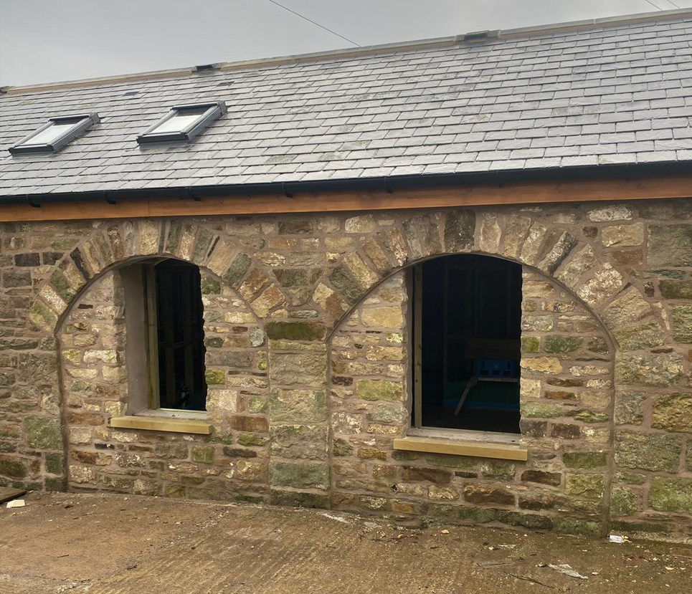 5/.

summary
The planning application aims to bring the project back on track due to the works approved under Class Q application not being complete with the three year time limited.

The submitted scheme is similar to the approved scheme but with an improved internal layout to suit a family domestic dwelling. This impacts on the fenestration which is of traditional design in existing openings.

The scheme also includes a modest extension which will enhance the internal accommodation whilst adding to the front elevation as the unstable unsightly wall will be removed.

Overall the proposals will fulfil the potential of the property, provide another dwelling in the village and be a positive contribution to the rural area.

6/.
architectural design and planning limited

