West elevation of No2 Thornton House
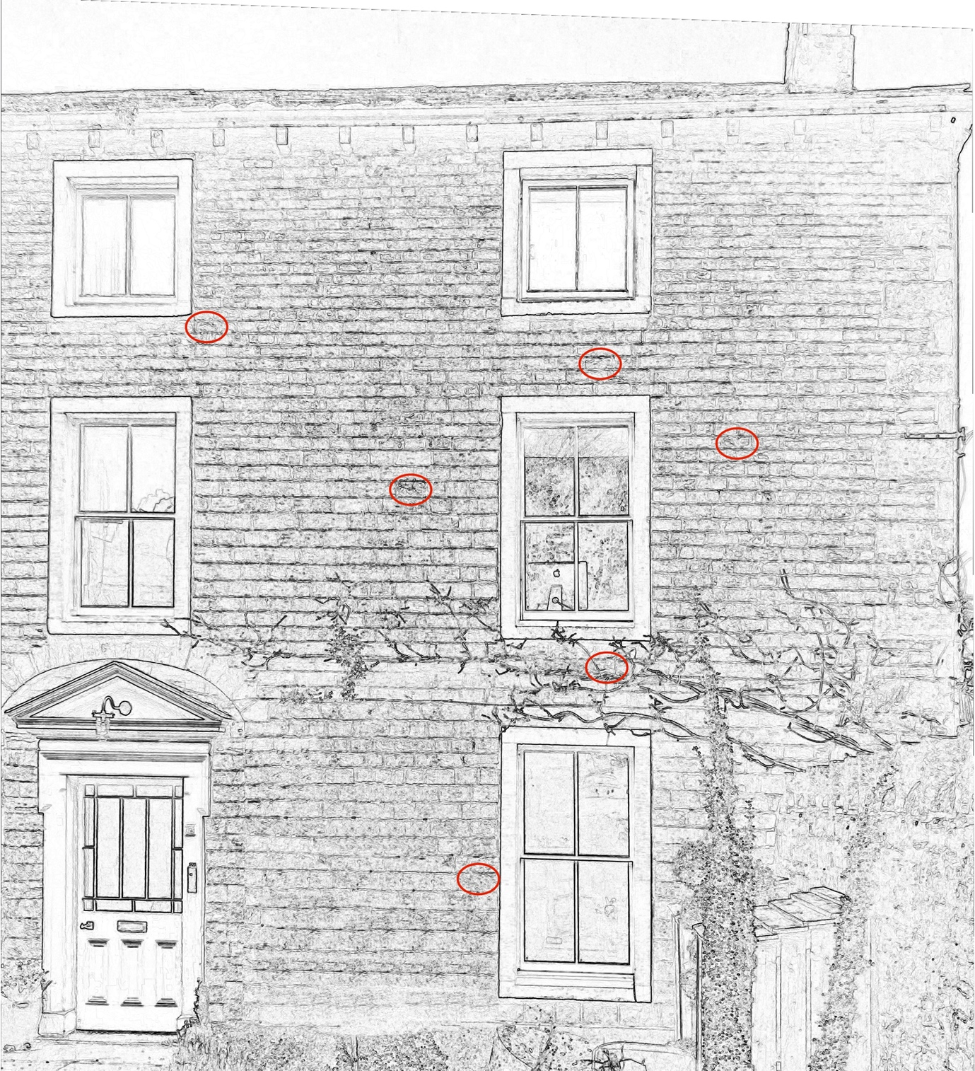

This image shows the west elevation of No 2 Thornton House (a graphic filter has been applied to help show the stonework).
Six stones have been identified (circled in red) which will likely need to be replaced due to deterioration.
The builder (Woodsbuild Heritage Ltd.) has stated: Remove and replace as required, only the stones that are crumbling away badly on the face of the stones. I have allowed to replace 10-15 stones approx.. Stone to be reclaimed to match in as near as possible.

