Location Plan of Land off Old Bury Road
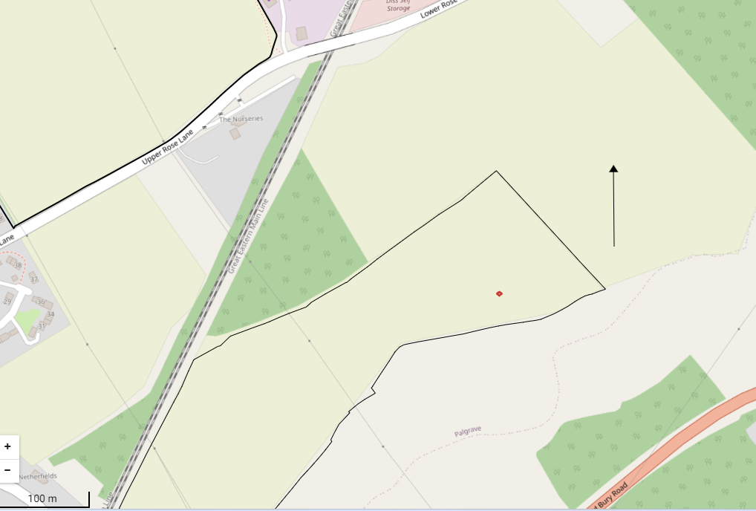
Location of new pumphouse 3.05m x 3.05m (10ftx10ft) and 2.59m to eaves/ridge (8.5ft)
N
N

