12/05/2023 Giuseppe Napoli
The Smithy
Old Forge Road
Great Rollright
OX7 5RR

Sustainability Statement
Town & Country Planning Act 1990 (as amended)

- Introduction
This statement accompanies an application for full planning permission of 2 small dormer windows to the rear of my property.

The development site is 165m2 consisting of a residential dwelling and a shed, the former post office and shop in the village of Great Rollright, Oxfordshire

The dwelling itself granted residential status in 2015 was constructed in 1989 on the site of an earlier shop, from character and new local stone and concrete roof tiles, occupying 93m2 on the above mentioned site.

The following sections of this statement therefore identify the relevant issues pertinent to the consideration of the application submission and include:

. A general overview of the characteristics of the site.
. Details of the sites recent planning history
. A description of the application proposals
. relevant material considerations

Overall this statement will demonstrate that the proposed development will achieve sustainable development in a manner that is entirely consistent with the NPPF. It will also be shown that the application proposal does not offend adopted development plan or emerging development plan policy. There are no planning reasons that would prevent planning permission being awarded. It is therefore respectfully requested that planning permission should be granted.

- SITE AND SURROUNDING AREA

The application site is a rectangular shaped area of land located centrally in the village of Great Rollright, upon which is built the previously mentioned dwelling.

- PROPOSED DEVELOPMENT
The proposed development comprises of the erection of 2 small dormers on the first floor to the rear of the building constructed from timber, insulation board, cement board and concrete Marley roof tiles to replicate the existing 3 dormers on the front of the building.

Front
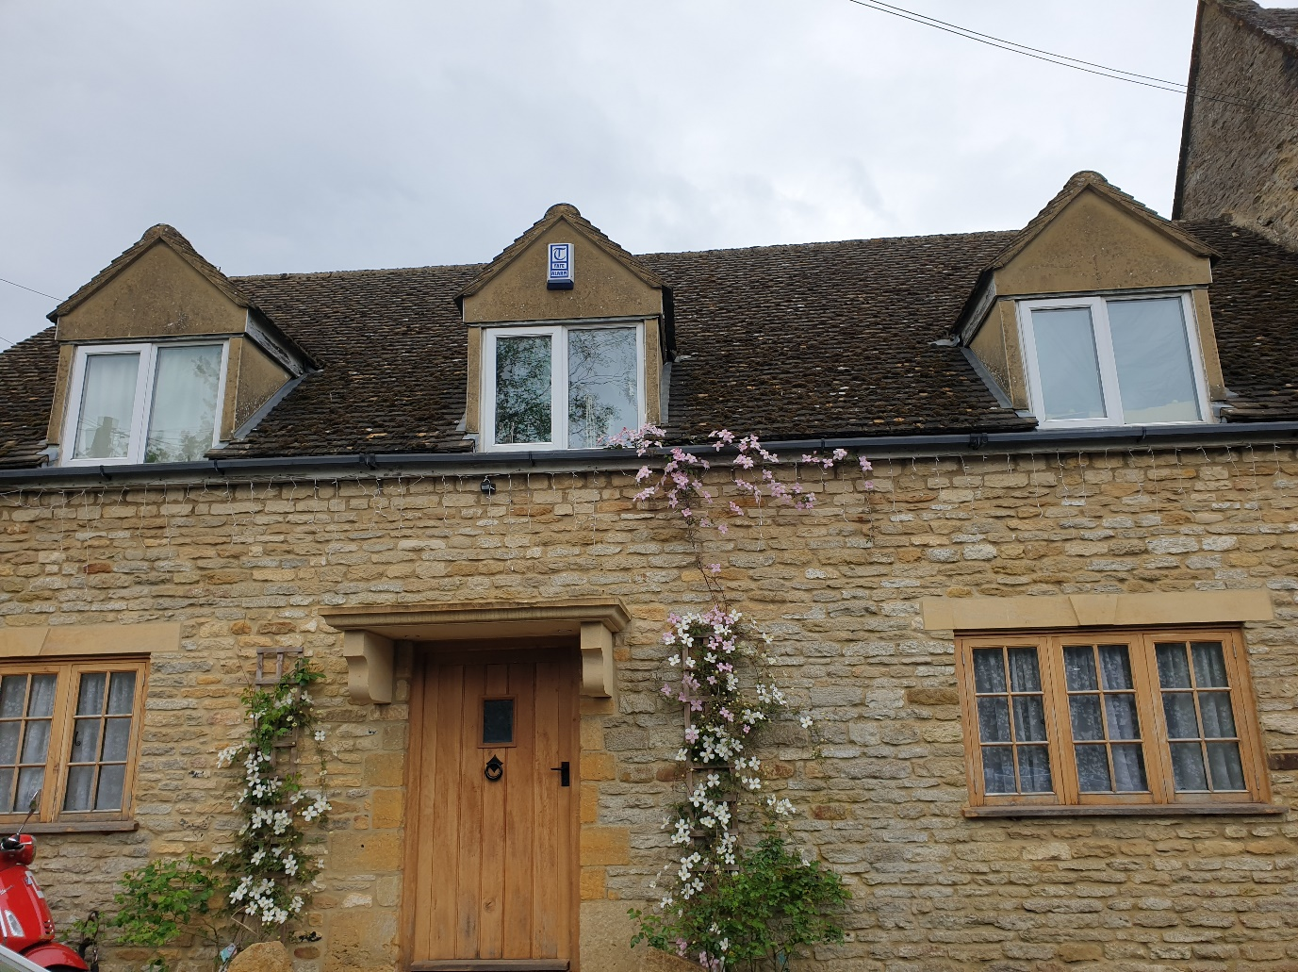

Rear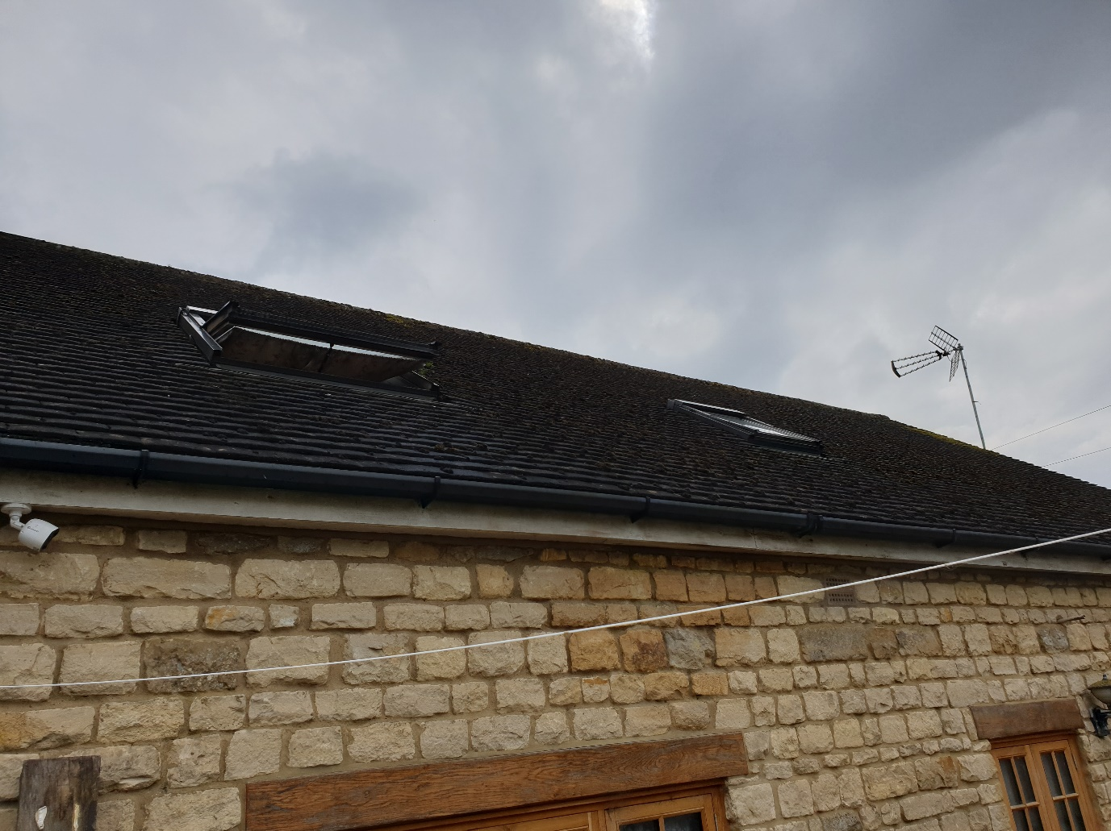

These would enable the two rooms affected to be more occupant friendly, creating space at head height on the rear outside wall allowing WC users to stand up straight while urinating and creating an area for a dressing table in the bedroom.
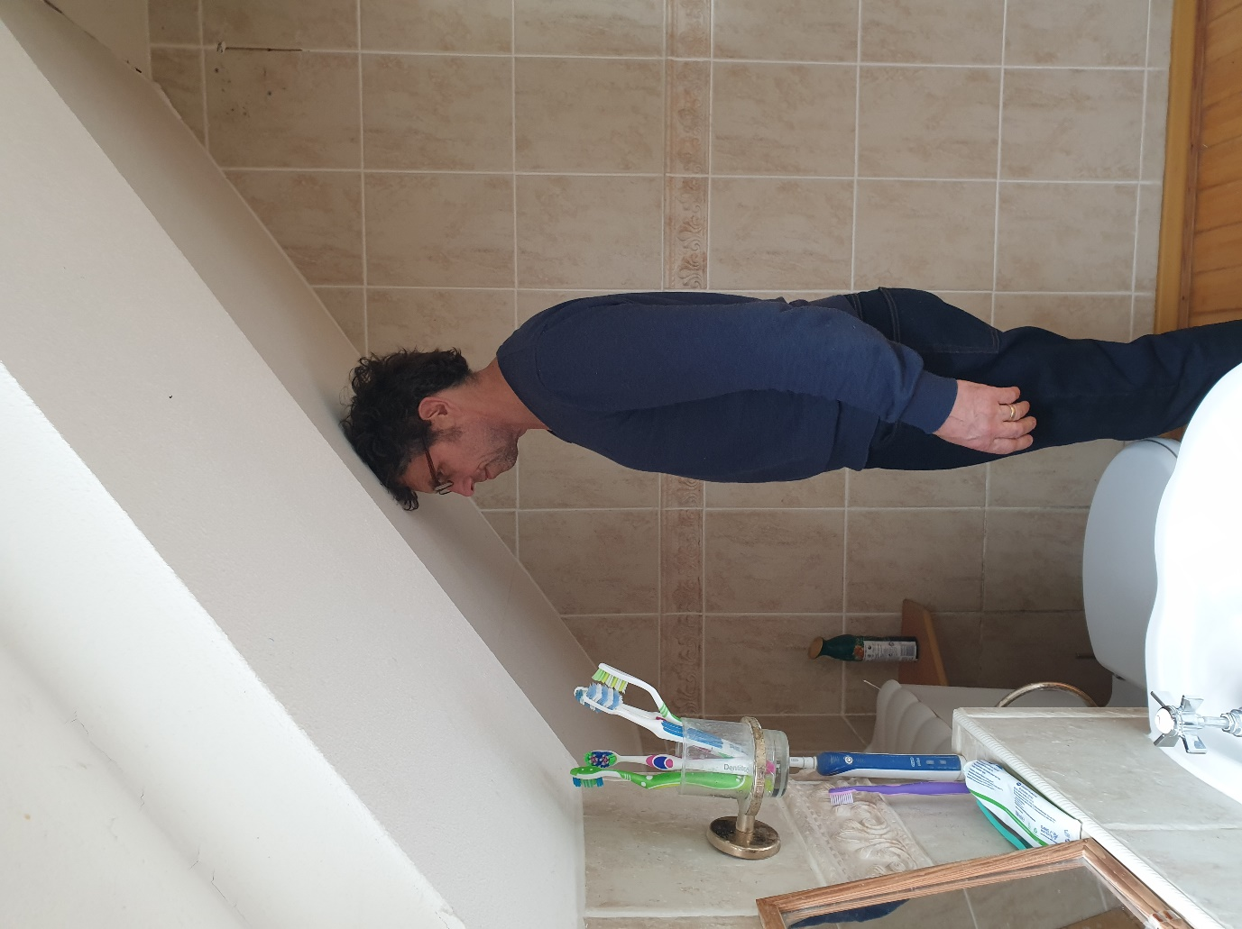

This property’s heating and hot water are entirely produced by a biomass boiler and all fuel is enplus A1 rated from Balcas Energy ensuring renewability.

Electrical requirements are met by the National Grid these do not include any form of heating or hot water.

The access to the property would be unaffected.

The rainfall volume currently going to soak away would be unaffected

The insulation of the property would be improved as existing rockwool insulation which is blocking airflow through the rafter cavity would all be removed and replaced with 120mm Insulation board allowing the loft space to be better ventilated, as has already been carried out at the front.

Proposal to install 3 x ridge tile vents.

I believe that the above information shows that this small project does not detrimentally affect its sustainability footprint.

This concludes my sustainability report

Giuseppe Napoli

