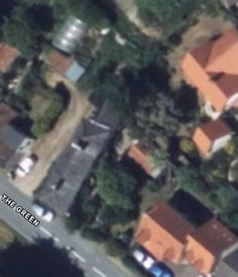

Garden
Salix spp.
Drummer cottage

-Re-pollard Salix spp. back to main stem, in which where it has been done previously. This will continue the re-pollarding cycle that has already been started.
-Please note we HAVE NOT pollarded this tree before, this is the first time we have quoted for this work, and have put in an application. In which one hasn’t been put in previously.

