Planning Permission DC/23/00968
Condition 3 – Materials to be agreed:
3 Bay Cart Lodge, The Nook, Priory Road, Diss, Norfolk IP22 1AJ
- Concrete base.

- Timber frame with weatherboard cladding – 175mm x 25mm featheredge to be painted Sandtex Cornish cream.

- Roof trusses – to be made by specialised company.

- Roof Tiles – Sandtoft Shire Concrete Pantile – Rustic (or similar).

- Roof windows – Velux pine finish.

- Doors to one bay – White UPVC.

Figure 2 – 175mm featheredge timber cladding
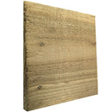

Figure 3 – Sandtoft Shire Concrete Pantile - Rustic

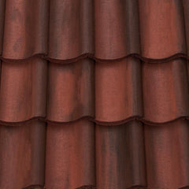

Figure 3 – Centre Pivot window pine finish

