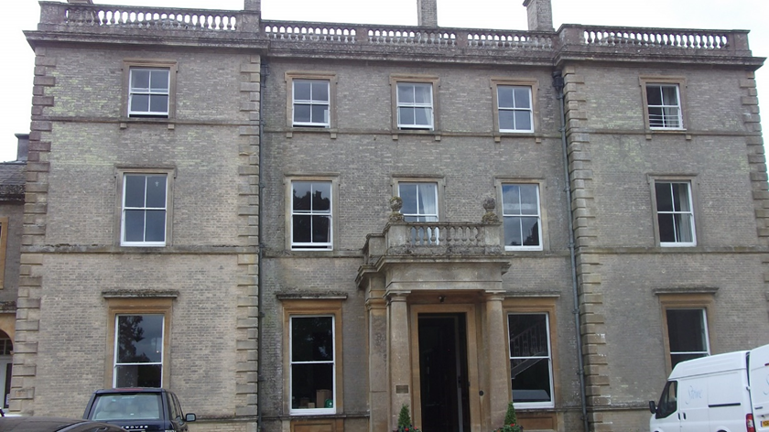

PLANNING AND DESIGN ACCESS AND HERITAGE STATEMENT

Installation of play equipment at Swanbourne House School

SWANBOURNE HOUSE SCHOOL
WINSLOW ROAD, SWANBOURNE, MILTON KEYNES, MK17 0HZ

Contents
1.0 Introduction
2.0 Site and Surrounding Area
3.0 The Proposal
4.0 Planning Policy
5.0 Design
6.0 Access
7.0 Heritage statement
7.0 Conclusion

- Introduction

1.1 Swanbourne house school is applying for Planning Permission and Listed Building Consent for the ‘Installation of play equipment’
at Swanbourne House School located at Winslow Road, Swanbourne, Milton Keynes MK17 0HZ.

1.2 This statement should be read in conjunction with the other submission documents.

2.0 Site and Surrounding Area
Swanbourne House School – Winslow Road, Swanbourne, Milton Keynes
2.1 The existing site comprises an independent co-educational boarding and day school for children
aged three to thirteen.
The former mansion house with attached service wing is a Grade II listed building. List Entry
Number: 1215266 and first listed 17th May 1984.

2.2 The mansion house, together with further buildings form part of Swanbourne House School.

2.3 Within the grounds of the school there is a Chapel & Manor house which are listed in their
own entirety.

2.4 The entire site, including the listed buildings located within the Swanbourne
Conservation Area boundary which was designated in 1989.

3.0 The Proposal

3.1 This Design and Access Statement covers the proposal for the installation of the play equipment in the grounds at Swanbourne House School
This Statement should be read in conjunction with the application drawings which show the
extent of the application.
3.2 Swanbourne House School is a business owned and operated by Swanbourne House School Trust
Limited.
3.3 Swanbourne House School wish to apply for the permission to provide the children with a play trail within the woods to engage the children in outside areas as well as the classrooms and to develop their outdoor and dynamic problem solving skills.
3.4 There will be no alterations or works to any parts of the buildings and the site has been chosen so that it is not visible from any vista and doesn’t obstruct any view of the house.
3.5 The Critical fall height was chosen to ensure that minimal ground works were required and that it would be accessible for all children at the school.

4.0 Planning Policy

4.1 No formal pre-application advice was sought.

5.0 Design
5.1 Please see the Disn document attached to the application

6.0 Access
6.1 Existing car park arrangements will not be changed, existing vehicular access will remain via the
existing road from Winslow Road.

7.0 Heritage statement
Swanbourne House School has four Grade II Listed structures; the change of use will involve the use of three of these as the Manor house won’t be affected by the change of use application. The principal building of the school is listed and is a former mansion built around 1865. The extension attached to the east side of this building is not listed and neither are the collections of buildings that comprise of classrooms and a school hall that are formed around and within a former stables and courtyard. To the south of these unlisted structures is the school chapel which is listed and is nicely articulated separate structure adjacent to the main school building. The third listed structure is the stone balustrade to the north side of the school buildings which will be protected by the restriction of vehicular access. The main consideration in terms of impact on Listed structures is the additional use associated with the change of use application. The below table outlines this and the mitigation we will put in place to reduce this risk.

Feature | Grade | List UID: | Significance | Proposed works | Possible impact | Justification or mitigation
Swanbourne house School (main building) | II | 1215266 | High | No works proposed to the House | As the location has no impact on the view of the house there will be no impact | N/A
Balustrade to forecourt of Swanbourne House School | II | 1215268 | high | No works - | No Impact | N/A
Chapel at Swanbourne House School | II | 1288176 | high | No works - change of use could result in increased use | As the location has no impact on the view of the Chapel there will be no impact | N/A
The Manor House | II | 1215272 | high | No works | No Impact | N/A

8.0 Conclusion

7.1 This statement supports the Planning and Listed Building Consent Applications for the:
Installation of play equipment at Swanbourne House School, Winslow Road, Swanbourne, Milton Keynes, MK17 1HZ.

7.2 It is considered that the applications constitute appropriate use to secure the future sustainability of the historic buildings and future use of the school.

