**Swanbourne House school Proposed play equipment location**

View of the proposed area from the Main House

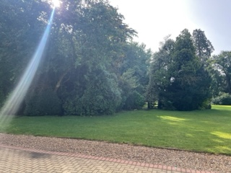

View of area from the Chapel  
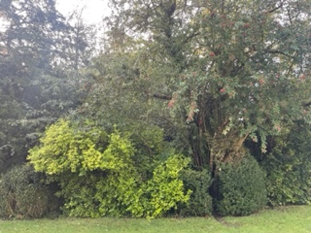

Proposed location for the play equipment  
