GOOSE ACRE

Land Rear Of Gooseacre Buckwood Road Markyate AL3 8JD
Application - 4/01283/19/FUL
Condition 3 – External Wall Materials

EXTERNAL WALLS
To be constructed from waste brick sourced from H.G. Matthews brickworks. Exact colour and type will depend on the particular waste products. A Sample panel has been constructed at the offices of Kirkland Fraser Moor, Berkhamsted. Alternatively, a new Para 80 dwelling at Wiggington has recently been completed using the same technique and materials. This can demonstrate the proposals over a larger area.
Waste Brick Walls
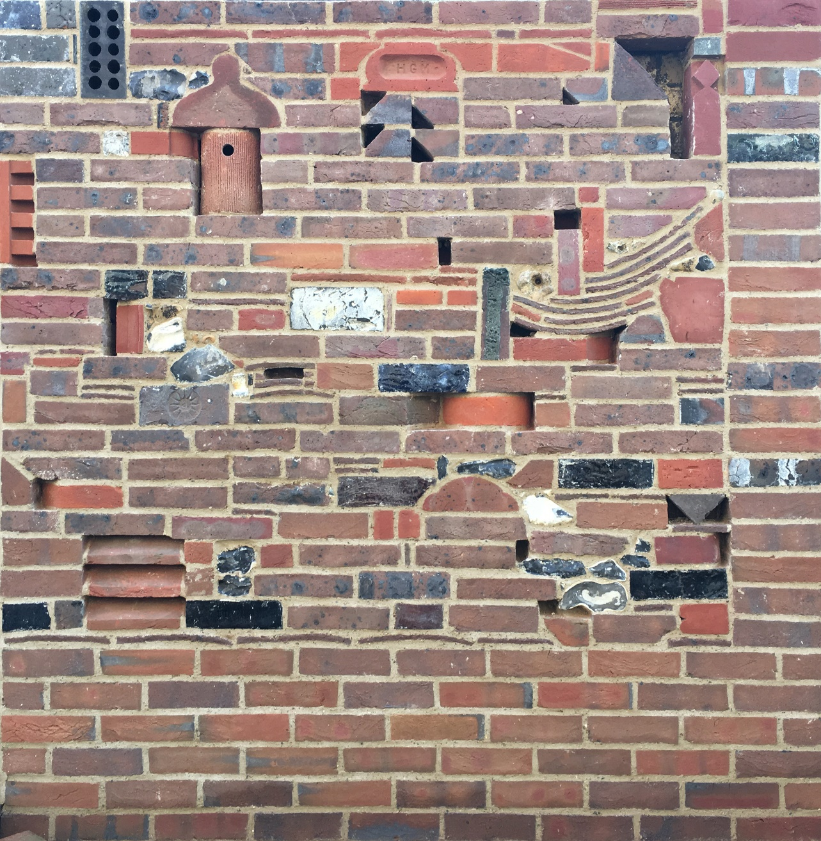
Goose Acre sample at KFM Studio, Berkhamsted.
Example from Park Farm (Para 80) House. Wiggington.
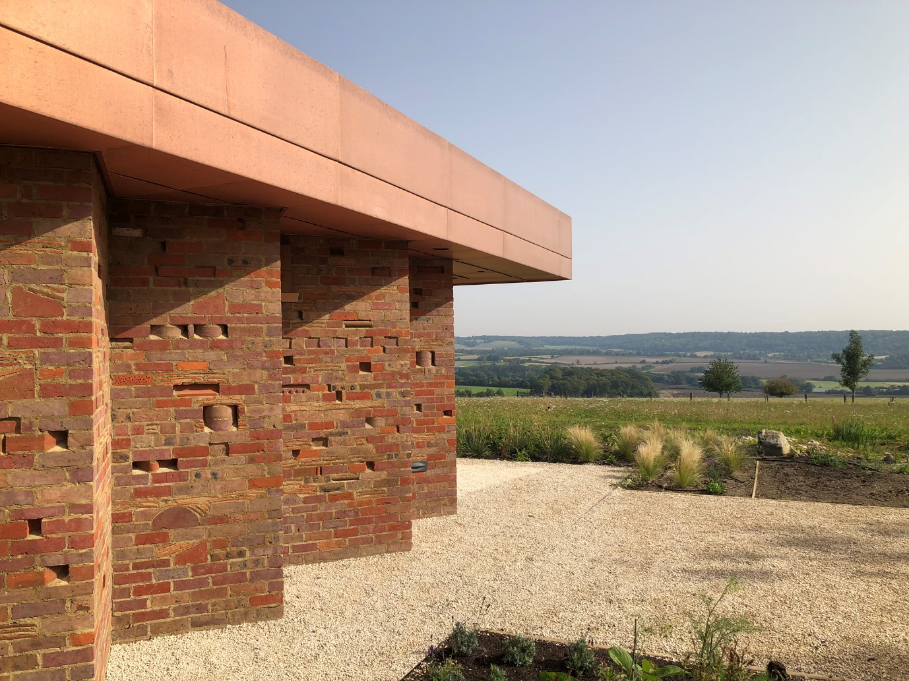
Other cladding will include standard Timber Clad Walls (Black Stained). . Samples available at KFM Studio Berkhamsted.
Glazing
Glazing will be high performance anodized aluminium glazing. To be determined following technical design.
Details
Parapets and wall details will be reconstituted Portland Stone. Samples available at KFM Studio Berkhamsted.

