Design and Access and Heritage Statement
August 2023
Preston Montford Hall, Montford Bridge, Shrewsbury, SY41DX
This Design and Access and Heritage Statement is to support our submission to carry out window replacement of sliding sash windows to the Queen Ann room and library and replacement of a timber casement window to room 41.
The property

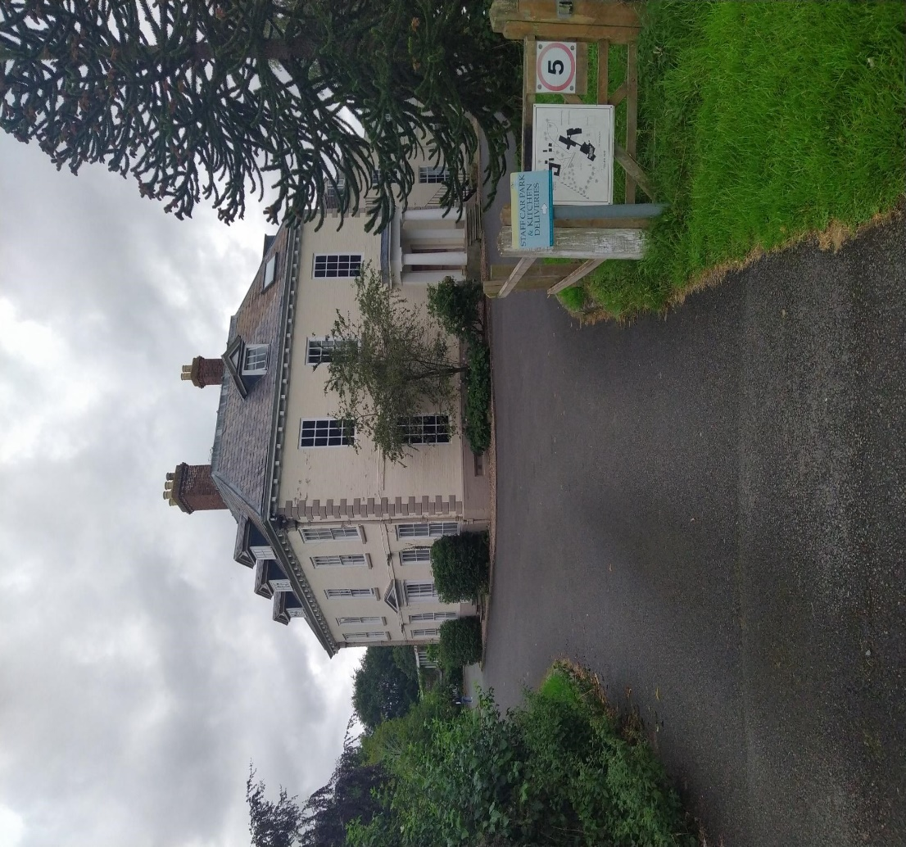

Preston Montford Hall is a Grade 11* listed building, and the following description is taken from the listing document for this dwelling.
Small country house, circa 1700, with some early C19 alterations and additions. Painted brick with some painted sandstone dressings. Hipped slate roof. Square plan. Two storeys and attic over basement. South front: plinth with moulded stone top, chamfered stone quoins, plat band, and moulded wooden modillion eaves cornice. Brick ridge stack off-centre to right, brick stack on left-hand return ridge, brick ridge stack to rear ridge and C20 stack off ridge to west. Three small-paned dormers with triangular pediments. 2:1:2 bays; boxed glazing bar sashes with painted stone cills and gauged-brick heads. Entrance altered in the early C19, consisting of tripartite glazing bar sash with flanking unfluted pilasters supporting entablature and triangular pediment. Flanking early C18 lead downpipes with fixing straps and cast rainwater heads with central monogram, acanthus ornament to sides and moulded tops. Right-hand return front: central pedimented dormer. Three bays. Some blind windows without cills, painted in imitation of glazing bar sashes. Blank centre to ground floor. Early C19 six-panelled door to eight with beaded flush panels and central beading, and Greek Doric stone porch with unfluted columns and antae, frieze, cornice and blocking course. Left-hand return front: single dormer to right. Three bays. Some blind windows without cills, painted in imitation of glazing bar sashes. Rear of 2 bays to north-east. Painted-brick service wing to rear with hipped slate roof. Two storeys and attic. Dentil brick eaves cornice, brick stacks and gabled dormers. Square wooden bellcote with pyramidal cap and weathervane. Two bays to east; boxed glazing bar sashes with painted stone cills. Interior: altered in the early C19. Front rooms with early C19 ornament. Early C19 three-bay Doric screen (now blocked) between central former entrance hall and left-hand room, with plain antae, and entablature with panelled soffit, anthemion and palmette ornament to frieze,and moulded cornice. Ground-floor front rooms with early C19 plaster cornices and soffits. Present entrance hall at rear with c.1700 raised and fielded and bolection- moulded panelling (probably resited) with moulded dado rail and moulded cornice. Windows with panelled internal shutters. Central staircase hall: 3-flight square-well oak staircase of c.1700, rising to attic, with panelled closed string, drop balusters, moulded handrail, panelled square newel posts with moulded caps and turned pendants, and raised and fielded dado panelling with moulded rail. Early C19 panelled doors with panelled architraves.
The property is now used as a Residential Field Centre by the Field Studies Council (FSC).

Condition of window sashes in Queen Ann room, Library and casement sash to room 41
The windows, in both the Library and Queen Anne room are sliding sash, single glazed units. The window in room 41 is a casement sash.
These windows have deteriorated and are suffering from wet rot. The left-hand window in the Queen Ann room has broken glazing rails caused by deterioration of window frame and is currently boarded up for safety reasons.
The glazing to these windows is also very fragile and is very easily broken.
Proposed Specification to replace sash’s to match existing design in Queen Ann Room and Library

The windows in the Queen Ann Room and Library are to be replaced with proposed sashes made from solid Sapele Hardwood with Heritage Double Glazed units.

Below is specification of works to be carried out when installing new sashes to window openings in the Queen Ann Room and Library:
Draught Seal and Overhaul Sash Windows:
-Remove and dispose of staff bead
-Remove lower sash, cords and counterweights
-Remove and dispose of parting bead
-Remove top sash, cords and counterweights
-Scrape down pulley stiles to remove excess paint if necessary
-Paint pulley stiles with single coat of acrylic paint - (see full decoration specification if ordered)
-Carry out any required repairs to sashes and frame - (see timber repair specification for costing)
-Replace any broken glass as required- (see glass replacement specification for costing)
-Repair and replace all loose putty
-Trim sashes to suit the frame
-Ensure mid rails are level
-Clean and paint between the middle rails
-Biscuit cut the middle rail to accept draught exclusion pile
-If replacement hardware is ordered, remove relevant existing hardware
-Repair where existing catches and locks have been if required
-If replacement hardware is ordered, install where required
-Re-Hang top sash with pre-stretched nylon cord, rebalancing counterweights as necessary
-Fit new draught exclusion parting and head beads
-Re-Hang lower sash with pre-stretched nylon cord, rebalancing counterweights as necessary
-Fit new draught exclusion staff bead with mitred joints
-Touch up chipped or bare surfaces - (see full decoration specification if ordered)
-Seal parting and staff beads with exterior grade sealant
-Test sashes operate and seal correctly
-Clean glass

Specification for replacement of Casement Window to Room 41

The window in room 41 is to be replaced with proposed casement made from solid Sapele Hardwood with Heritage Double Glazed units.

Below is specification of works to be carried out when installing new casement to window openings in room 41:
Draught Seal and Overhaul Casement Window Service:
-Remove casement from hinges
-Remove existing hinges
-If replacement furniture is ordered, remove relevant existing hardware
-Repair where existing furniture and locks have been if required
-Scrape excess paint from frame
-Paint rebate with single coat of acrylic paint - (see full decoration specification if ordered)
-Carry out any required repairs to casements and frame - (see timber repair specification for costing)
-Route capillary groove into bottom rail of casement
-Replace any broken glass as required- (see glass replacement specification for costing)
-Repair and replace any loose putty
-Biscuit cut casement to accept draught exclusion pile
-Install new hinges
-Re-hang existing casements
-If replacement hardware is ordered, install where required
-Test casements operate and seal correctly
-Clean glass

Information about our appointed Contractor – WRSW ltd (Wiliam Richards Sash Windows)
The company was established in 1984 and over the years have developed experience and knowledge of working and replacing sash windows to listed buildings. The company are based locally to Preston Montford at Stafford Park, Telford.

Owners and Consultation
The property is owned by the Field Studies Council (FSC)and they are supportive of this work being carried out to their property to ensure the property is wind and watertight again.

As this is not a fundamental change, we have not consulted with local residents, however, we have consulted with the Centre Manager.

August 2023

