Natural Stone to be used in elevations, Syreford Quarry, Cheltenham. Rough Dressed

https://www.syreford-cotswold-stone.com/

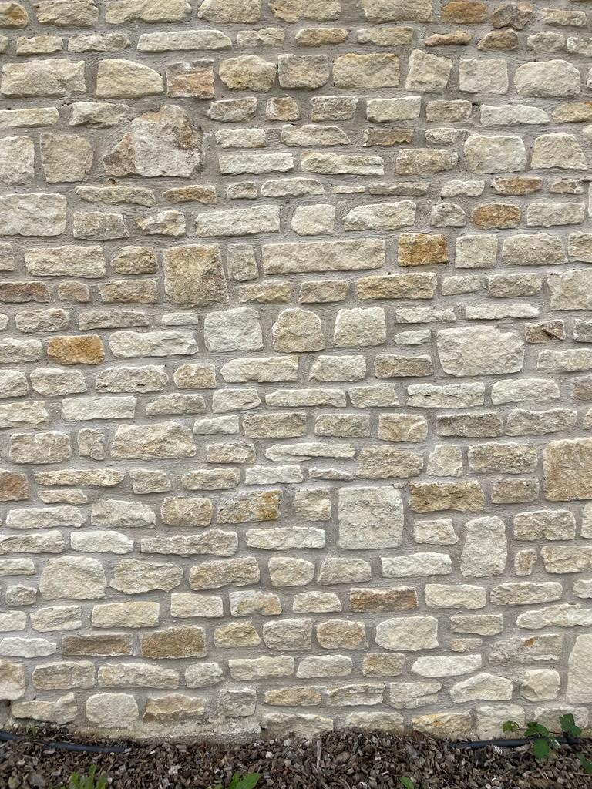

Bradstone Cotswold Re-constituted Stone Slates
https://www.aggregate.com/products-and-services/building-products/roofing-tiles/conservation

