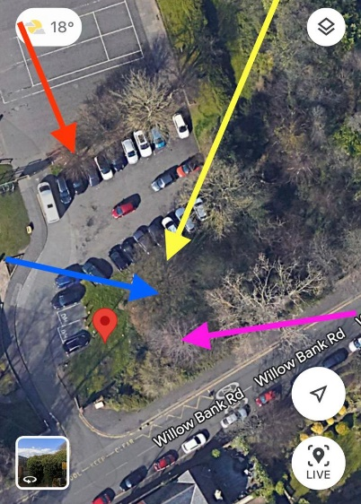

36A Ellesmere Court, Sunderland, SR2 9UA

Tree Preservation/Conservation Order Application
Date 4th October 2023
St Aidan’s Catholic Academy
Willow Bank Road
Sunderland
SR2 7HJ
Description of works –
Category U Works –

T346 - Remove Swedish white beam to ground level, tree in decline with huge westerly lean. Blue Arrow.

T348 - Remove Horse chestnut to ground level, huge cavity in east side of stem at 4m. Yellow Arrow.

These works have been identified on the Tree Survey carried out by Amenity Tree with the works and TPO application carried out by ATW Tree and Landscaping Specialists LTD.

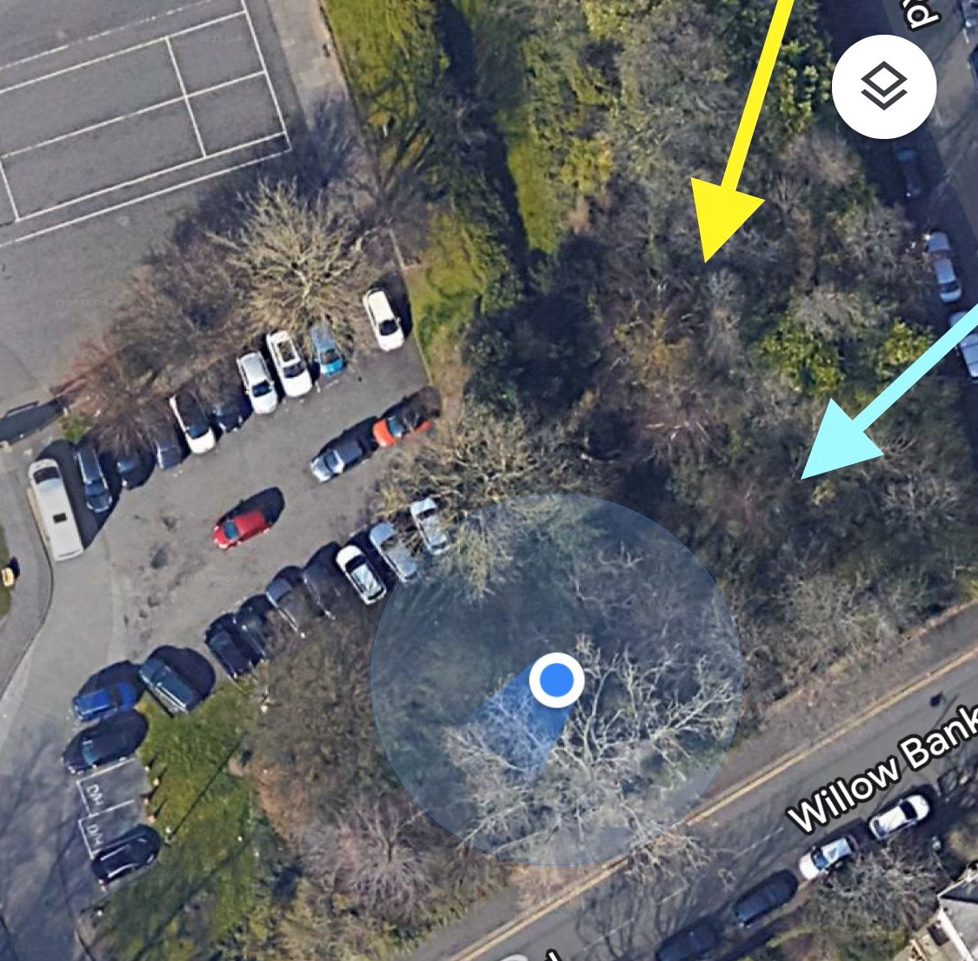
T348
T346

