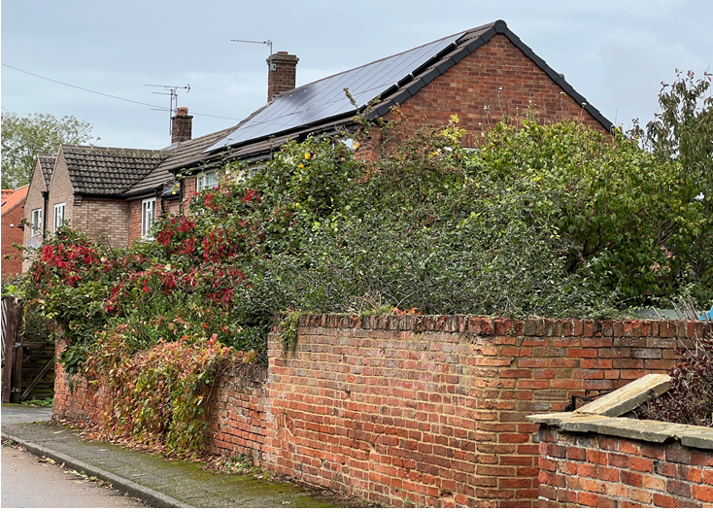
Solar Panel Installation in Church Lane visible from the High Street. This installation is almost opposite the proposed installation and at approximately the same distance as 120 High Street and is also in the conservation area.

