Supportive Statement from Andrea Carr, neighbour

“I am a resident, freeholder and owner of ground floor and first floor flats. I have lived here since the 80’s. I can confirm that the conservatory footprint, height and all dimensions have not changed.

“Before buying my flats I was a tenant in the basement flat in the 80’s. The conservatory was built by John Clancy who was a builder and owner of the flat. When he built the conservatory he laid expensive Italian tiles which remain today exactly as laid. This dates the conservatory build to be well over 30 years. The flat was then bought by Adrian Meadows who could if need[ed] give further testimony.”

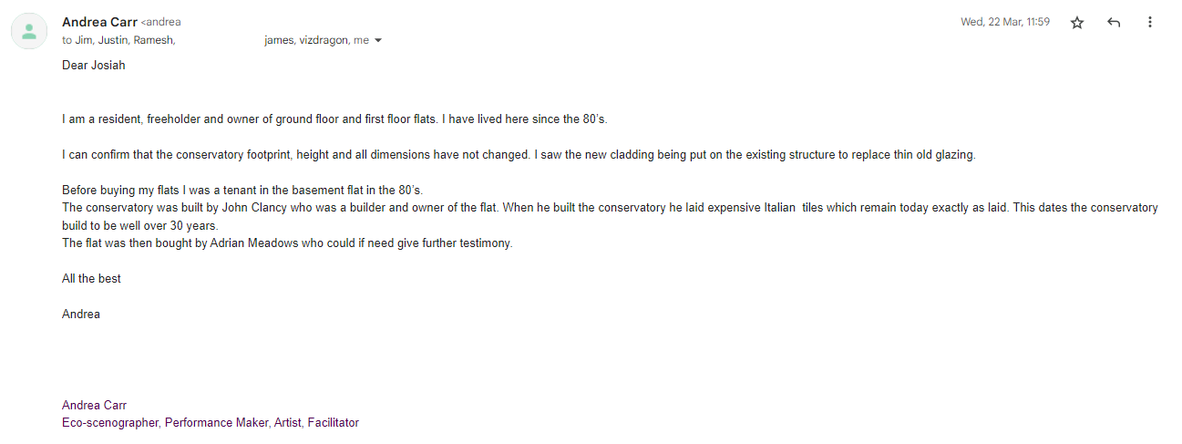

Statement from neighbour Jim Glennon (Flat 4, 356 Coldharbour Lane)

[…]
I can testify that the conservatory was already here when I moved in 35 years ago (and probably Andrea can from round the same time). I considered buying your flat and was shown round in 1991 and saw the conservatory then.

I also have plans including ground floor plans drawn up by original architect involved in conversion to flats around 1980 which might be useful. One qualification being that these are plans/designs and may not show final build but at least they give an impression of territory at the time.

[...]

Jim

