Application for Listed Building consent for alterations to 5 Yate Cottages, Lumb Lane, Waterfoot BB4 9RW

Heritage assessment

H | P
D | A

September 2023

Prepared by Hartley Planning and Development Associates Ltd

The National Planning Policy Framework 2023 (the NPPF) advises that heritage assessments shall be proportionate in their comprehensiveness to the degree of proposed change: -

‘194. In determining applications, local planning authorities should require an applicant to describe the significance of any heritage assets affected, including any contribution made by their setting. The level of detail should be proportionate to the assets’ importance and no more than is sufficient to understand the potential impact of the proposal on their significance. As a minimum the relevant historic environment record should have been consulted and the heritage assets assessed using appropriate expertise where necessary. Where a site on which development is proposed includes, or has the potential to include, heritage assets with archaeological interest, local planning authorities should require developers to submit an appropriate desk-based assessment and, where necessary, a field evaluation.

195. Local planning authorities should identify and assess the particular significance of any heritage asset that may be affected by a proposal (including by development affecting the setting of a heritage asset) taking account of the available evidence and any necessary expertise. They should take this into account when considering the impact of a proposal on a heritage asset, to avoid or minimise any conflict between the heritage asset’s conservation and any aspect of the proposal.

196. Where there is evidence of deliberate neglect of, or damage to, a heritage asset, the deteriorated state of the heritage asset should not be taken into account in any decision.

197. In determining applications, local planning authorities should take account of:
a) the desirability of sustaining and enhancing the significance of heritage assets and putting them to viable uses consistent with their conservation;
b) the positive contribution that conservation of heritage assets can make to sustainable communities including their economic vitality; and
c) the desirability of new development making a positive contribution to local character and distinctiveness.

The nature of the listing and the characteristic of their setting

No. 5 Yate Cottage, along with No. 3 Yate Cottage, was listed in November 1984 and the listing states as follows: -

Pair of cottages in 2 builds, late Cl8. Watershot sandstone in diminishing courses, stone slate roof with one chimney on the ridge, one at junction with barn to left, and one at right gable. Single depth each cottage 2 bays. Two storeys; in the centre of each a doorway with plain surround (glazed porch to No.3 on left); No.3 has 2 stepped triple-light windows on each floor, No. 5 formerly had matching fenestration but 1st floor windows are now altered. Rear wall has various windows of less interest, and no door. Abutting at left end is barn to No.l. Yates Cottages (q.v.) with which this item forms an interesting ensemble.

The listed properties form a terrace along with a barn which has been converted to the dwelling occupied by the applicant.

They are two storey stone-built dwellings with double pitch roofs. Internally they have been modernised and with an absence of original features. The listing stresses their external features.

Proposed change to No 5 Yate Cottage.
The proposed external change is limited to the replacement of a window on the rear elevation by a glazed door.

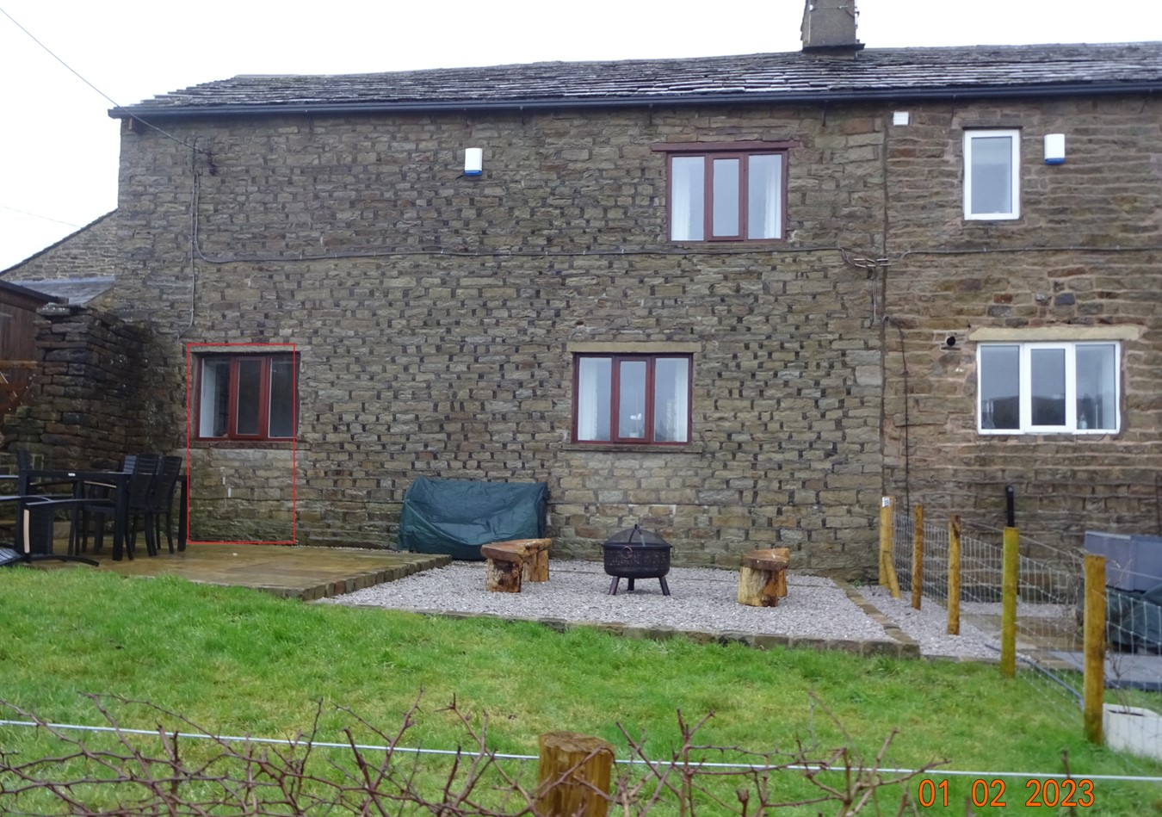

.
. The proposal is to replace the above window with a double, glass door. The proposed door would be fit flush with the outside wall.

Summary

The above change would reflect the approved rear door to No 3 Yate Cottage and would have no material or significant impact on the listed buildings or their settings.

