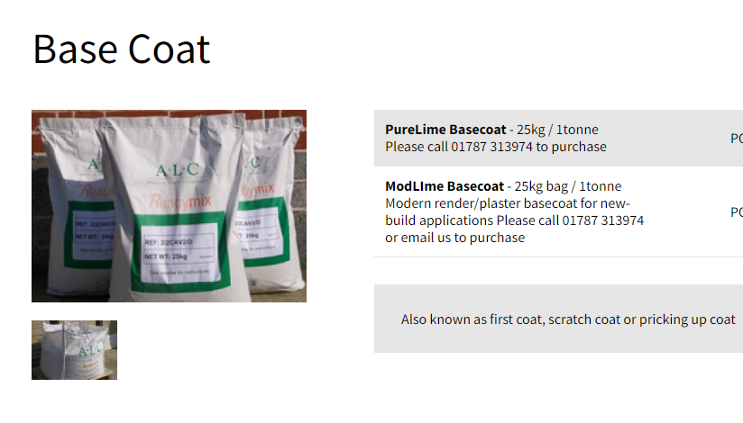
Base Coat
Applied To Waterproofing Membrane – 12-15mm. In Thickness

