Heritage Statement - Installation of Solar Photovoltaic Panels to 24a The Street, Ashwellthorpe

Significance of the heritage asset
24a The Street sits within the curtilage of the grade II listed building Wood Farmhouse (List entry number 1170287; 26 The Street). Wood farmhouse dates from mid 19th century and includes a 17th century timber-frame south wing. It is constructed in red brick with a pantile roof. The external features include sash windows with glazing bars and a central doorway with panelled architrave with hood on brackets. 24a The Street is part of a recent conversion of buildings adjacent to Wood Farmhouse which formed 3 new domestic properties which sit within the curtilage of Wood Farmhouse. 24a The Street is formed from what was the brick granary and adjoining clay lump lean-to addition, plus parts of a further timber framed barn and a clay lump open fronted cart shed. 24a The Street is constructed in red brick with a clay pantile roof, with painted black render at the base of the brickwork, painted black wood cladding to what was the cart shed and black painted render on the lean-to. 24a The Street also includes a modern garage, build in red brick, with black painted timber and clay pantile tile roof. There is a further neighbouring grade II listed building, Peel Farmhouse (1049675; 24 The Street), whose boundary adjoins 24a The Street.

Wood Farmhouse and 24a The Street sit within approximately 1ha of a mixture of agricultural buildings, agricultural driveway, lawn gardens, mature trees and hedges, and drainage ditches. The properties sit within a wider residential and agriculture village setting, which largely consists of a linear settlement along a road.

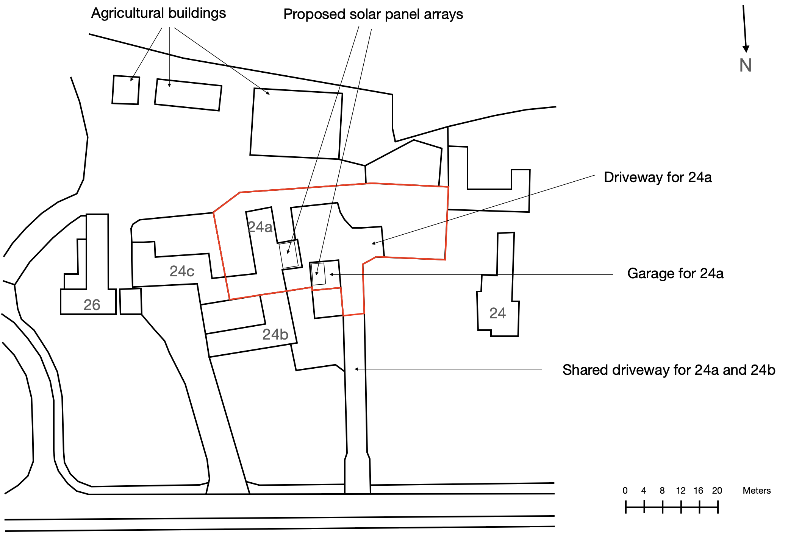
Site overview, showing 24a The Street and neighbouring properties, with proposed solar panel installation site indicated.
Proposed works and their impact on the asset
It is proposed to install 18 solar photovoltaic panels to the east facing garage roof and west facing lean-to roof, as indicated on the site overview, and configured as shown in the elevations. 10 of the panels will be located on the lean-to and 8 on the garage. The photovoltaic panels will be mounted on metal frames fixed to the existing roof. The pantiles will be retained under the panels and no other alterations to the roof structure or its coverings will be made. The height from the roof face to outer face of solar panels will be no more than 200 mm. The inverter will be located within the property alongside the existing consumer board. The proposal is regarded as temporary and is reversible. The only impact on the fabric of the building will be a single cable entry point to the north face of the lean-to, as close to ground level as permissible. A cable will run from the garage to the lean-to, using the existing trench for the cable from the electricity supply to the garage. All cables will be black, in keeping with the paint colour of the lean-to, garage timber cladding and brick render, and will run at ground level alongside existing cables.

The installation of the panels will have minimal impact on the setting of Wood Farmhouse as they will only be visible from the most westerly agricultural building. Furthermore, the lean-to roof is approximately 16 degrees, substantially limiting the visual impact of the solar panels. The garage roof array faces back towards an enclosed portion of the 24a The Street, such that the visual impact will also be substantially limited. The boundary between 24a The Street and Peel Farmhouse consists of an approximately 1.8 m high wall and hedge on the Peel Farmhouse side. As such, the only line of sight from Peel Farmhouse to the solar panel arrays will be from a limited number of east facing upper floor windows towards the array on the lean-to. The solar panel arrays will not be visible from the road.

Mitigating factors incorporated into the development
To attempt to minimise the impact of the development on both 24a The Street and Wood Farmhouse, the following design aspects were incorporated:

- Choice of precise location. Detailed advice was obtained from 3 independent experts regarding the efficiency of the solar panel arrays in various locations. The optimal placement of the arrays would be the east and west faces of the main roof of the property, which was originally the brick granary. The placement of the arrays on the garage roof and lean-to roof was chosen instead to limit the visual impact of the solar panels and effect on the character of 24a The Street.
- Choice of panels. It is intended that Jinko JKM 435W All Black Panels will be used in the installation. These panels were selected for their low visual impact. The panels have a black frame, black cells, and black back sheet, in contrast to alternative panels with the appearance of white gridlines. The panel data sheet is included in the application.

