Dover District Council

New pole

White Cliffs Business Park

Honeywood Road

Whitfield

CT16 3EH

Our ref: ONEA74663413

Title: The Electronic Communications Code (Conditions and restrictions) (Amendment) Regulations 2017 – BT intends to install fixed line broadband electronic communications apparatus in Honeywood Road, Whitfield CT16 3EH.

Under Regulation 5 of the above Code, I hereby give you 28 days notice informing you of our intention to install a new pole at the location below. I enclose a copy of the plan indicating the approximate position for the apparatus.

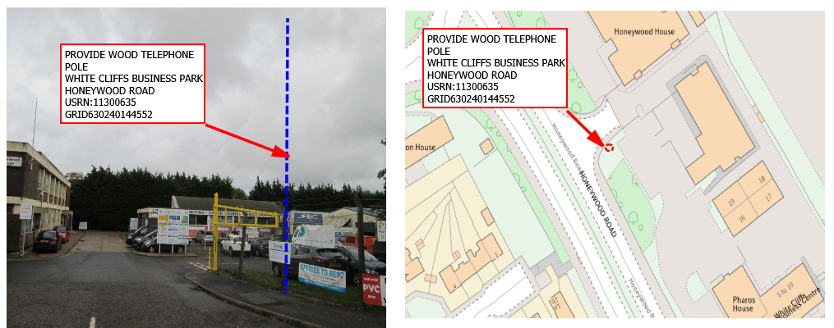

Should you require further information with regard to the above works, please do not hesitate to contact me.

Yours faithfully



Stephen Buck