Proposal

Static caravan

8a north kirklands holdhouse road, eaglesham

Document history
Issue | Date | Comments
1.0 | 12/09/2023 | Original
2.0 | 10/11/2023 | - Amendment of section 2.1  - Clarification added in section 2.3  - Addition of section 4 (Supporting Documentation) – in response to points 1, 2 and 3 from “Invalid Application” letter  - Addition of section 5 (Additional Supporting Information) – in response to Point 4 from “Invalid Application” letter

Contents
1. Summary 2
2. Development Details 2
2.1 Site plan 2
2.2 Style and colour 4
2.3 On-site parking arrangements 4
2.4 Sustainability 5
3. Development Outcomes 5
3.1 Enhance the accommodation offering in the area 5
3.2 Support the local economy and tourism 5
3.3 Ancillary support to our household 6
4. Supporting Documentation 6
5. Additional Supporting Information 6
5.1. Connection to services 6
5.2 Static Caravan Siting 6

Summary
We would like to apply for planning permission for the installation of a static caravan in our side garden which will have multiple uses over time: accommodation for visiting family and friends, short-term visitor let, play space for our children, potential accommodation for elderly parents.

Development Details
Our objective is to purchase and run a sustainable static caravan appropriately sized for the garden to the side of our house. The style and colour would be in keeping with our property which is white and black, with long pitched roofs.

2.1 Site plan

The diagram below shows the space occupied by the static caravan within the side garden. The side garden of the house has a dimension of 7.6m X 14.3m. The static caravan would occupy approximately 3.81m X 11.60m within this space according to standard caravan sizes research.

Please find Proposed Site Plan attached to the application – File 8A000.pdf

Pictures of the side garden:

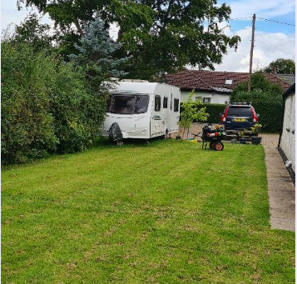

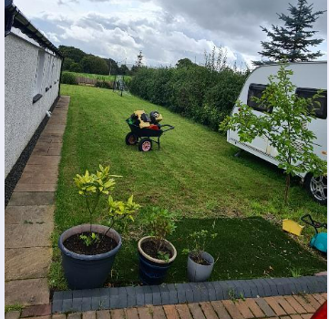

The hedge would be retained which would mean minimal visual impact for the neighbours across the road or across the fields.

2.2 Style and colour

The style would be similar to the example picture below and the colour would be white, grey or cream.
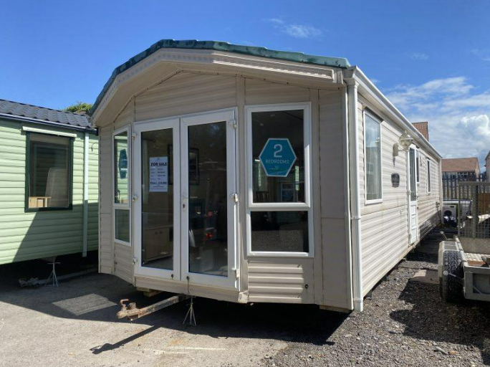

2.3 On-site parking arrangements
Parking for any visitors would be on our property at the front, which has capacity for a number of cars (4 would fit in comfortably).
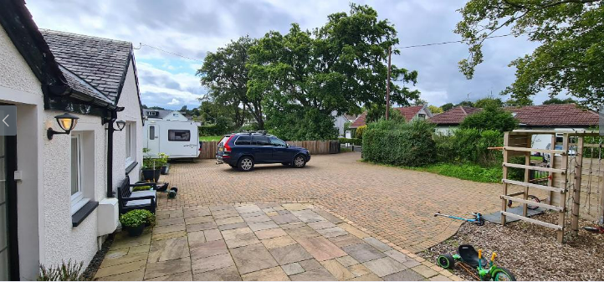
Clarification: We do not expect visitors to require more than 2 car parking spaces to the utmost. Usually, we would expect 1 car.

2.4 Sustainability
The static caravan will be supplied with electricity from our house, which has 14 solar panels installed. We would also be looking to purchase a caravan with double glazing and, if possible, fully or largely electric powered.

Development Outcomes
Our development will enhance the visitor accommodation offering in the area, support the local economy and tourism and provide ancillary support to our household.

3.1 Enhance the accommodation offering in the area
Our development would add to the mix of short-term visitor accommodation on offer in the village, which currently consists, to our knowledge, of a hotel and room/flat lets. This would be attractive to a range of tastes and audiences (including families) and therefore complement the existing offering.

3.2 Support the local economy and tourism

Through short-term lets we would encourage visitors to the area to enjoy the local natural beauty, the countryside, and biking trails. There are several biking routes passing through our village and even our street which connect to Darvel, Whitelee Windfarm, Thortonhall, Bonnyton and other local areas.
Our guests would shop at the local businesses: restaurants, souvenir shops and even golf courses and equestrian centres, therefore encouraging the local economy. A cleaner would be hired which would lead to an element of job creation.
We expect the guests would either visit for recreational/leisure purposes or for work-related business (particularly people who work with businesses from East Kilbride). In terms of frequency of rental we would expect the caravan would possibly rent out a few times per month to 1-to-4 people for 1-2 nights at a time.

3.3 Ancillary support to our household
We often have visiting family from abroad who would use the static caravan for 3-4 weeks at a time. Also, other family and friends would benefit from this. We have elderly parents who live locally who would use the caravan for respite and access to our care. We also envisage that it would provide an additional space for our children to use.

Supporting Documentation
Please find reference documents attached to application as follows:
Name | Date | Comments
8A000.pdf | 10/11/2023 | Drawing of Proposed Location/Site Plan
8A001.pdf | 10/11/2023 | Drawing of Proposed Internal Layout
8A002.pdf | 10/11/2023 | Drawing of Proposed Elevations

Additional Supporting Information

5.1. Connection to services
The static caravan would require connecting into the mains sewerage, electricity and water connections of the house.
We would like to request this for the duration of the caravan’s life, which can be around 40 years.

5.2 Static Caravan Siting
To site the caravan both concrete blocks and support stands will be used: solid concrete blocks will support the main longitudinal chassis beams; support stands will be used at points between the chassis and the corner steadies.
We will subcontract the siting work to a specialised company, who we expect will opt for a typical support mechanism, such as:
