Dear Sir/Madam,
Dover District Council
Planning Department,
White Cliffs Business Park,
Dover,
CT16 3PJ
14/11/2023

Our ref:
OGEA75144519
Title:– BT intends to install fixed line broadband electronic communications apparatus O/S No
23 ST GEORGES ROAD, SANDWICH CT13 9LF
Under The Electronic Communications Code (Conditions and restrictions) (Amendment) Regulations 2017, I hereby give you notice under Regulation 5 informing you of our intention to 1 New 9m light wooden pole at the above location.
I enclose a copy of the plan indicating the approximate position for the proposed apparatus.
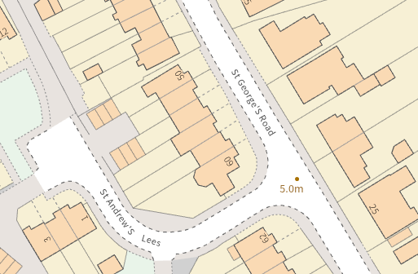
Approximate Grid ref:- 633365,157639
USRN: 11301151
Should you require further information about the above works, please do not hesitate to contact me.
Yours faithfully,

