Retrospective change of use of the outbuilding to
Ancillary holiday let

Seagulls, West Bracklesham Drive, Bracklesham Bay, PO20 8PF

Statements

Mitigation

The development has resulted in a net increase in dwellings within 5.6km of the Chichester and Langston Harbour Special Protection Area (SPA). We therefore acknowledge the need to mitigate a scheme and commit to providing mitigation via a financial contribution to Bird Aware Solent.

Surface Water Drainage

Rainwater from the downward sloping roof of the cabin is discharged to the guttering at the rear of the cabin which is connected by a downpipe into existing drainage system of the main house.
Image 1

West facing view of downpipe from guttering connecting to existing drainage system
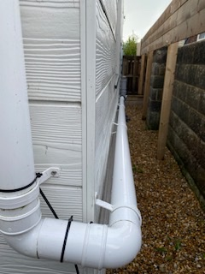

Image 2

East facing view of cabin showing pipe connecting downpipe from guttering to cabin attached to existing drainage system of main house.
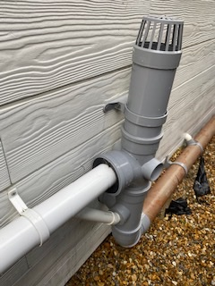

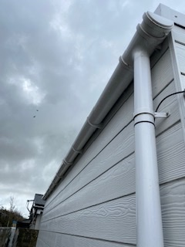
Image 3

North facing view of cabin showing guttering and downpipe

Rain water onto the decking area naturally falls under the decking through the gaps in the boarding onto existing soil and shingle.

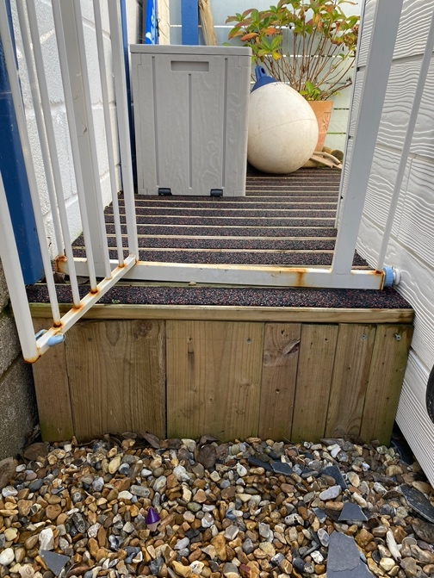
Image 4

West facing view of raised decking area, non-slip decking with 2mm gap in between to allow for natural drainage to shingle/soil below.

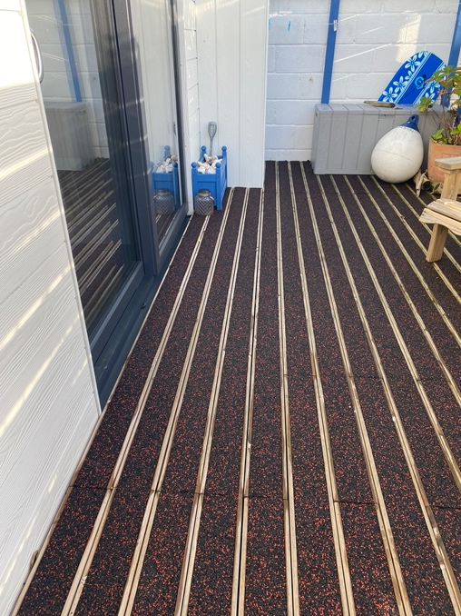
Image 5

View of decking in front of cabin entrance with gaps in between boards to allow for natural drainage of rainfall to soil/shingle below.

