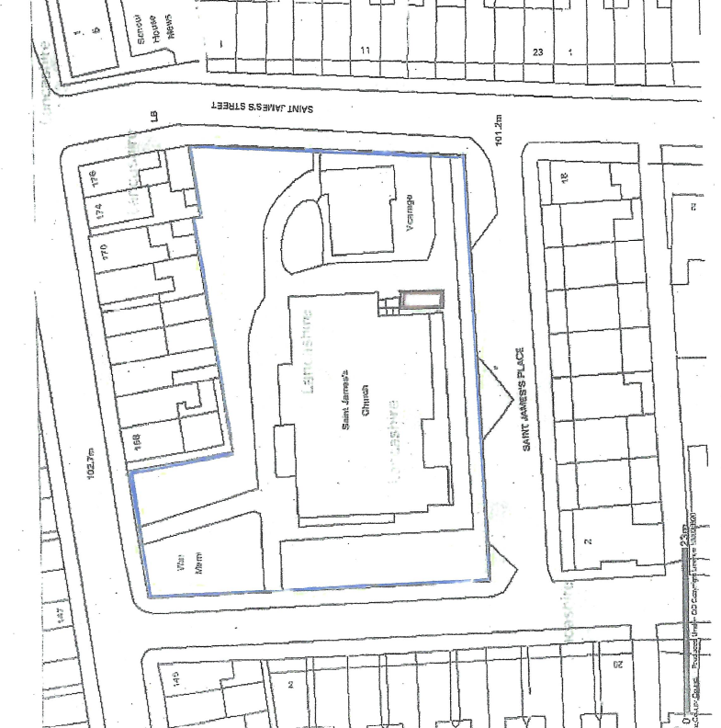
Classroom (container location)

Plan of Church & Temporary Classroom (converted 20ft container) location.

