Andrew Lockley,
3, Maple Drive,
Heath Farm,
Shrewsbury,
SY1 3SE.
Date 17th Nov 2023.
Central Validation Team
Planning Dept,
Shropshire Council,
Shirehall,
Abbey Foregate,
Shrewsbury.
SY2 6ND.

Dear All,

RE:- 38, High Cross Avenue, Cross Houses, Shrewsbury, SY5 6LJ

Please find accompanying this letter a new planning application for a proposed extended drop kerb at the above address.
We wish to apply for the extended drop kerb as it will allow easier access onto the new porous drive that is to be constructed thus ensuring that there is no further on-street parking. This will then reduce the on street parking and allow better and safer passing and movement of vehicles.
At the current time there are vehicles being parked on the highway / pavement and the property as you can see from the OS maps is sited at the end of the road, this means that vehicles are very often having to drive up to the end of the street to turn around this mean that parked vehicles are posing a road safety issue and a new drop kerb would allow the passage of vehicles safely onto the property and off the highway.
The work would be carried out be an authorised contractor and a drop kerb application to the highways dept will be submitted if there is a positive decision from the planning dept.

The following photograph shows the existing frontage of 38, High Cross Avenue and where the proposed dropped kerb is planned to be positioned. The existing shared driveway’s dropped kerb to the left is 5500mm wide. The new dropped kerb is planned to remove the existing diminishing kerb stone and the next two to the left and then have a diminishing kerb stone. It would make the dropped kerb wide enough to allow access onto the proposed new driveway and ensure that cars are not parked in the cul-de-sac end.

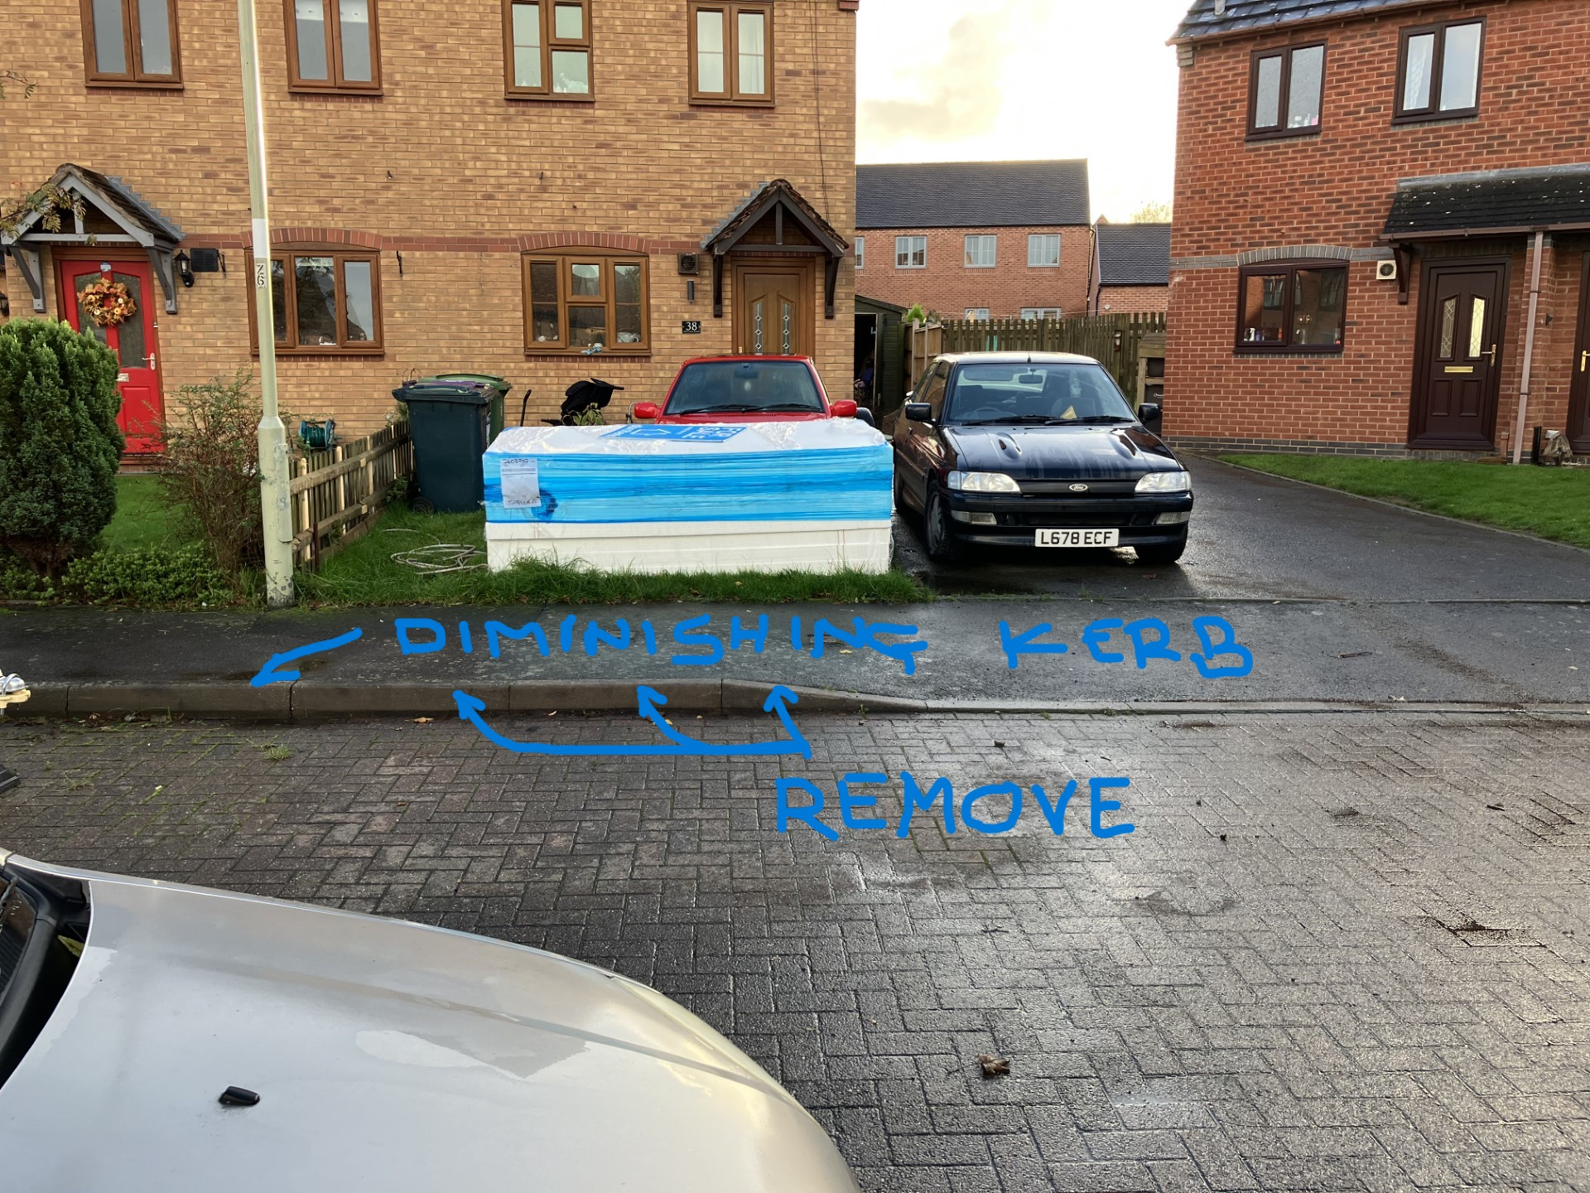

If more information is required then please by all means let me know.
Regards.

Andrew Lockley.
Phone number 363237
Mobile 07976593205
Email :- andrewlockley3@hotmail.com

