6 BRUNNER ROAD, EALING, LONDON, W5 1BA
DESIGN AND ACCESS STATEMENT

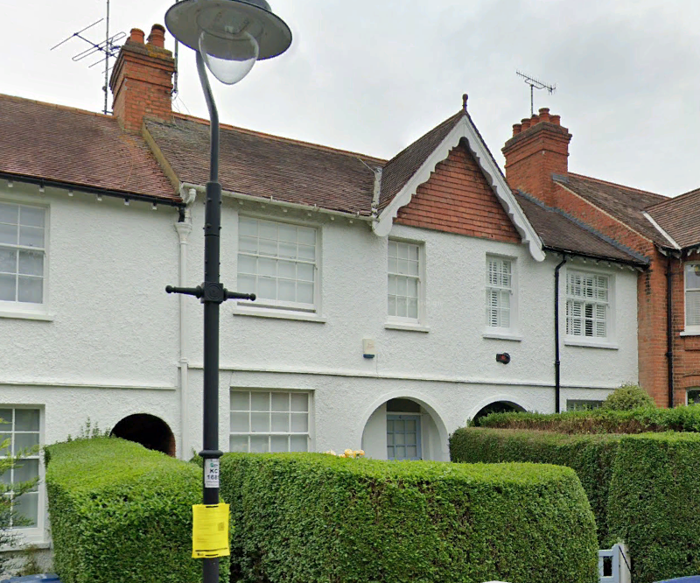

- EXISTING BUILDING
The existing building is a two-storey terraced house in the Brentham Conservation area.

- PROPOSED ALTERATIONS.
The proposed works are to build a single storey rear extension to the same depth as that to the adjoining property, no. 5 Brunner Road.

- LIST OF DRAWINGS.
Drawings included with this application are:

1861 / 01 AS EXISTING floor plans
02 AS EXISTING elevations and sections
03 BLOCK and LOCATION PLAN
04 LOFT CONVERSION floor plans
05 LOFT CONVERSION elevations and sections

- NEIGHBOURING PROPERTIES.
The adjoining property, no 5 Brunner Road has already been extended in the same manner, as has no. 8 Brunner Road.

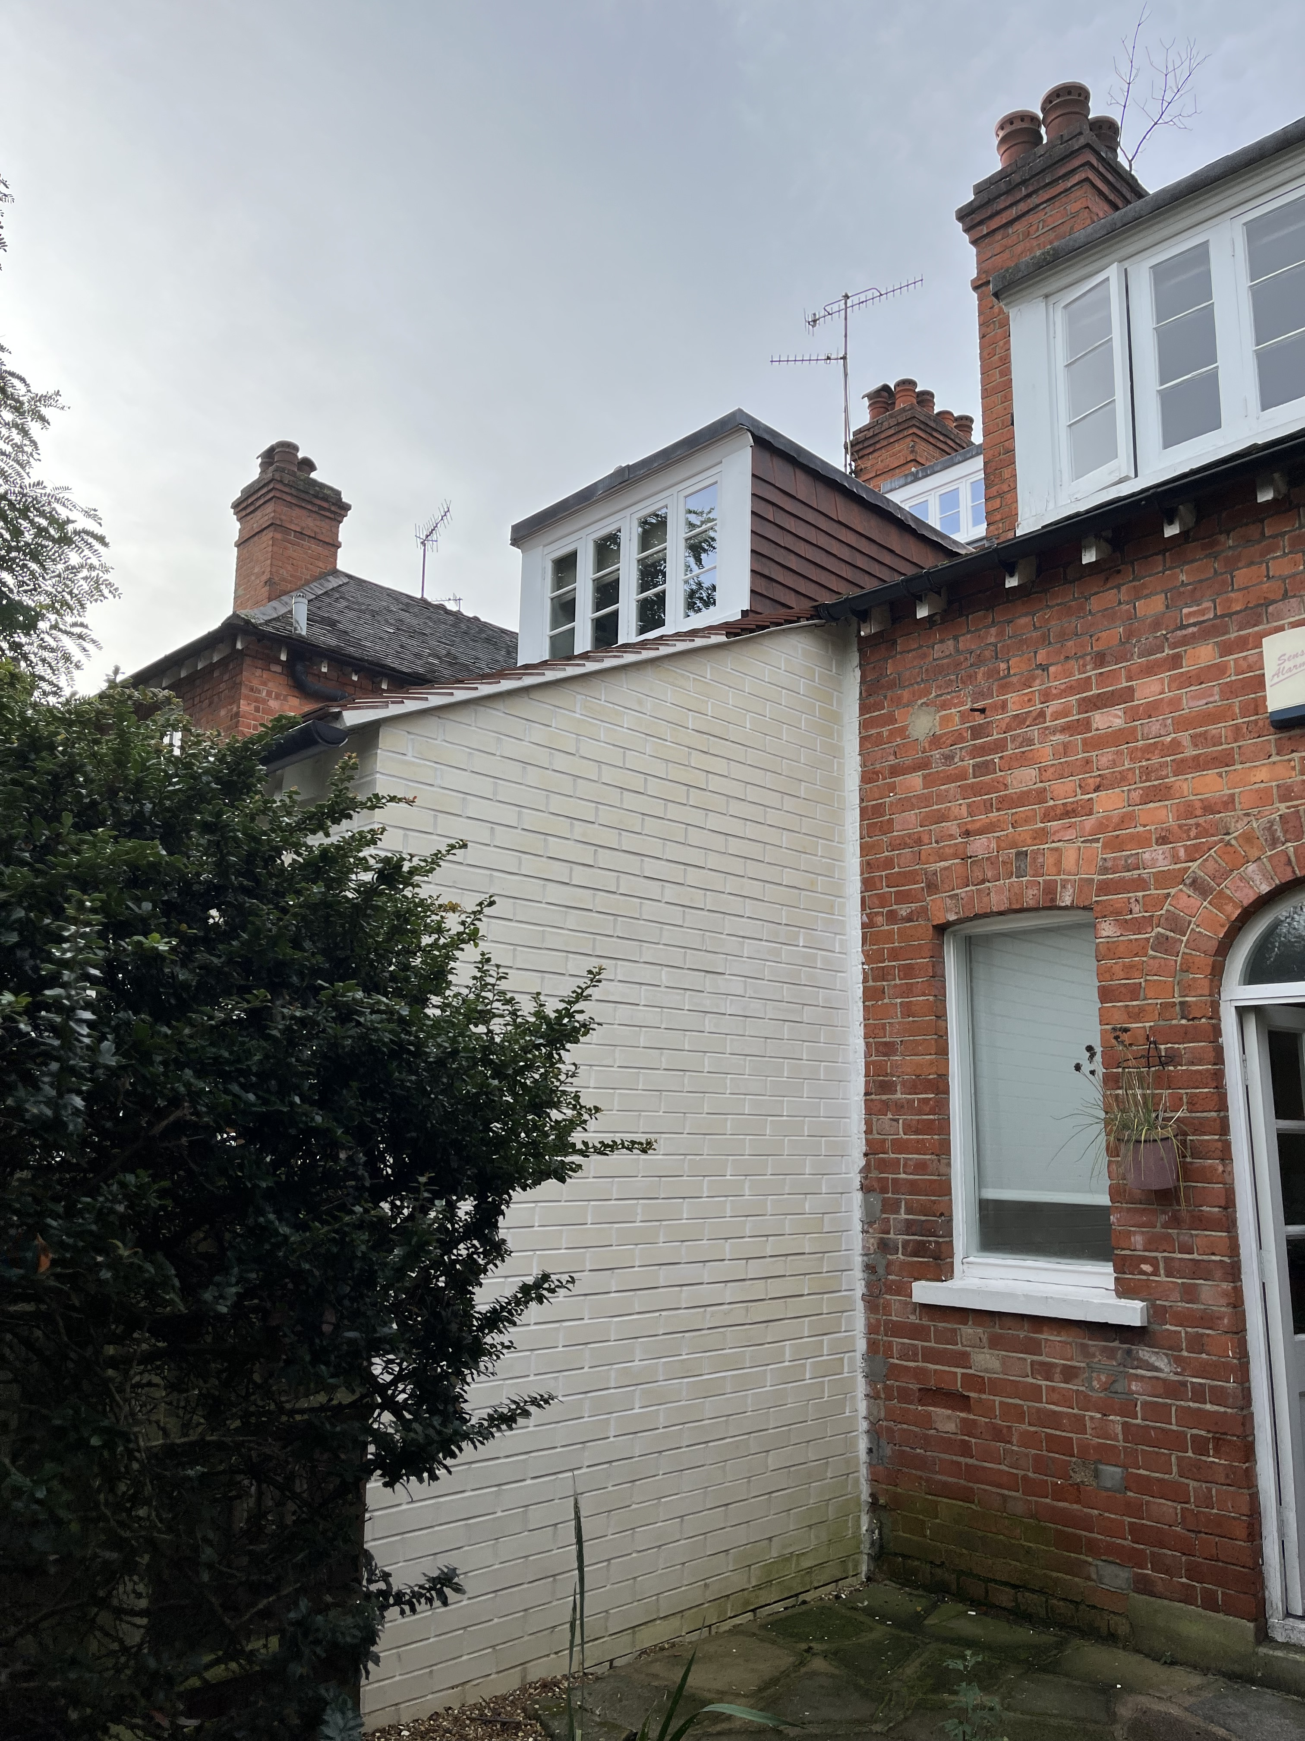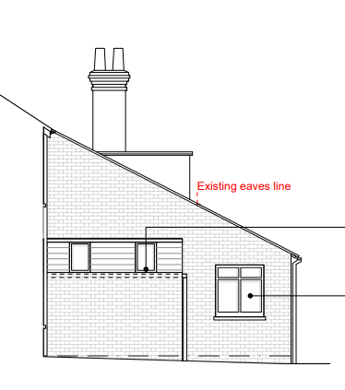
5 BRUNNER ROAD

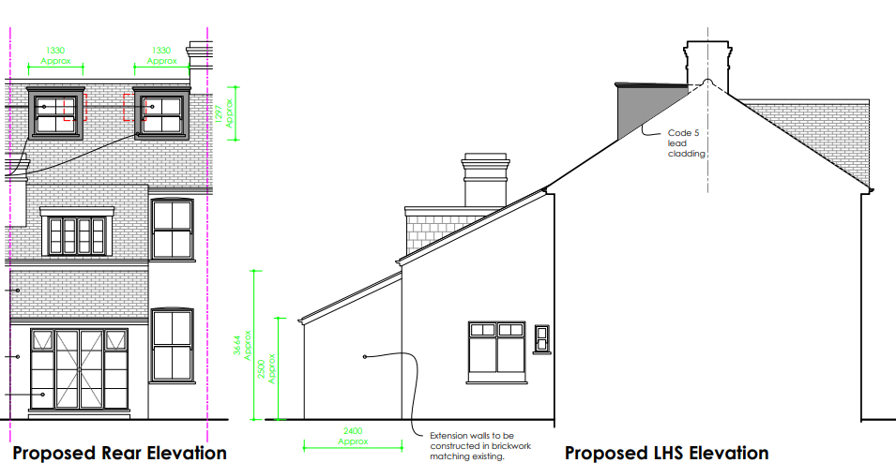

8 BRUNNER ROAD

- DISABLED ACCESS DESIGN.
The proposed works will have no negative impact on the existing disabled access to the property.

