Planning, Design and Access Statement

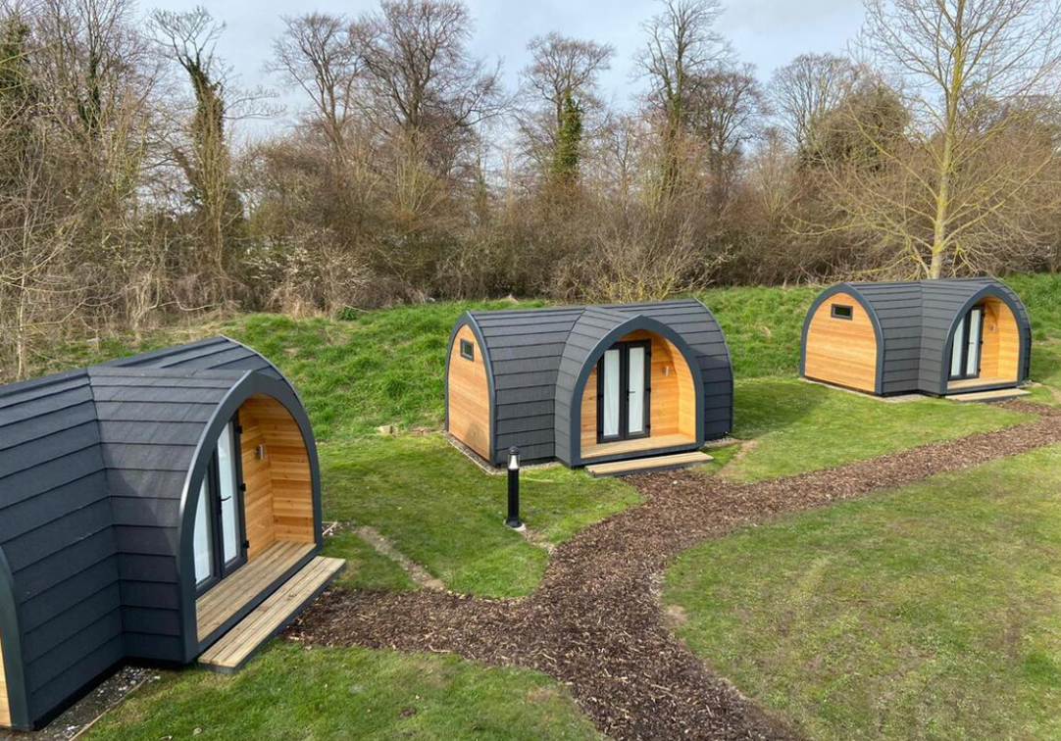

Application for the use of land for the stationing of two “holiday pods” - Bellogas Farm, Buryas Bridge, Penzance, TR19 6AP.

On behalf of Mrs. Stephanie Goody.

November 2023.

Kevin Moseley BSc (Estate Management), MRTPI.
Chartered Town Planner.

Contents:

- Description of the application site and surrounding area.

- Description of the proposed development.

- Relevant National Planning Policy considerations.

- Development Plan and local policy considerations.

- Planning history.

- Design issues.

- Access issues.

- Submissions and Conclusion.

Appendices:

- Photographs.
- Cornwall Local Plan Policies.
C. Green Infrastructure Plan/Statement.

- Description of the application site and surrounding area.

The proposal relates to the use of land for the stationing of two “holiday pods”.

The site is located at Bellogas Farm, Buryas Bridge, Penzance, and is identified on the plans submitted with the application, and the details attached at Appendix A to this Statement.

The site comprises a small triangular plot of land, with an area of approximately 0.02ha, which is roughly grassed and contains some remains of a former Nissan hut.

A location plan and aerial photographs are attached at “Appendix A”.

- Description of the proposed development.

Bellogas Farm is a 24 acre holding where the applicant farms the land with a herd of 40 beef cattle. In addition, one of the fields in the south-west corner of the holding is used as a campsite during the summer months.

The proposal involves the stationing of two small “holiday pods” on the identified small area of land which, as a farm diversification project, together with the existing camping, will help the applicant to maintain the farming operation.

- Relevant National Planning Policy considerations.

Central Government planning policy guidance is contained primarily in the revised National Planning Policy Framework (published in September 2023). This revised Framework replaces previous versions of the National Planning Policy Framework (originally published in March 2012).

The Framework sets out the Government’s planning policies for England and how these are expected to be applied.

The purpose of the planning system is to contribute to the achievement of “sustainable development”.

Achieving sustainable development means that the planning system has three overarching objectives, which are interdependent and need to be pursued in mutually supportive ways (so that opportunities can be taken to secure net gains across each of the different objectives):

a) an economic objective – to help build a strong, responsive and competitive economy, by ensuring that sufficient land of the right types is available in the right places and at the right time to support growth, innovation and improved productivity; and by identifying and coordinating the provision of infrastructure;

b) a social objective – to support strong, vibrant and healthy communities, by ensuring that a sufficient number and range of homes can be provided to meet the needs of present and future generations; and by fostering a well-designed and safe built environment, with accessible services and open spaces that reflect current and future needs and support communities’ health, social and cultural well-being; and

c) an environmental objective – to contribute to protecting and enhancing our natural, built and historic environment; including making effective use of land, helping to improve biodiversity, using natural resources prudently, minimising waste and pollution, and mitigating and adapting to climate change, including moving to a low carbon economy.

The main thrust of the Government policy is set out at paragraphs 10 and 11 of the Framework as follows:

10. So that sustainable development is pursued in a positive way, at the heart of the Framework is a presumption in favour of sustainable development (paragraph 11).

11. Plans and decisions should apply a presumption in favour of sustainable development.

For plan-making this means that:

a) plans should positively seek opportunities to meet the development needs of their area, and be sufficiently flexible to adapt to rapid change;

b) strategic policies should, as a minimum, provide for objectively assessed needs for housing and other uses, as well as any needs that cannot be met within neighbouring areas, unless:

i. the application of policies in this Framework that protect areas or assets of particular importance provides a strong reason for restricting the overall scale, type or distribution of development in the plan area; or
ii. any adverse impacts of doing so would significantly and demonstrably outweigh the benefits, when assessed against the policies in this Framework taken as a whole.

For decision-taking this means:

c) approving development proposals that accord with an up-to-date development plan without delay; or

d) where there are no relevant development plan policies, or the policies which are most important for determining the application are out-of-date, granting permission unless:

i. the application of policies in this Framework that protect areas or assets of particular importance provides a clear reason for refusing the development proposed ; or
ii. any adverse impacts of doing so would significantly and demonstrably outweigh the benefits, when assessed against the policies in this Framework taken as a whole.

At paragraph 38 of the Framework (Decision-making) it is stated that:

38. Local planning authorities should approach decisions on proposed development in a positive and creative way. They should use the full range of planning tools available, including brownfield registers and permission in principle, and work proactively with applicants to secure developments that will improve the economic, social and environmental conditions of the area. Decision-makers at every level should seek to approve applications for sustainable development where possible.

At paragraphs 84 and 85 in regard to “Supporting a prosperous rural economy” the following advice is given:

84. Planning policies and decisions should enable:

a) the sustainable growth and expansion of all types of business in rural areas, both through conversion of existing buildings and well-designed new buildings;

b) the development and diversification of agricultural and other land-based rural businesses;

c) sustainable rural tourism and leisure developments which respect the character of the countryside; and

d) the retention and development of accessible local services and community facilities, such as local shops, meeting places, sports venues, open space, cultural buildings, public houses and places of worship.

85. Planning policies and decisions should recognise that sites to meet local business and community needs in rural areas may have to be found adjacent to or beyond existing settlements, and in locations that are not well served by public transport. In these circumstances it will be important to ensure that development is sensitive to its surroundings, does not have an unacceptable impact on local roads and exploits
any opportunities to make a location more sustainable (for example by improving the scope for access on foot, by cycling or by public transport). The use of previously developed land, and sites that are physically well-related to existing settlements, should be encouraged where suitable opportunities exist.

- Development Plan and local policy considerations.

Planning law requires that applications for planning permission must be
determined in accordance with the development plan (Section 38(6) of the Planning and Compulsory Purchase Act 2004 and section 70(2) of the Town and Country Planning Act 1990) unless material considerations indicate otherwise.

The Cornwall Local Plan.

The Local Plan was formally adopted on 22nd November 2016 and now forms part of the “development plan” for the area. It is therefore considered to be an important “material consideration” which should be afforded significant weight in the determination of the application.

The following policies of the Local Plan are considered to be of particular relevance to the consideration of the application:

Policy 1: Presumption in favour of sustainable development
Policy 5: Business and Tourism

Copies of these policies are attached at “Appendix B”.

Also of relevance is the advice at paragraphs 2.7 & 2.8 of the Local Plan:

2.7 Agriculture: Cornwall’s agricultural sector accounts for almost 10,699 jobs and 3% of the GVA for Cornwall. Overall, it is estimated that Cornwall’s agricultural sector contributes more than £244m to the gross domestic product of Cornwall. Agriculture also adds considerably to the management of our landscape, upon which tourism relies. It also supplies our food. Supporting the continued growth of the agricultural sector and supporting diversification of the industry will be critical to the Cornwall’s future, long term prosperity.

2.8 Tourism: The quality of Cornwall’s landscapes, seascapes, towns and cultural heritage, enables tourism to play a major part in our economic, social and environmental wellbeing, it generates significant
revenues, provides thousands of jobs and supports communities. Our key challenge is to realise this opportunity in better wages through improved quality and a longer season.

- Planning history.

There is no planning history of any particular relevance to the proposal relating to the application site. It is noted however that one of the fields in the south-west corner of the holding is already used for camping purposes during the summer months.

It is also noteworthy that other small scale tourism proposals in rural areas have been supported, both by the Council and the planning inspectorate on appeal. Examples include, inter alia; the permission granted by the Council under decision no. PA22/08807 for the formation of three holiday pods following Appeal Decision APP/D0840/W/22/3290276 at Little Inside Farm, Feock, and also the permission granted on appeal for the conversion of existing ancillary building to form a holiday unit at Pendragon, Newmill, Penzance (Council ref. PA22/06369).

- Design issues.

It is proposed to station two small pre-fabricated pods on the site.

As shown on the illustrative information submitted with the application, the units are made from wood panelling, and will sit well on the site backed by the existing natural hedge and trees to the west.

- Access issues.

Vehicular access to the farm is available from the private access drive that serves the property, which has junctions directly onto the A30 and the county highway from the Drift crossroads heading towards Chyenhal.

The current application, and any future advertising, will indicate that the latter entry/exit from the site is the most preferable.

- Submissions and Conclusion.

Government policy in the NPPF is that applications should be considered in the context of the presumption in favour of sustainable development.

The application relates to the provision of a very small scale tourist proposal. Government policy in the NPPF (particularly paras 84 and 85) provide support for such a proposal.

In particular at para 84 it states:

Planning policies and decisions should enable:

b) the development and diversification of agricultural and other land-based rural businesses;

c) sustainable rural tourism and leisure developments which respect the character of the countryside

Within para 85 the point is emphasized that:

Planning policies and decisions should recognise that sites to meet local business and community needs in rural areas may have to be found adjacent to or beyond existing settlements, and in locations that are not well served by public transport.

The development would fall within the scope of Policy 5 of the CLP.

The relevant sections of preamble to Policy 5 state:

2.7 Agriculture: Cornwall’s agricultural sector accounts for almost 10,699 jobs and 3% of the GVA for Cornwall. Overall, it is estimated that Cornwall’s agricultural sector contributes more than £244m to the gross domestic product of Cornwall. Agriculture also adds considerably to the management of our landscape, upon which tourism relies. It also supplies our food. Supporting the continued growth of the agricultural sector and supporting diversification of the industry will be critical to the Cornwall’s future, long term prosperity.

2.8 Tourism: The quality of Cornwall’s landscapes, seascapes, towns and cultural heritage, enables tourism to play a major part in our economic, social and environmental wellbeing, it generates significant revenues, provides thousands of jobs and supports communities. Our key challenge is to realise this opportunity in better wages through improved quality and a longer season.

The current application is for the provision of a very small scale tourist proposal. The development will involve the clearance and tidying up of a relatively unkempt small parcel of land with the remains of a former dilapidated structure, and will enhance the rural character of the area.

Bellogas Farm is a 24 acre holding where the applicant farms the land with a herd of 40 beef cattle. The viability of commercially maintaining a small rural business such as this solely on the basis of the income from agriculture is becoming more and more difficult, such that it is almost impossible.

The proposal represents a small farm diversification project that will add to the income generated by the existing campsite already running at the holding.

In the view of the applicant, and under all of the circumstances it is considered that the proposed holiday use, on this very small scale, is supported by national and local policy in the NPPF, and the Cornwall Local Plan.

Further, the decisions made (including the views of Planning Inspectors) in other cases, including those specifically referred to at Section 5 of this Statement above, support that view.

There will be no harm to the amenities of any neighbours as a result of the development.

Albeit in a small way, the development will result in an economic investment that would benefit local employment and services.

It is stated at paragraphs 10 and 11 of the revised National Planning Policy Framework that there is a presumption in favour of sustainable development. There will be no adverse impacts that would significantly and demonstrably outweigh the benefits of the development, when assessed against the policies in the Framework taken as a whole. The development accords with the policies of the Cornwall Local Plan (as set out in this statement) and, having regard to all of the above circumstances, planning permission for the proposed development should be granted.

“Appendix A”

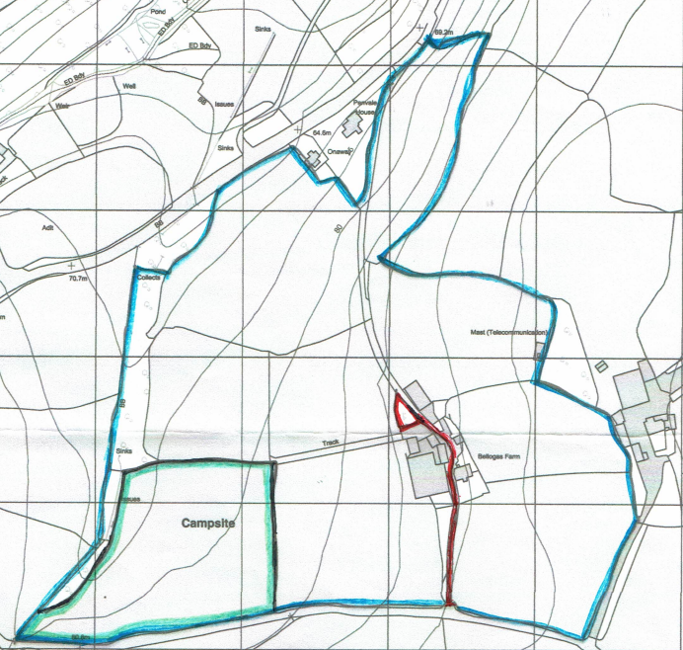

Figure 1 – Location Plan identifying site.

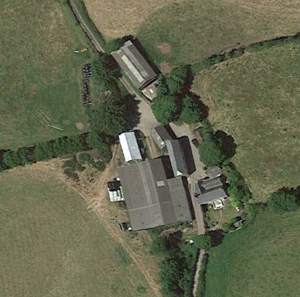

Figure 2 – Aerial photograph.

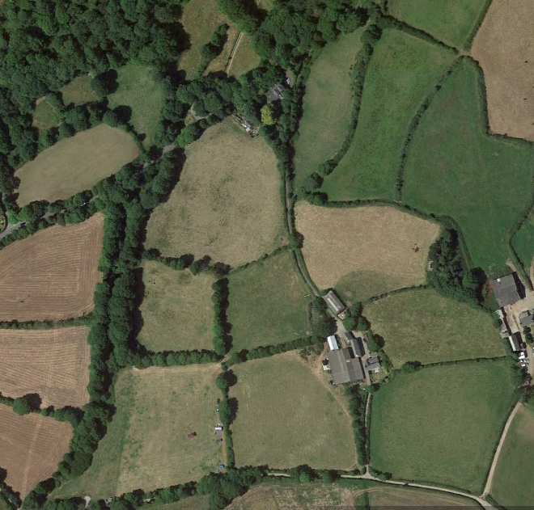

Figure 3 – Aerial photograph.

“Appendix B”

Cornwall Local Plan Policies

Policy 1: Presumption in favour of sustainable development

When considering development proposals the Council will take a positive approach that reflects the presumption in favour of sustainable development contained in the National Planning Policy Framework and set out by the policies of this Local Plan.

We will work with applicants, infrastructure providers and the local community to find solutions which mean that proposals will be approved wherever possible, and to secure development that improves the economic, social and environmental conditions in the area.

Planning applications that accord with the policies in this Local Plan and supporting Development Plan (including, where relevant, with policies in Neighbourhood Plans) will be regarded as sustainable development and be approved, unless material considerations indicate otherwise.

When considering whether a development proposal is sustainable or not, account will be taken of its location, layout, design and use against the three pillars of economic development, social development and environmental protection and improvement.

Where there are no policies relevant to the application or relevant policies are out of date at the time of making the decision the Council will grant permission unless material considerations indicate otherwise – taking into account whether:
a) Any adverse impacts of granting permission would significantly and demonstrably outweigh the benefits, when assessed against the policies in the National Planning Policy Framework taken as a whole; or
b) Specific policies in that Framework indicate that development should be restricted.

Policy 5: Business and Tourism

1. To ensure a continued supply of appropriate business space, proposals for new employment land and uses should be:
a) well integrated with our city, towns and villages; or
b) within areas that are well served by public transport and communications infrastructure; or
c) in the countryside and smaller rural settlements be of a scale appropriate to its location or demonstrate an overriding locational and business need to be in that location such as farm diversification; or
d) an extension to an existing business where re-location would be impractical or not
viable.

2. Proposals that would result in the loss of business space must:
i. demonstrate there is no market demand through active and continued marketing for at least a period of 9 months; or
ii. result in the provision of better quality employment space allowing for mixed use; or
iii. be necessary to meet a clear need for community facilities; or
iv. be unsuitable to continue as business use due to environmental considerations.

3. The development of new or upgrading of existing tourism facilities through the
enhancement of existing or provision of new, high quality sustainable tourism facilities, attractions and accommodation will be supported where they would be of an appropriate scale to their location and to their accessibility by a range of transport modes. Proposals should provide a well balanced mix of economic, social and environmental benefits.

4. Site Allocations Development Plan Documents and Neighbourhood Plans should
identify new land, and safeguard appropriate existing land, necessary for the delivery
of the economic strategies for Cornwall. These allocations should be based on an
assessment that considers the ability of the quantity, nature and quality of existing space and any commitments to meet the space requirements set out in Policy 2a and the needs of particular sectors.

The assessment should:
• assess the ability of vacant sites and buildings identified in the Employment Land Review to meet that need; and
• consider if any shortfall can be reasonably met through windfall sites coming forward; and
• Identify sites for further employment space, where necessary, to address the
targets set out in the policy 2a; and
• Identify existing employment land and/or buildings that are considered to be of strategic, and where appropriate, local significance for safeguarding.

Strategic Employment Sites or allocations are sites of 5ha or more, including those comprising multiple units predominately within the B use classes, or sites that offer the potential to attract particular sectors or end users that have specific requirements with respect to scale, location or the particular attributes of a site,
e.g. for marine uses/ aerospace/telecommunications related to the smart specialisations set out in the Local Plan Strategy.

Locally Significant Employment Sites are sites which make a significant contribution in terms of space or job provision within a Neighbourhood Plan area.

“Appendix C”

Green Infrastructure Plan/Statement.

In January 2023 Natural England launched its new “Green Infrastructure Framework”.

The “Framework” comprises; Green Infrastructure Principles, Standards, Maps, Process Journeys, and a Planning & Design Guide.

There are 15 “Principles” which are split into 3 categories as follows:

Benefits principles

1. Nature rich beautiful places
GI supports nature to recover and thrive everywhere, in towns, cities and countryside, conserving and enhancing natural beauty, wildlife and habitats, geology and soils, and our cultural and personal connections with nature.

2. Active and healthy places
Green neighbourhoods, green / blue spaces and green routes support active lifestyles, community cohesion and nature connections that benefit physical and mental health and wellbeing, and quality of life. GI also helps to mitigate health risks such as urban heat stress, noise pollution, flooding and poor air quality.

3. Thriving and prospering communities
GI helps to create and support prospering communities that benefit everyone and adds value by creating high quality environments which are attractive to businesses and investors, create green jobs, support retail and high streets, and to help support the local economy and regeneration.

4. Improved water management
GI reduces flood risk, improves water quality and natural filtration, helps maintain the natural water cycle and sustainable drainage at local and catchment scales, reducing pressures on the water environment and infrastructure, bringing amenity, biodiversity, economic and other benefits.

5. Resilient and climate positive places
GI makes places more resilient and adaptive to climate change and helps to meet zero carbon and air quality targets. GI itself should be designed to adapt to climate change to ensure long term resilience.

Descriptive principles

1. Multifunctional GI should deliver a range of functions and benefits for people, nature and places, address specific issues and to meet their needs. Multifunctionality (delivering multiple functions from the same area of GI) is especially important in areas where provision is poor quality or scarce.

2. Varied
GI should comprise a variety of types and sizes of green and blue spaces, green routes and environmental features (as part of a network) that can provide a range of different functions, benefits and solutions to address specific issues and needs.

3. Connected
GI should function and connect as a living network for people and nature at all scales (e.g. within sites, and across regions/at national scale). It should enhance ecological networks and support ecosystems services, connecting provision of GI with those who need its benefits.

4. Accessible
GI should create and maintain green liveable places that enable people to experience and connect with nature, and that offer everyone, wherever they live, access to good quality parks, green spaces, recreational, walking and cycling routes that are inclusive, safe, welcoming, well-managed and accessible for all.

5. Character
GI should respond to an area’s character so that it contributes to the conservation, enhancement and/or restoration of landscapes; or, in degraded areas, creates new high-quality landscapes to which local people feel connected.

Process principles

1. Partnership and Vision
Work in partnership, and collaborate with stakeholders from the outset to co-plan, develop and deliver a vision for GI in the area. Engage a diverse and inclusive range of people and organisations including citizens, local authorities, developers, communities, land owners, green space managers, environmental, health, climate, transport and business representatives.

2. Evidence
Use scientific evidence, and good land use practices when planning and enhancing green and blue infrastructure. Understand the evidence for the benefits of current GI assets; and data on environmental, social and economic challenges and needs in the area.

3. Plan Strategically
Plan strategically and secure GI as a key asset in local strategy and policy, at all scales. Fully integrate and mainstream GI into environmental, social, health and economic policy. Create and maintain sustainable places for current and future populations, and address inequalities in GI provision.

4. Design
Understand an area’s landscape/townscape, natural, historic and cultural character to create well-designed, beautiful and distinctive places.

5. Managed, valued, monitored, and evaluated
Plan good governance, funding, management, monitoring, and evaluation of green infrastructure as a key asset from the outset and secure it for the long-term. Make the business case for GI. Engage communities in stewardship where appropriate. Celebrate success and raise awareness of GI benefits.

It is considered that the “Green Infrastructure Framework” and the above principles are clearly primarily aimed at sizeable development proposals rather than very small scale minor developments such as the current proposal.

In the case of the current application the design principle is to site two small pre-formed holiday “pods” on the land. These “pods” are manufactured from sustainably grown timber, and will blend into the rural setting and natural tree and hedgerow backdrop to the site.

The development proposes the provision of parking space for two cars, and space for bicycles. The site lies in a rural area where walking cycling is an attractive proposition for future occupiers of the proposed dwelling, and there are public footpaths nearby. There is also a local bus service that runs nearby.

The site due to its location will provide the future occupants with “clean air”, and a clean source of water is available to serve the site.

All in all, the proposed development will make a reasonable contribution to the provision of green infrastructure for a proposal of such a small scale.

