NOT LIVE Deactivated
£600 pcm

Single bedsit farmhouse annexe
1 bed flatGreat Horwood ( mk17 0nz )
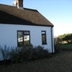
0

Refurbished ground floor self contained farmhouse annexe. Furnished single bedsit with separate kitchen, bathroom, washing machine and conservatory....
Now let

