Pole location – 53.645821° -2.573615°
Peewit Farm, Moor Road, Anglezarke, PR6 9DQ

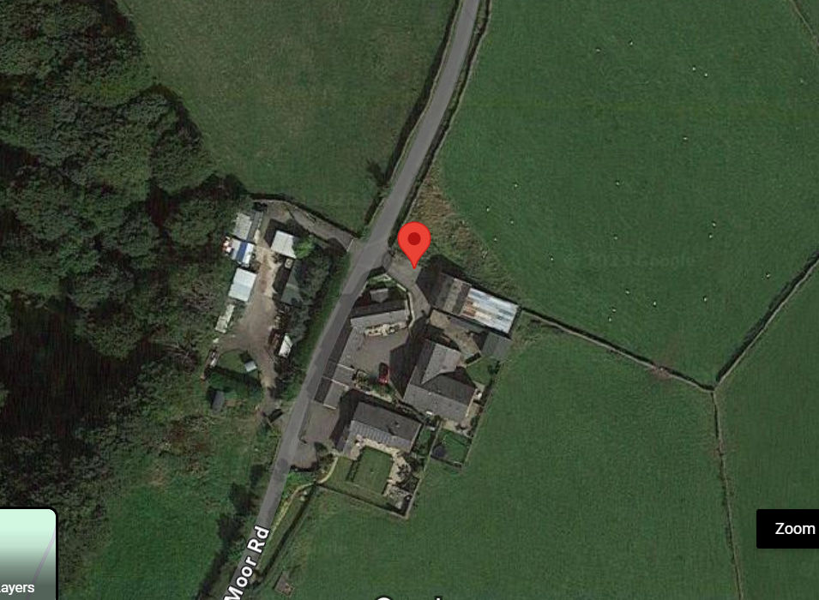

As per the Town and Country Planning (General Permitted Development) Order 2016 (amended) (England) and The Electronic Communications Code Conditions and restrictions) Regulations 2003 (as amended) Quickline is serving notice for the installation of a telecommunications pole (12M) for the deployment of superfast broadband and wireless at the location as below and attached.

I can confirm that a notice has been erected on site for the Publicity for the proposed Telecommunications Development.

