DESIGN & ACCESS STATEMENT
1 STATION COTTAGES, LASHAM, ALTON, HAMPSHIRE, GU34 5RX
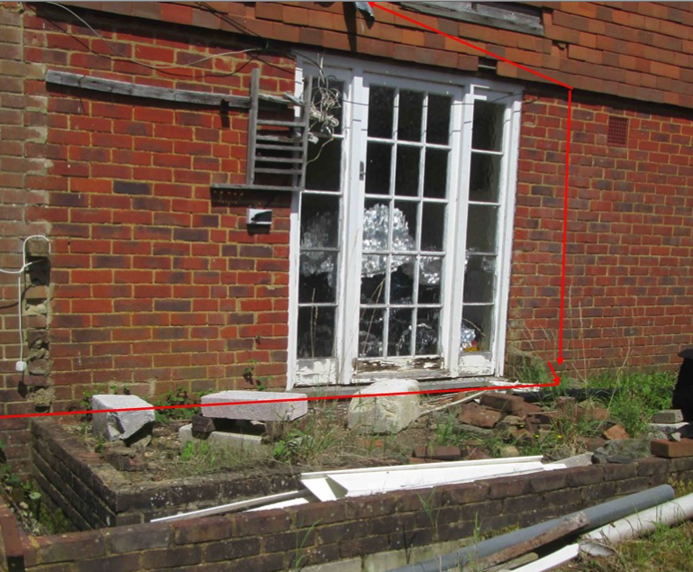

Lasham Conservation Area Conservation areas are designated areas of special architectural interest, the character or appearance of which it is desirable to preserve or enhance. It is the quality and interest of the area rather than individual buildings which is important. The consequence of conservation area designation is not to preserve conservation areas unchanged but requires that new development is designed in a sensitive manner which has regard to the special character of the area. The Council’s policy on allowing development within conservation areas is set out in Policy HE4 of the East Hampshire Local Plan: Second Review, where development will be permitted only where it would preserve or enhance the character or appearance of the area. Village Design Statement - Lasham Village Design Statement - non statutory planning guidance that has been the subject of public consultation and therefore is a material planning consideration.

Proposal Outline: Anglian Home Improvements have been contracted to erect a white PVCu Conservatory to the front elevation of the detached property. Our customer has chosen a conservatory to meet their personal requirements whilst being considerate to the natural surroundings and council guidelines.
Previous History: The property has been the subject of 1 previous planning application. Application reference number 20888/007 was for the erection of single storey to the front. The application was refused at the time.
Design Principles: Our customer has chosen a white PVCu Conservatory. The colour of the frames has been selectively chosen so the white with the white windows to existing property match. Due consideration has been given to the overall look The conservatory will provide better weather proofing and thermal efficiency to the property and therefore protect the internal and external fabric of the property. In addition, draught proofing, sound insulation and security measures will all be improved upon to the benefit of the quality of the life of the homeowners.
We consider the proposal to be of a modest addition in relationship to the existing property and
surrounding grounds

Access: No change to the property to the existing access arrangements.

Landscaping: We will not be required to remove or cut back any hedges or trees on the site.

To conclude the scheme proposed gives the most aesthetically pleasing look, is not overbearing, is sited to the side of the property and does not create any neighbourly privacy issues and not be detrimental to the conservation area.

We trust our application for our conservatory project will achieve a positive determination.