Planning Statement

To support the

Change of use of Agricultural Land
to
Dog Walking Field

At
Land adjacent to Shipway Gate Farm
Sheepway
Portbury
BS20 7TB

Applicant

Mr C M H Crossman

Agent

Mrs Tina Derrick

Summary of Application

Description Change of Use on Agricultural Land to Dog Walking Field
Address Land adjacent (West) of Shipway Gate Farm Sheepway, Portbury BS20 7TB
Agent Mrs Tina Derrick
Agent Address Oakdale
19 Albert Road
Portishead
North Somerset
BS20 6PP
Telephone 07495016444
E mail office@derrickconstruction.co.uk

Drawings & Plans submitted.

- Planning Statement
- Location Plan
- Block Plan
- Ecology Report

Contents

Introduction & The Proposal.……………………………………………………………………………………….4

Site Address………………………………………………………………………………………………………………….5

About the Land …………………………………………………………………………………………………………….7

Proposed Dog Walking Facility………………………………………………………………………………………8

Advertising & Marketing……………………………………………………………………………………………….9

Access & Parking…………………………………………………………………………………………………………..9

Water Management……………………………………………………………………………………………………..9

Waste Management……………………………………………………………………………………………………..9

Exercising & Walking Dogs…………………………………………………………………………………………,,10

Need for the Proposal………………………………………………………………………………………………….10

Benefits of the Proposal……………………………………………………………………………………………….11

Wildlife & Biodiversity………………………………………………………………………………………………….12

Nation Planning Policy Framework……………………………………………………………………………….13

Rural Development Policy CS17……………………………………………………………………………………14

Design , Siting & External Appearance………………………………………………………………………….16

Conclusion……………………………………………………………………………………………………………………17

INTRODUCTION

This Planning Statement is submitted in respect of the change of use of agricultural meadow land to a fenced field that will also be occupied for Dog Walking, on the property know as land east of Shipway Gate Farm Sheepway, Portbury BS20 7TB.

Shipway Gate Farm is set in 125 acres of land the proposal is for a change of use on 1.95 acres of land adjacent to the farm entrance as marked on the Location Plan.

This proposal will provide 50minute sessions for members of the of the public to walk and exercise their Dogs in an enclosed and fenced field that compliments the field’s use as a meadow.

This will form part of the Farms diversification enterprises.

This application is submitted by the Landowner Mr C M H Crossman of Shipway Gate Farm, Sheepway, Portbury BS20 7TB.

The Proposal

This application is submitted for the change of use of 1.95 acres of Agricultural Land situated adjacent to the Shipway Gate Farm on land to the East. The Entrance to the Farm adjacent to the Proposed Dog Walking Field benefits from an existing Parking Area that used to serve as a parking area for the now redundant Farm Shop.

The Site/Location Plan sets out the location of the proposed area subject to the change of use.

The land identified on the plan has been selected for the Dog Walking field as it is smaller and in places uneven which is unsuitable for farm machinery this is the residual effects of bomb damage in World War II. The land will be cropped to grass and farmed as a low input traditional meadow. As part of this proposal the applicant wishes to improve the biodiversity of the field by the reintroduction of wildflowers to the meadow.

The land will be enclosed with a 1.8mtr high post and wire fence, which can lawfully be erected under the permitted development (Class A, Part 2 of the General Permitted Development Order 2015) we have included this within submission for completeness.

The fence will enable people to walk with their dogs off the lead without the worry of them running away or causing problems for other people. This service will also appeal to those owners who have dogs which may become nervous/antisocial or have poor recall, a disability or it could be an area for initial puppy training away from other dogs.

A Dog Walking Facility set in the rural countryside which is easily accessible will be a valuable addition to the dog walking community in and around the Portishead and Portbury Areas.

Site Address

The Land is accessed from the Main road through Sheepway turning into Shipway Gate Farm. The means of access onto the land is via an access gate which has existing adjacent car parking next to the Field and access is through an existing Steel Farm Gate

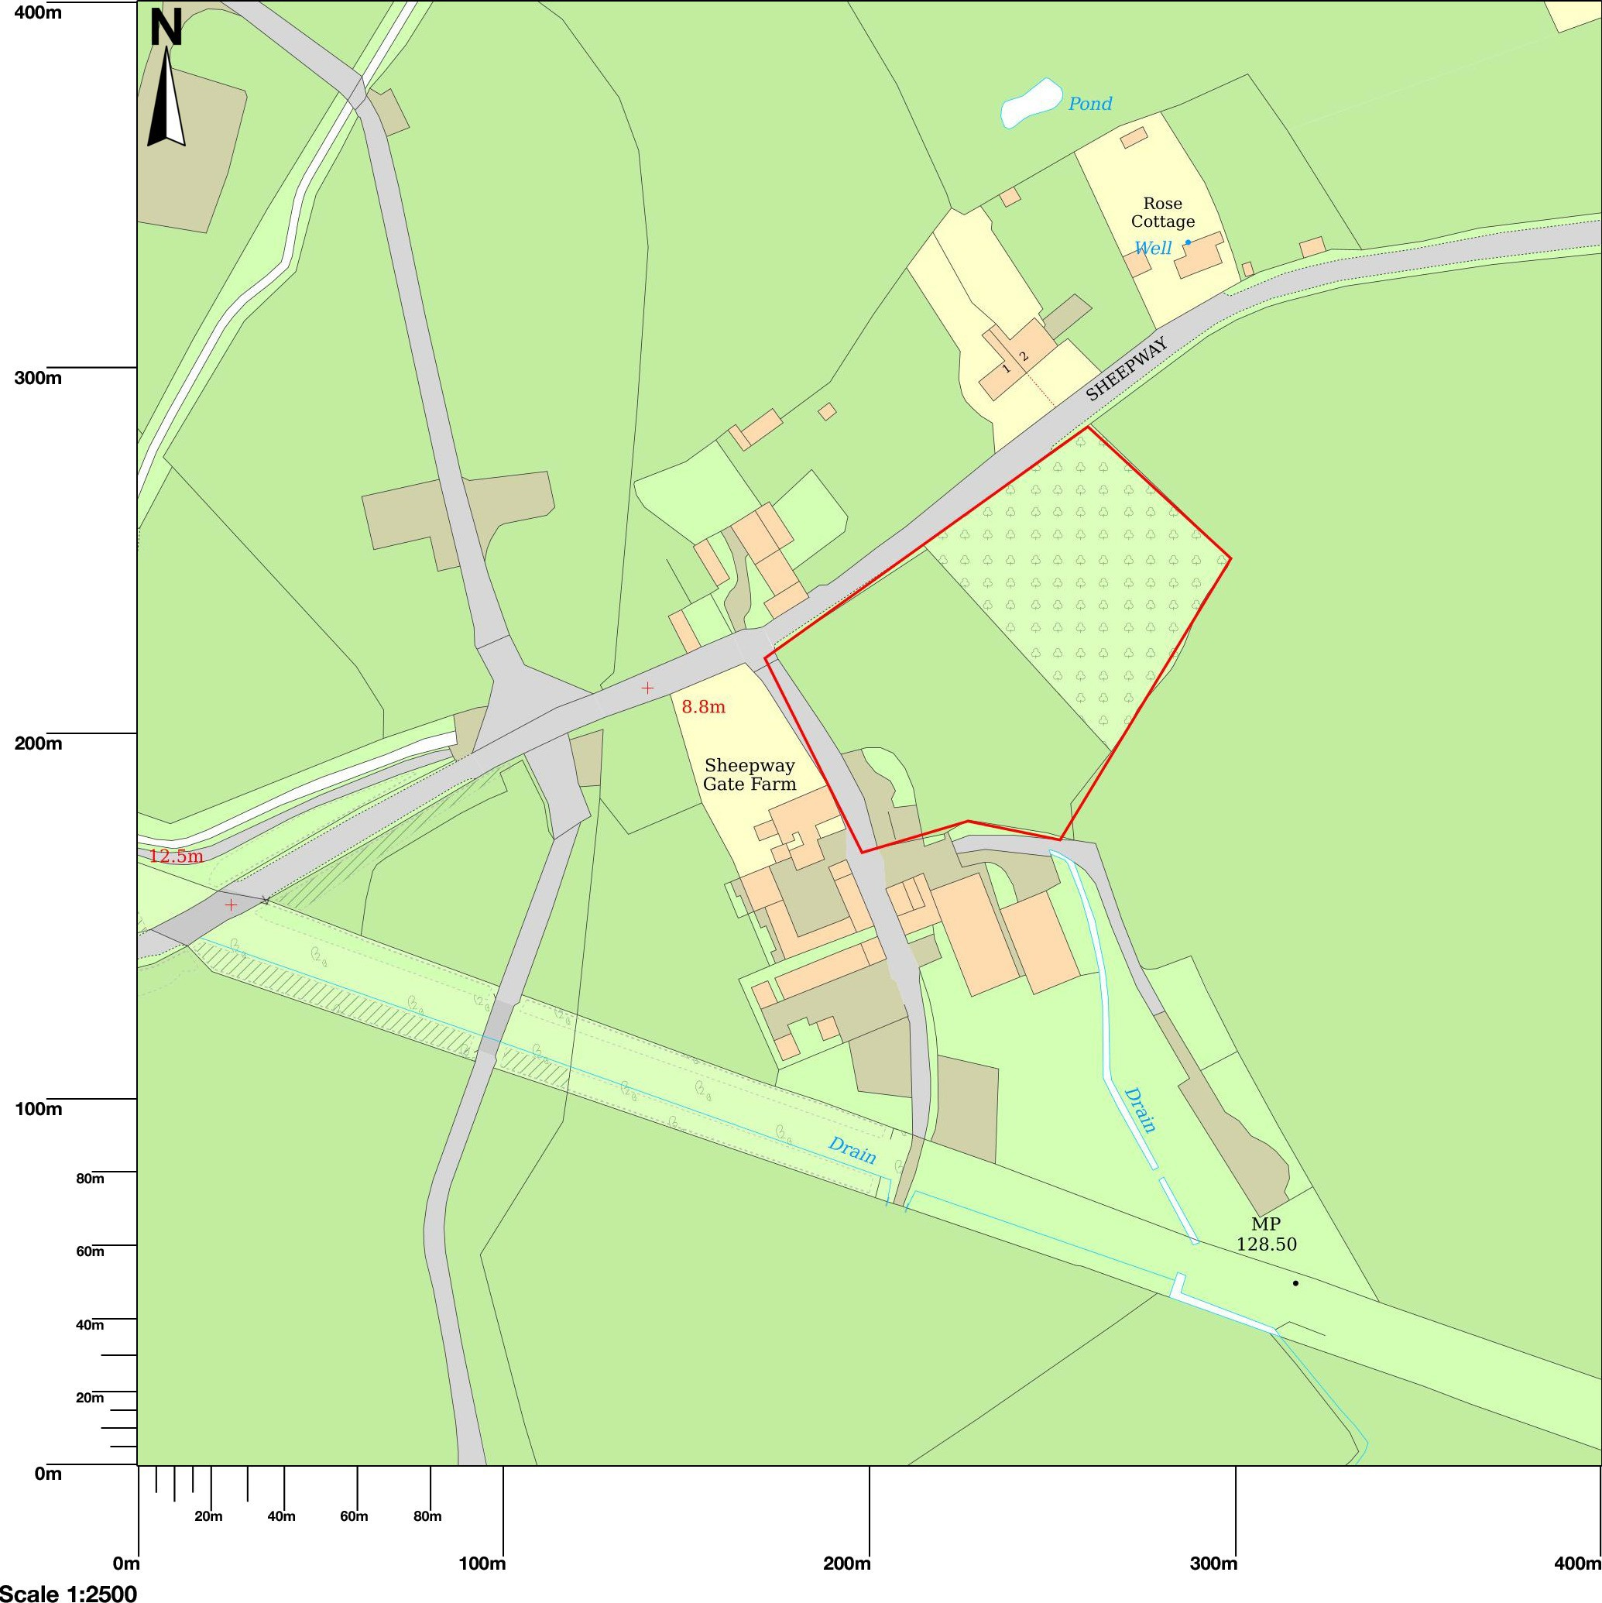

The site is located approximately 1.13 miles (1.81 kilometres) from the larger settlement town of Portishead with it major housing developments constructed in recent years. The site is accessed via the old main road running through Sheepway Portbury. The Main Portbury Hundred A369 to Portishead runs adjacent to the old main road through Sheepway approximately 600mtrs apart at it furthest distance.
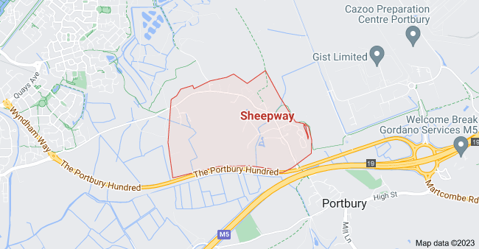
Figure 1 Sheepway Main Road from Wyndham Way to Portbury Hundred
Sheepway is serviced under changes made by North Somerset Council’s Bus Service Improvement Plan (BSIP) Changes ensure that the X10 Bus runs through the village instead of the Portbury Hundred
.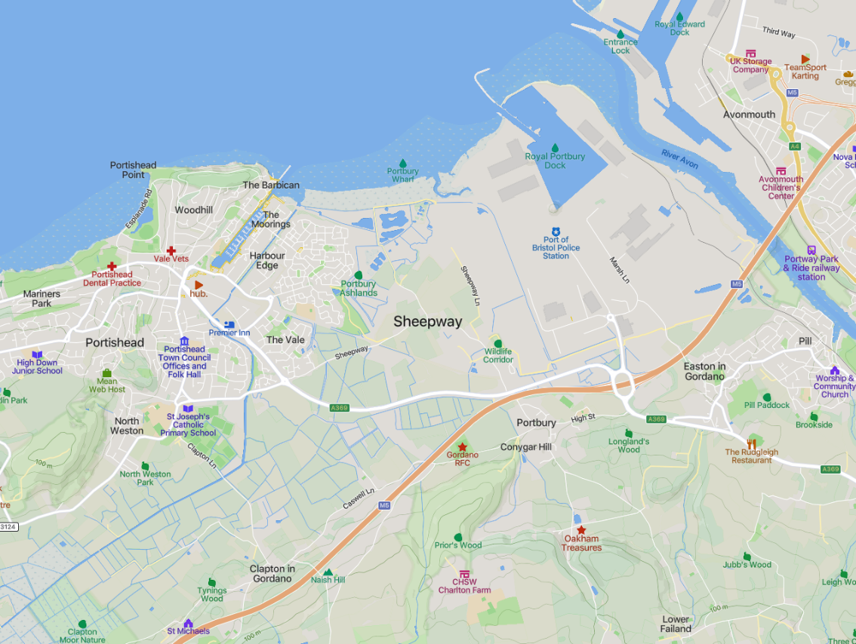

About the Land

The main use of the Proposed Land is Agricultural grassland. The site is not located close to any/or on any of the following:
- Listed Buildings
- Conservation Areas
- Areas of Outstanding Natural Beauty (AONB)
- National Parks
The site is located close to Portishead Wharf Nature Reserve which is a Site of Specific Scientific Interest and is a Special Protection Area – this means that the needs of the wildlife it is important to keep a wide berth and dogs must be kept on leads and under control and stay on the paths and off the salt marsh.
The proposed Dog Walking Area land falls within the “Washed Over” Green Belt that covers the whole of the Portbury Parish and surrounding Portishead area.
The Area of land proposed for Dog Walking Field is currently used for grazing and the change of use will enable this field to remain with an open visual aspect, and the grass and hedgerows to be maintained regularly.
The area of land proposed already has an existing Car Parking Area that used to serve the redundant Shop – this has been closed for many years and will not be re-opened.
The existing Car Parking Spaces will be able to support the dog walking facility as they are directly adjacent/next to the Area of land’s gateway.
It is the intention to use this Car Parking Facility as part of the Farm’s diversification scheme.
The Farm needs to adapt to the changing practices and policies, it needs to diversify to secure its productivity and income for the generations to come.
The proposed Dog Walking Facility is part of the Farms Diversification scheme and will enable the Farmland to work in a low intensity basis as one of the sources of income to support the family of the Farm and allow the Farm to continue working for generations to come.
Shipway Gate Farm has planned the diversification scheme to help the local community and support local people.

Proposed Dog Walking Facility

- The field proposed to provide Dog Walking is to be used for private or individual hire.

- Bookings will be made via an on-line website or over the phone.

- The facility will offer one client exclusive sole use of the field.

- The dog/s will be able to run freely with in the field.

- The field hire will be for a selected time slot and will strictly be limited to one car per booking to use the field.

- It is not necessary to construct any other Buildings or Structures.

- Clients will be told that they must clear dog waste and dispose of the waste either in the Bins provided or taken home for disposal.

- The Dog Walking Facility/Land will be fenced off using 1.8mtr Deer Fencing around the perimeter which will make the facility totally secure, very discreet, and barely visible.

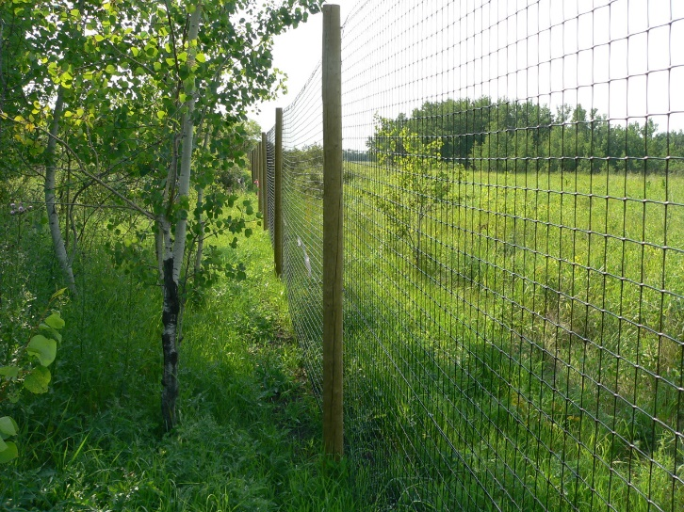
- There will be no permanent development of the land in the change of use other than the erection of the Deer Fencing which will sit adjacent to the current Hedgerows and is very discreet.

Advertising & Marketing

The Dog Walking Facility will be promoted using Social Media and local Advertising and by word of mouth. It will be available for individuals to exercise their dogs safely and securely.

Access & Parking
The access to the Facility will be via the Farm’s Main Entrance from the Main Road through Sheepway. There is existing Car Parking provision adjacent to the field/land and access is via the existing Steel
Gate situated next to the parking area.
Sheepway is a small village of 131 Residents and very low traffic through its Main Road.
There is good visibility either side of the junction to the Farm and the Farm has signage in place for easy recognition.
Water Management
No groundworks are proposed for the Facility and the existing Carpark has a crushed stone finish which is a permeable surface and allows the rainwater to drain through.

Waste Management
Dog Waste will be disposed of via an Installed Dog Waste Bin for the users of the field and will be situated inside the perimeter fence – this will be emptied twice weekly by the applicants. The waste will then be collected by a licensed waster contractor.
The site will also be surveyed at regular intervals, so the land remains clear and clean.
The proposed Dog Waste Bin will be installed and serve as a sealed and enclosed container ensuring no waste smell will be emitted.
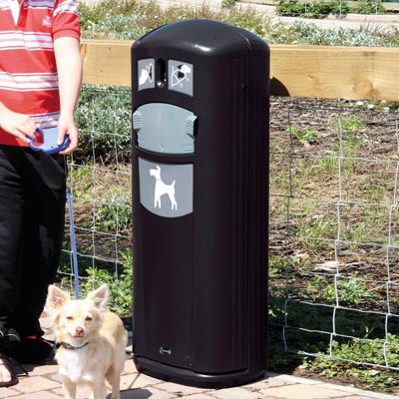
Design Features
- Integral dispenser allows only one sack to be taken at a time.
- Secure, tamper-resistant chute system. Extremely robust body and door.
- Clear graphics encourage correct use.
- Secure, vandal-resistant locking mechanism.
- Door-opening design provides easy access for removal and replacement of sacks.

Exercising & Walking Dogs

Over recent years the UK has seen a rise in the number of dogs. There are approximately 10 million dogs in the uk which equates to 1 in every 4 homes.
In recent years local authorities have brought in legislation where public green spaces and areas must have dogs on their leads. This is to protect the public from Dogs who may be anxious or nervous of strangers. The general Public are very wary of strange dogs and their unpredictable behaviour – some dogs have reacted in dangerous or aggressive behaviour which has led to a rise in complaints to Councils which why a lot of these spaces are now “Lead Only”.
Dog Owners wish to find areas that they can freely exercise their dogs without being fearful of other dogs or members of the public stressed by them being off the lead. The Public are worried by “Uncontrollable Dogs” off the lead so the proposed Dog Facility would provide a haven for the dogs to exercise.
The Local Housing Developments in recent years have resulted in very compact housing masses with very little green space for exercising dogs.
Another problem which has risen quite significantly in recent years is the huge increase in media reports of Dog thefts all making owners turn to private fields to walk their dogs.
The facility will offer a site with secure fencing, single point of access, coded entrance point and pre-booked private time allowance. The Dog Owners can feel very safe and secure with their animals which increases the health of the dogs and reducing the anxieties of the owners this in turn will result in the other green spaces being freed up. It is anticipated that the proposal will benefit the Dog Owners, Dogs and the public.

Need for the Proposal
Local and National Policy Strategy Levels are supported and encouraged when Farms are diversifying this has been reported by Local and national bodies.

Benefits of the Proposal
Economic Benefits
Shipway Gate Farm has identified a unique Rural Business opportunity within the area and this venture would ensure the Applicants Business has a source of valuable diversification income from the Dog Walking Facility.
Over recent years Farming incomes have decreased because of the National Agricultural Policy changes. It is important that the Farm diversify and identify business opportunities to utilise the land of less productive areas this will ensure the successful running of the Farm.
The Dog Walking Facility will provide employment for the day to running of the business and coordinating bookings along with maintenance of the Land and its hedging.
Environmental Benefits
The proposal has ensured that the environment is not harmed in anyway by using the “Deer Fencing” which is very discreet and barely visible from a distance this will allow the open nature of the land to remain and for the existing Hedgerows and Grassland to be maintained.
There are no groundworks or lighting to be installed and no structures to be installed.

Social Benefits
The open aspect and nature provide a relaxed and peaceful place away from the busy urban development. This is good for both the Dogs and their Owners.
The benefits of dog walking are known to improve Mental Health, reduce Blood Pressure, reduce Stress, which in turn results in a healthier lifestyle and habits. Studies have proved that owing a Dog can alleviate the feelings of loneliness, alleviate Stress, depression, and social isolation. Providing this stress-free activity contributes to the benefits of a healthier and happy lifestyle.

Farm Diversification
Shipway Gate Farm has experienced volatile commodity prices, UK droughts and unpredictable weather patterns; the farm business is pursuing ways to diversify its income streams away from the practices used by the Farm over the last 40 years. The volatile farming income and reduction in payments to Farmers needs underpinning to ensure the continued sustainability of the Farming Business for future generations. One idea for this diversification is through the provision of a community service for dog exercising as well as the promotion of the health and exercise for local residents and the community.
Since COVID-19 and the pandemic more people are working from home and now are looking to have pets as they are at home for longer periods of time due to working from home. The Kennel Club has seen a 180% rise in enquiries for puppies since the pandemic. These dogs need to be exercised and the local are lacks open spaces where the dogs are allowed to run freely off their leads. The dog walking field will provide this for the Owners and Dogs.

Wildlife & Biodiversity

The plans for the Farm include the promotion of increased biodiversity across the Farm and are seeking to encourage Wildlife. As part of the proposal the applicants will enhance the existing grass with a wildflower meadow mix of:
Wildflower Native Species:
Red Campion
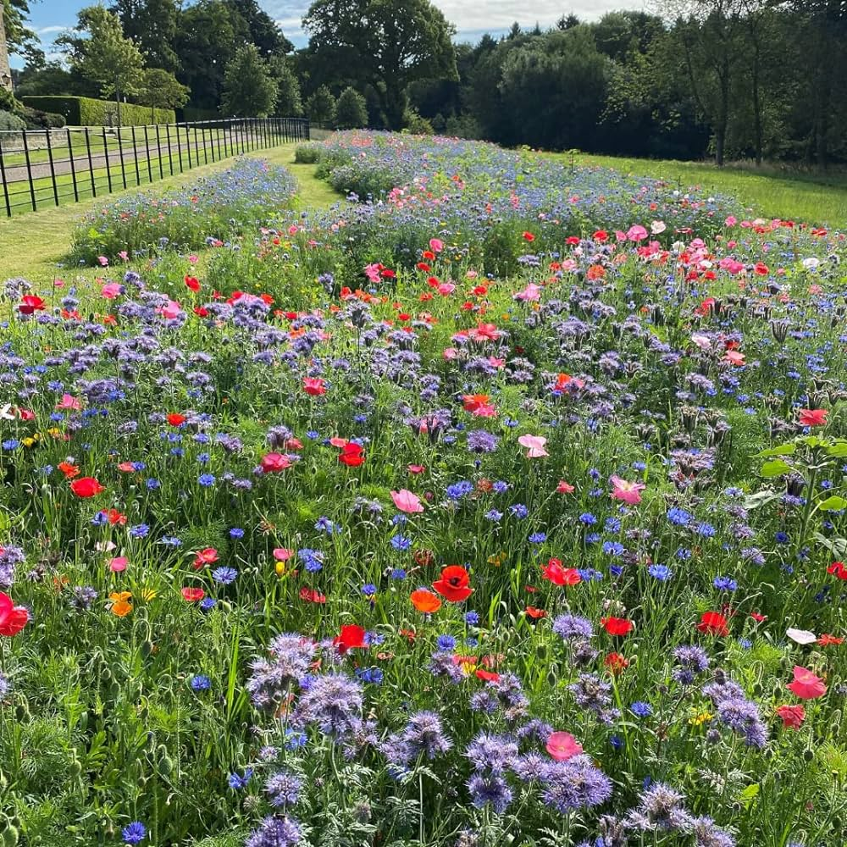
Black Medick
Common Knapweed
Oxeye Daisy
Ribwort Plantain
Yarrow
Field Poppy
Lady’s Bedstraw
Meadow Buttercup
Cowslip
Salad Burnet
Grass Species
Brown top Bent, Strong Creeping Ref Fescue, Crested Dogs Tail, Chewings Fescue & Sheep’s Fescue

These plantings will create a traditional Wildflower Meadow that will encourage pollinating insects species.
Part of the plan to encourage3 wildlife will be the installation of Bat Boxes around the land.

NATIONAL PLANNING POLICY FRAMEWORK (NPPF)

The National Planning Policy Framework sets out the Governments up to date strategy for planning and decision making.
The NPPF sets out core planning policies which set out the planning decisions and the process for taking those decisions. The presumption within the policy is in favour of sustainable development and is a central point within the policy approach in the framework. It highlights the need to plan positively for the future for appropriate new developments.
The core principles that relate to this case is the planning should:
- Contribute to the achievement of sustainable development. At the very high level, the objective of sustainable development can be summarised as meeting the needs of the present without compromising the ability of future generations to meet their own needs.
- Achieving sustainable development means that the planning system has three overarching objectives, which are independent and need to be pursued in mutually supportive ways (so that opportunities can be taken to secure net gains across each of the different objectives);
- An economic objective – to help build a strong, responsive, and competitive economy, by ensuring that the sufficient land of the right types is available in the right places and at the right time to support growth, innovation, and improved productivity; and by identifying and coordinating the provision of infrastructure.
- A social objective – to support strong, vibrant, and healthy communities, by ensuring that a sufficient number and range of homes can be provided to meet the needs of present and future generations; and by fostering a well designed and safe built environment with accessible services and open spaces that reflect current and future needs and support communities’ health and social and cultural well-being.
- An environmental objective – to contribute to protecting and enhancing our natural, built, and historic environment; including making effective use of land, helping improve biodiversity, using natural resources prudently, minimising waste and pollution and mitigating and adapting to climate change including moving to a low carbon economy.
The proposed Dog Walking Field fulfils each of the above Social, Economic, and Environmental objectives.
This diversification stream for the Farm will support the farm to withstand the current and future economic fluctuations within the Farming industry. It will offer employment opportunities in the area and will also offer employment opportunities to dog walking enterprises again supporting the rural economy.
The social objective is also fulfilled by addressing the issue of Mental Health and Physical wellbeing, this service offers people and their dog’s space and fresh air and to exercise freely in a setting away from others.
The improvements to the grass by the planting of the wildflowers will increase the biodiversity and wildlife by attracting them to the area along with the installation of Bat boxes.
The land would be effectively used and is a Carbon Neutral Activity.
Section 6 of the NPPF provides Policy on “supporting a prosperous rural economy” Paragraph 83 sets out that in Planning Policies and decisions should enable:

- The sustainable growth and expansion of all types of business in rural areas.
- The development and diversification of agricultural land and other land based rural businesses.
- Sustainable rural tourism and leisure developments which respect the character of the countryside; and
- The retention and development of accessible local services and community facilities, such as local shops. Meeting places, sports venues, open space, cultural buildings, public houses, and places of worship.

This proposal meets all the criteria as set out under paragraph 83 in that it is sustainable growth of the existing farm business and is subtly enhancing the land.
It is also a sustainable income source for rural leisure developments which focuses on a need for safe outdoor exercise areas for dog owners and walkers. The farm diversification project will also develop local community facilities by offering this green open space for local residents and members of the public to utilise the safe and secure setting for their dog walking.
No development is proposed in the form of structures, the fencing and land use appearance is unchanged to what would be changed agriculturally under permitted development.
Paragraph 92 of the NPPF states that “to provide the social, recreational and cultural facilities and services the community needs, planning policies and decisions should plan positively for the provision and use of shared spaces, community facilities (such as shops, meeting places, sports venues, open space, cultural buildings public houses and places of worship) and other local services to enhance sustainability of communities and residential environments”.
North Somerset Replacement Local Plan
Rural Development Policy CS17: The Rural Economy
Introduction
6.1 The countryside of North Somerset has faced considerable development pressure in recent decades. The Plan aims to relieve this pressure by encouraging development to locate in the towns. However, the countryside also faces economic pressures as the declining prospects for farming force farmers to look for ways to broaden their income. There is a need for a planning framework that enables the rural economy to modernise and diversify, yet which protects the countryside from the urbanisation that would reduce its attractiveness to residents and visitors, increase the need to travel and undermine efforts to regenerate existing urban areas
Diversification
6.10 Farm diversification activities can contribute to the local economy by providing opportunities for employment or recreation for residents and visitors and by resulting in increased patronage for local shops and services. Such activities, where they come within planning control, will generally be supported provided that the character and appearance of the countryside are not harmed.
Aim
6.3 The Local Plan objectives in respect of rural development are:
•to make the best use of existing resources and infrastructure, particularly through bringing empty properties back in to use, more intensive use of under-used and vacant land, re-development of previously developed land and buildings, and reclamation of derelict land, including decontamination where appropriate.
Outcome objective:
To encourage farm diversification activities, where they come within planning control, that contribute to the local economy by providing opportunities for employment or recreation for residents and visitors, resulting in increased patronage for local shops and services, provided that the character and appearance of the countryside are not harmed.

As the field is only 1.95 acres in size it is uneconomically small for commercial farming with the scale of large agricultural tractors. Therefore, the use of this field can underpin the farming income, as well as providing a unique facility for the local area and dog walkers whilst also having a significant emphasis on landscaping and biodiversity, which is considered to be positive from a planning perspective. The proposal can be seen to be complying with Policy CS17.

The anticipated Vehicle movements would be approximately 8 cars per day. In the Summertime the field opening would be 6am – 8pm and Wintertime would be 6.30am – 4pm.
The use is compatible with surrounding uses based on character of the proposal being unchanged to that of normal dog walkers on public footpaths which regularly occurs on rural areas and the application site. The use of the field for users walking their dogs is not a new concept in terms of character of the countryside.

Design, Siting and External Appearance

Design & External Appearance
The proposal is for the change of use of agricultural land, although the character and appearance of the field will remain unchanged to that of an agricultural field when it is not occupied.
The field is design ed to be enclosed with Deer Fencing (square steel wire on timber fence posts to a height of 1.8mtrs). The field will operate with one person at a time as the focus of the project is to provide owners seeking to walk their dogs in a secure and enclosed environment.

Siting
The choice of land for this project has been chosen to be close to the existing Parking Area and Steel Gate into the Field.

Access
Access to the field will by the means of a Steel Gate. The gate will be fitted with a combination coded access system so that only authorised clients will be able to use the field in accordance with the submitted drawings.
The sessions will be booked for 50minutes to allow 5-10 for the dog/dogs to exit the field before the next owners arrive negating the risk of crossover. This also reassures the owners that they have exclusivity with the field and maintains social distancing.

Conclusion
The proposal is for the Change of Use of Agricultural land to an enclosed, secure Dog Walking Field for Local Residents and Dog Owners from the local Area of Portishead, Portbury, Clapton In Gordano and the other local Villages.
- The Dog Walking Field will be accessed using a pre-booked time slot via telephone or Website Booking Online. The field will be accessed using an access code system on the Gate.

- The Field/Land is surrounded by existing Hedgerows and is laid to Grass/Pasture this already supports the local Wildlife, Birds, and Insects. The Farms Diversity Plan involves the planting of a Wildflower Meadow to encourage further pollinating species. This will positively increase and improve the Biodiversity of the site and enhance the local environment.

- The Change of Use relates to the use of the land and will not alter the appearance nor the character of the field. The proposed use is a low-key farm diversification activity that does not require change to the land.

- There is no requirement for Structures or Buildings or any excavation as a consequence of the use.

- There is no requirement for lighting on the land as it will only be open during daylight hours.

- There is existing Car Parking Provision adjacent to the Gateway of the Field.

- The installation of the fencing would not alter the character of site it has very little visual impact and would blend into the existing Hedgerows. The appearance would be no different from the members of the public using the footpath network, this proposal would enable users to walk their dogs off the lead in an enclosed and secure field.

- The proposal complies with the concept of supporting a prosperous rural economy as set out in the NPPF and this encourages Farm Diversity Enterprise to blend with the other farm operations at Shipway Gate Farm.

- Since Covid-19 there have been a proven increase in the amount of people working from home, this has led to more people committing to owning dogs as they are at home more than before. In the local area there is the Portbury Wharf Nature Reserve, but Dog Owners are required to keep their Dogs on a lead this is becoming more common on green spaces as local councils review their Byelaws regarding Dog Exercising on the green spaces. More Dog Owners are looking for a private secure and enclosed space that they can exercise their Dogs. This proposal meets that requirement.
This proposal for the Dog Walking Field is a unique opportunity for the local area whilst improving Social, Economic and Environmental Policies as set out in this report.

