PLANNING, ACCESS AND DESIGN STATEMENT.

New dwelling to side garden of 24 Worlebury Park Road,
Weston Super Mare.

Introduction

The proposal is to construct within the existing side garden of 24 Worlebury Park Road, a new highly energy efficient detached dwelling served by a new access and parking

Existing Site

The existing site is currently the side garden of No.24 Worlebury Park Road

The property sits on a large plot surrounded by existing bungalows to the North and existing two storey houses to the South in a residential area of Weston Super Mare

It is understood, due to the postal numbering that there was originally an additional property planned for the site but when first built the first occupiers acquired the additional plot to form a bigger garden.

Please refer to Appendix A for photographs of the existing site.

Local context and Distinctiveness – refer to Character Assessment

Worlebury Park Road is a residential area predominantly made up of large individual semi-detached and detached houses and bungalows set within good sized gardens.

The surrounding area has a mix of Architectural Styles developed over the years and therefore there is no distinctive style of dwelling but the majority are painted rendered with brick detailing and red/brown tiled roofs.

Please refer to Appendix B for examples of nearby properties.

Planning Policy Requirements

The North Somerset Core Strategy 2012 policies CS1, CS2, CS11, CS12, as well as the Replacement North Somerset Local Plan 2007 policies GDP/3, T/6, T10 and H/7 are pertinent to the development proposals, as follows:

CS1: Addressing Climate Change and Carbon Reduction: The policy sets principles to guide development to help reduce CO2 emission and tackle climate change.
CS2 & GDP/3: Delivering Sustainable Design and Construction: This policy governs new residential development to ensure commitment to energy efficient design.

The new dwelling will be constructed to be energy efficient and to exceed the current regulations and to reduce carbon consumption.

CS11, T/6 & T1/10: Parking & Traffic Safety: This policy required adequate parking is provided without detriment to the highway safety.

The access has been provided to comply with the local authorities parking standards with good visibility to ensure all road/footpath users are safe.

CS12: Achieving High Quality Design and Place Making: This policy seeks to demonstrate the commitment of NSC to achieving high quality buildings and settings.

The architectural plans submitted, demonstrate how the proposed dwelling is designed in sympathy with the surrounding rural outbuilding in a subservient way..

National Planning Policy Framework (NPPF)

The NPPF sets out key principles for development as follows:

- Para 11 sets out a presumption in favour of sustainable development
- A requirement for 10% of new sites to be under 1 hectare in size.
- To significantly boost the supply of housing.
- To provide a diverse choice of housing types.
- Encourages the effective use of land, providing it is not of high environmental value.
- To deliver a wide choice of quality housing,

It should also be noted North Somerset Council does not have a 5-year land supply.

Local Precedent

North Somerset District Council have within recent years granted permission for new residential dwellings in gardens, located in the nearby area, as follow:.

07/P/0415/F – New dwelling Worlebury Park Road
2698/87 - New dwelling Worlebury Park Road
08/P/0351/RM – New dwelling in Woodspring Avenue
05/P/2934/RM - New dwelling in Worlebury Hill Road
16/P/3053/F – New Dwelling in The Glen

Design

Concept and Principles

The new dwelling will continue to utilise a residential function.

Layout
The proposed layout responds to the site conditions with the property orientated to minimise impact on its neighbours with sufficient privacy distances between new and existing properties.

Density
The overall density is well below government guidelines but maintains the local character of the neighbourhood.

Massing, Form and Scale
The massing and scale of the building has been articulated to respond to the existing constraints of the site and to reflect adjacent buildings. The roof height of the new dwelling will be subservient to the adjacent properties.

Materials
High quality materials are proposed to reflect the local area

Vehicular Access

Vehicular access to the new property will be via a new vehicle access off Worlebury Park Road with onsite parking for 2 cars.

The new access will be formed in the existing boundary wall, as indicated , and the existing wall will be lowered to provide visibility in both directions.

The existing retained properties garage and parking will be retained and unaffected by the new dwelling.

Pedestrian and Public Transport

Due to the site lying within the settlement limits of Weston Super Mare there are plenty of local amenities and Bus/Train Networks within close proximity and this will encourage sustainable forms of transport.

The approaches to the new property will be of a shallow gradient with level access thresholds into the property in accordance with Building Regulation Approved Document M.

Sustainability

The new dwelling will incorporate extremely high levels of energy efficiency measures, to exceed building regulations and to offset at least 10% of CO2 produced through renewable technologies.

Bio – Diversity

New native hedge and tree planting will be provided.

This together with the installation of bird and bat boxes will greatly increase bio-diversity opportunities.

Hard Landscape

Hard landscaping will be kept to a minimum to reduce the impact of the development within its surroundings and to aid sustainable forms of surface water drainage.

Soft Landscape

New tree and shrub planting will be provided to enhance and greatly improve the landscape setting.

Conclusion

The proposed scheme will not cause any additional harm to the amenities of nearby residents and will be sustainable.

For the reasons set out above, it is respectfully requested that this planning application for the construction of a single dwelling is permitted.

APPENDIX A - Photographs of 24 Worlebury Park Road.

Photo of existing house, drive and parking from Furze Road

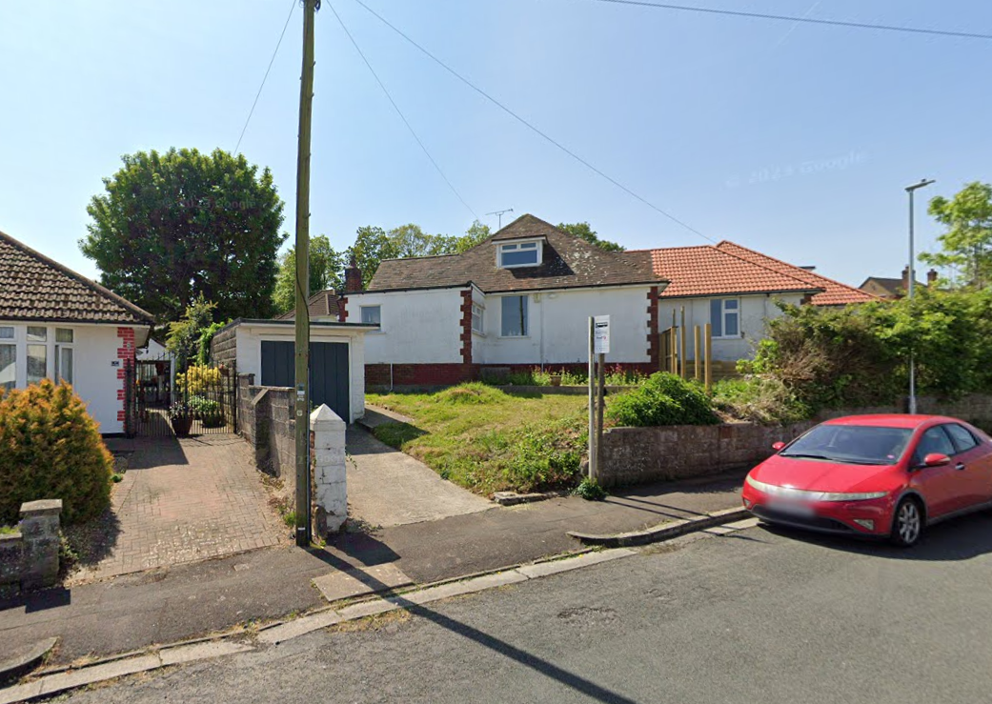

Photo taken at front of No.24 looking towards plot
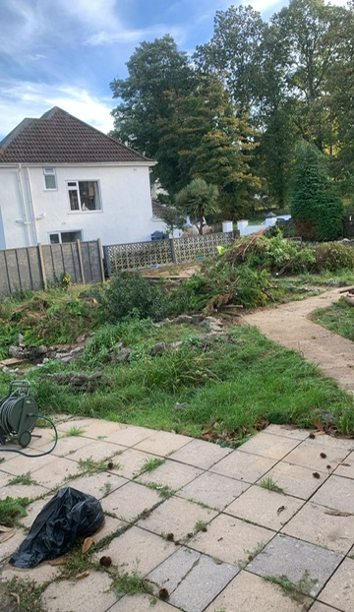

Photos taken on opposite side of road looking towards plot

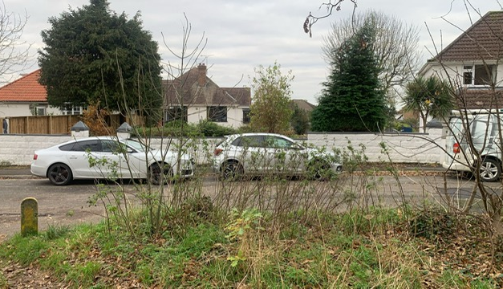

APPENDIX B – Photos of nearby properties to show varied architectural styles

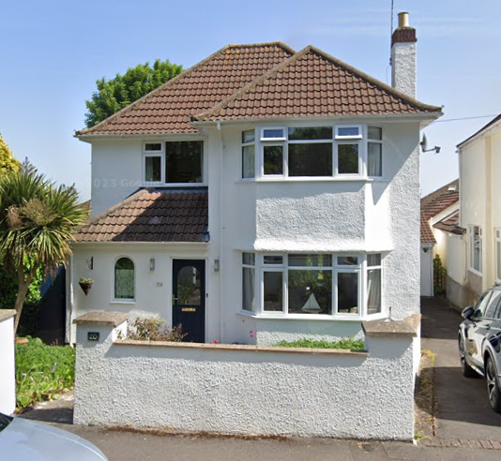
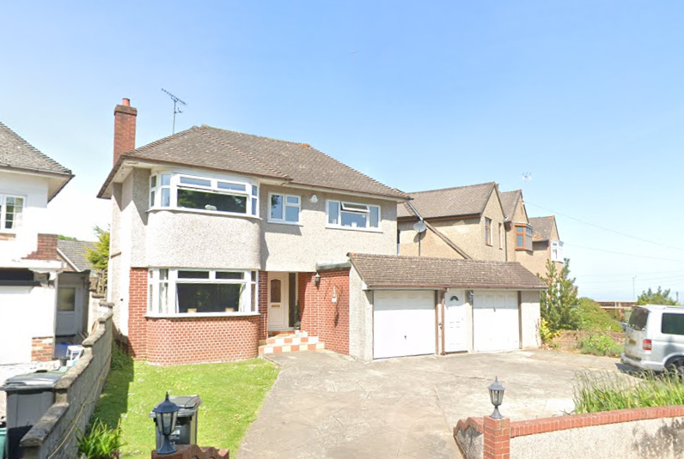.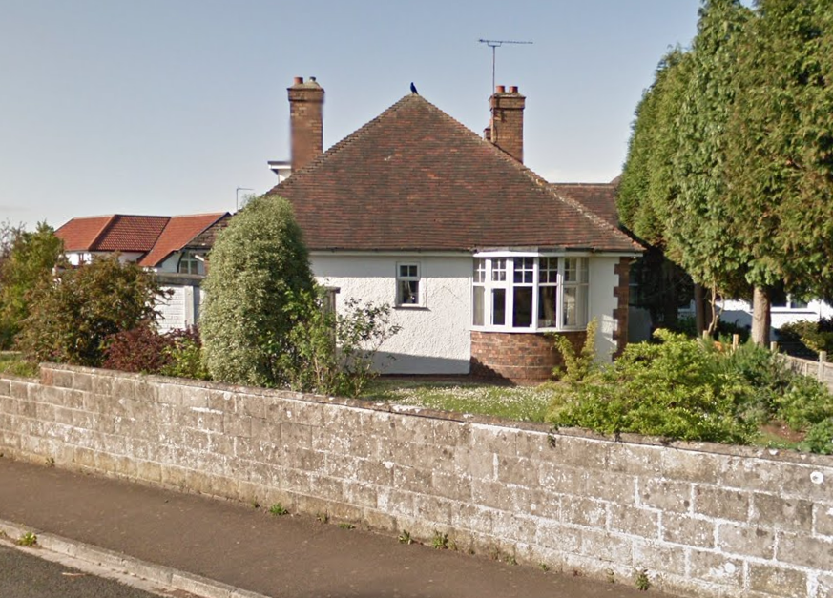
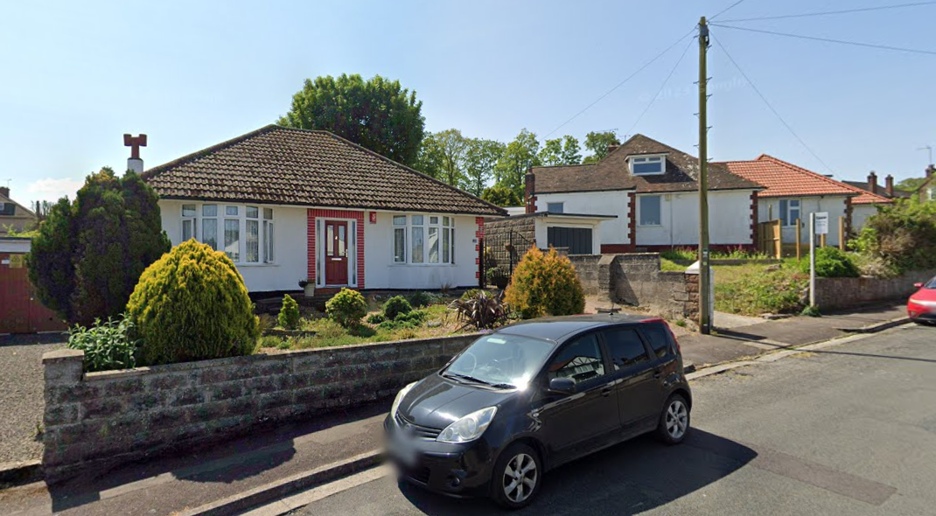
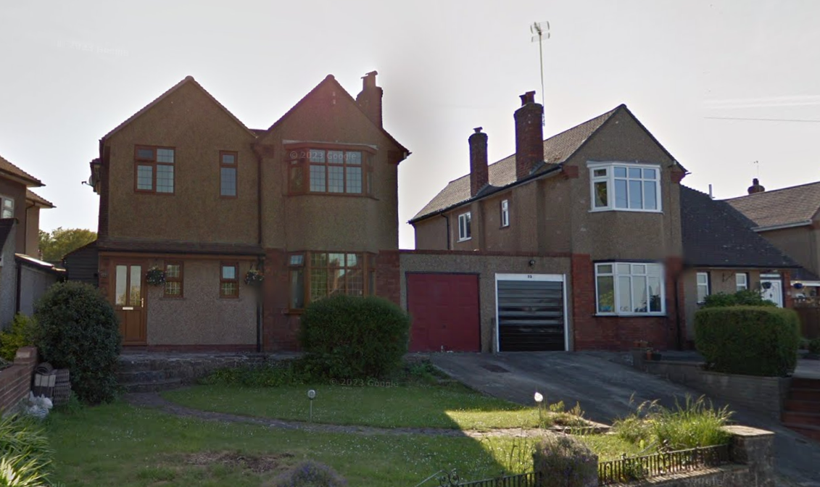
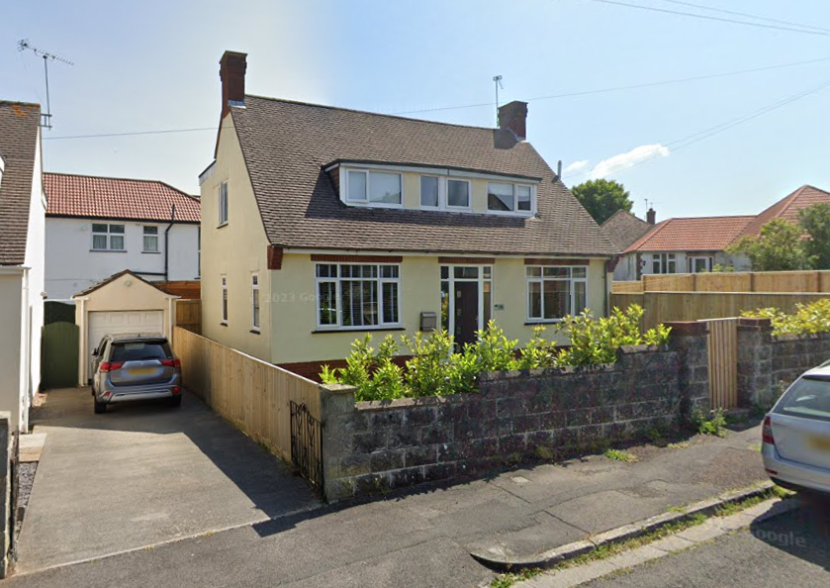

End.

