PERMISSION SOUGHT FOR CHANGE OF USE OF THE EXISTING OUTBUILDING TO A 1 BED ROOM RENTAL ACCOMODATION, WITH THE ADDITION OF TWO WINDOWS.
TO
‘THE LITTLE BARN’ OUTBUILDING AT THE OLD MANOR, CHURCH LANE, MARSWORTH, HP23 4LX

DESIGN & ACCESS STATEMENT

November 2023

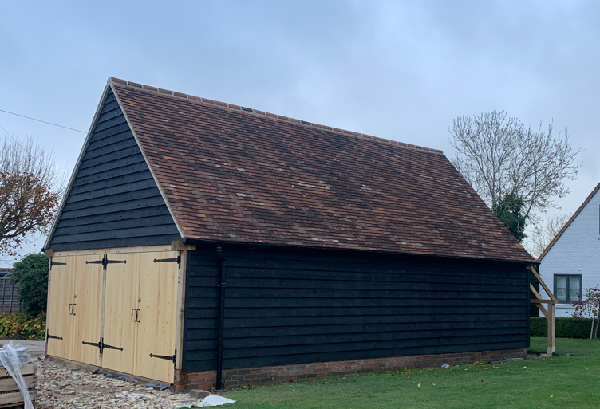

- INTRODUCTION
  - This Design and Access Statement has been prepared to support a planning application for a change of use of an existing outbuilding at the Old Manor, Church Lane, Marsworth from a garage to a 1-bedroom rental accommodation.
  - It will demonstrate that the proposed works have evolved following a structured process involving assessment, involvement, evaluation, and design.
  - Planning policy relevant to the site has also been identified and plays a significant role in shaping the proposal.
  - The process of design is covered throughout this document following the generic headings identified in CABE guidance for assessing proposals in terms of design and the integration of access. These headings are:
- Use: Establishes the proposed use and how it will fit in with the local context.
- Amount: Identifies the amount of building being proposed and why it is appropriate.
- Layout: Explanation of why the layout has been chosen and how it will work and fit with its surroundings.
- Scale: Refers to the size of building and spaces, showing why those sizes are right for the site and how they relate to existing buildings and why the proportions of the building are appropriate.
- Landscaping: Explanation of principles used to establish the landscape concept and how it has influenced the overall design.
- Appearance: Explanation of what the proposals will look like and why.
- Access: Proposals for pedestrian, vehicular and inclusive access.

- SITE DESCRIPTION & BACKGROUND
  - The outbuilding, referred to from here on in as ‘The Little Barn’, is situated in the rear grounds of the Old Manor, a Grade II Listed farmhouse. The listing states that the property dates to the seventeenth century. It lies in the historic core of Marsworth village centred on the Church of All saints and contributes to the Marsworth Conservation area.
  - The property was originally listed on the 26^{th of} September 1951 and was formerly known as Russell’s farmhouse.
  - A site plan can be seen in the supporting documentation accompanying the Heritage Statement.
  - The property is timber framed construction, with plain clay tile roof and black cladding and plain clay tiled roof. Three conservation Velux windows are present on the South-West elevation.
  - The following previous applications have been downloaded from the Planning Portal and are potentially relevant to this application:

23/02835/ALB – Listed building application for proposed masonry paint removal and lime render to panels of the historical elevations of the Old Manor - APPROVED

22/C2184/DIS – Application for approval of details subject to condition 9 (details of replacement joinery components) of listed building consent ref: 22/02184/ALB – APPROVED

22/02184/ALB – Application for approval of details subject to condition 9 (details of replacement joinery components) of listed building consent ref: 22/02184/ALB – PARTLY SATISFYS

22/04248/APP – Householder application for erection of a detached garage/store outbuilding – APPROVED

22/A2184/DIS – Application for approval of details subject to condition 2 (materials), condition 3 (details of new chimney cowl), condition 4 (lime mortar specification) and condition 5 (rainwater goods) of planning approval ref 22/02184/ALB) – APPROVED

22/02184/ALM – Listed building application for maintenance and restoration works to the roofs, timber frame, window casements, rainwater goods, gable end wall and microstrip of internal beams – CONSENT GRANTED

22/01612/APP – Householder application for erection of a detached garage store/outbuilding and erection of pagoda – WITHDRAWN.

22/00970/APP – Residential conversion of a Grade II listed thatched barn and associated alterations to access and parking arrangements and the provision of two detached car ports (amendment to approval 19/02993/APP. – REFUSED

19/02994/ALB & 19/02993/APP – Application for residential conversion of a Grade II listed thatched barn and associated alterations to access and parking arrangements and the provision of two detached car ports. – APPROVED

18/01538/APP - Erection of garden shed, 3.5m wide by 5m long by 2.4m high on an earth base – APPROVED.

17/00753/APP & 17/00754/ALB - Repair and rebuilding of a brick wall in like for like materials. Re-instating steps on the bank from the road to the wall, including a new gate as entry to the garden. – APPROVED.

05/00161/ALB 7 05/00162/APP - Single storey rear and side extension with storage above and internal alterations – APPROVED
  - The Little Barn is laid out in a functional manner, with entrances via the front and side elevations.
SCHEME PROPOSALS
  - The proposals relate to the change of use of an existing outbuilding from a garage/outbuilding to a 1-bedroom rental accommodation for air bnb. The double garage ground floor section will remain as garaging use for the Old Manor.
  - The proposals are set out within the supporting documentation. There are few external changes to the current outbuilding, with the acceptance of two windows.
  - The closest neighbouring property is approximately 22m from the existing building.
- USE
  - The works require Planning Permission and consent for change of use and as such relate to the potential effect on the setting of the surrounding listed building and on the Conservation Area in which the property sits.
- AMOUNT
  - The proposed works will create no additional space, as the proposed works are to the internal layout of the current outbuilding.
- LAYOUT
  - The proposals are explained within the supporting architectural drawings.

- SCALE
  - There are no issues with scale for the reasons outlines above.

- LANDSCAPE
  - There are no changes proposed to any landscaping as agreed under 22/04248/APP.

- APPEARANCE
  - There are minimal changes to the external of ‘The Little Barn’ for this conversion to rental accommodation. The addition of two windows is proposed to allow for ventilation and as method of fire escape. Internally, a staircase and first floor will be installed to create a studio space. Provisions for a small-scale kitchen, shower room and waste services are also proposed (refer to supporting documentation).
  - The works will have minimal visible impact to the Old Manor House and its surroundings.
  - To ensure that there is no increase in the potential for over-looking of neighbouring properties no additional glazing has been placed within the South-west facing roof slope. The new escape roof window has been placed on the North-east elevation facing the rear garden of the Old Manor.
- ACCESS
  - No proposals are being undertaken to the front or rear access doorways. Access to the accommodation will via the existing entrance door on the South West elevation.
  - The proposals do not involve any new access to the Public Highway.
  - Access for emergency vehicles will be via the same access as per the residential vehicles and will not change because of these works.
  - The proposals do not include any works that impact on the inclusivity of the existing dwelling.

- SUSTAINABILIY
10.1 The building will meet building regulations for thermal efficiency and performance.
11.0 CONCLUSION
11.1 As a result of a thorough process of evaluation and design the proposals should be regarded as sustainable development with an intention for supporting local economic and social gains.

