PERMISSION SOUGHT FOR CHANGE OF USE OF THE EXISTING OUTBUILDING TO A 1 BED ROOM RENTAL ACCOMODATION, WITH THE ADDITION OF TWO WINDOWS.
TO
‘THE LITTLE BARN’ OUTBUILDING AT THE OLD MANOR, CHURCH LANE, MARSWORTH, HP23 4LX

HERITAGE STATEMENT

December 2023

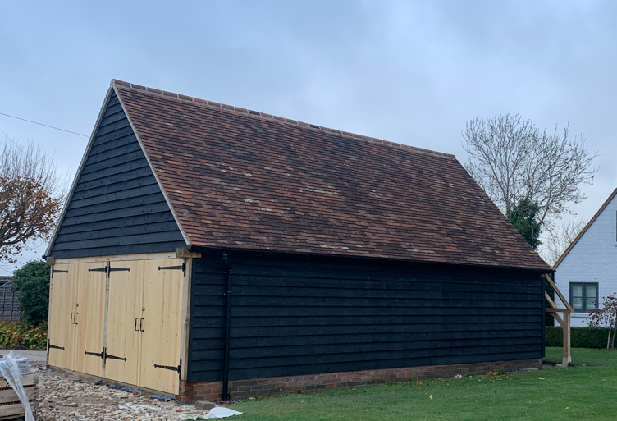

SITE ADDRESS
The Old Manor, Church Lane, Marsworth, Buckinghamshire, HP23 4LX
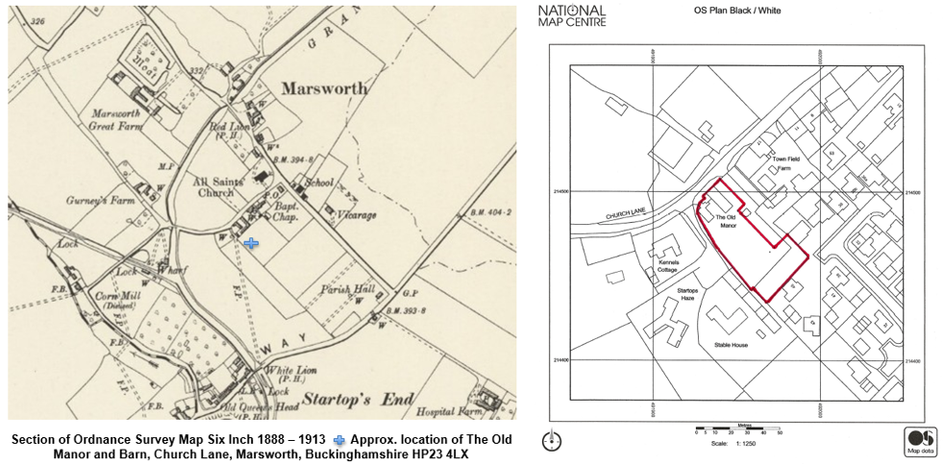

CONTEXT

The Old Manor is part of a historic group of buildings in Church Lane, Marsworth, including the parish Church, and makes a significant contribution to the setting of the Marsworth Conservation Area.

This application is seeking permission for changes to be made to an existing outbuilding in the grounds of the Old Manor and it should be noted that there are no alterations to the Old Manor itself. It is however recognised that the impact of the proposed changes should take into consideration both the heritage asset as well as the Conservation area of Marsworth.

All supporting documentation should be read in conjunction with this Heritage Statement.

MARSWORTH

Location

Marsworth is located 6.5 miles northeast of Aylesbury and 2 miles north of Tring close to the county boundaries of Buckinghamshire and Hertfordshire. The physical, historical, and economic development of the village and surrounding landscape have been shaped by the proximity of the Lower Icknield Way, part of the ancient route between Wessex and East Anglia, and by the construction of the Grand Union Canal in the late 18th century. The canal which passes immediately to the east of Startop’s End and sweeps a wide curve to the west of the Church of All Saints, provided a direct route from the Thames at Brentford to Braunston in Northamptonshire and then by other canals to the industrialised Midlands. To the west of the canal are Tringford, Marsworth, Startops End and Wilstone reservoirs which maintain the water level in the canal, and which have been designated nature reserves.

History

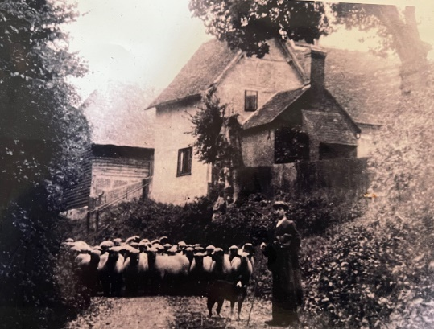
Little is known of the early history of Marsworth, although there have been several significant archaeological finds in the area. A short distance to the north-east of Marsworth, beyond the boundary of the Conservation Area, is the site of a Roman Villa. Marsworth is first mentioned in 970, when Queen Elgiva left the Manor of Marsworth to her brother-in-law, King Edgar. On King Edgar’s death in 975 the manor passed to the Monastery at Ely. The next record of Marsworth survives in an entry in the Domesday Book of 1086/7. Thurston Bassett, lord of the manor of Marsworth built the first church in the village in 1190. It was probably constructed of wood and nothing of the original
structure has survived. Bassett died without a male heir, so he left the Church to Cadwell Priory. At the Dissolution of the Monastries in 1536, the church was given to Trinity College Cambridge, in whose care it remained until 1926 when it became the responsibility of the Diocese of Oxford.

In 1635 the village had 40 dwellings and a population of 200 people. Agriculture formed the mainstay of the economy and in common with most villages, the land was worked three field system farmers cultivated strips of land in each of the three fields, rotating their crops every year so as to leave two of the fields fallow. This is also reflected in the design of individual buildings such as the Barn at the The Old manor which was previously known as Russells Farmhouse. The remains of another Manor house are located to the north of the church at Moat Farm, but there is little evidence above the surface, and another prominent 16th century family, the De La Hays’s manor house was located to the North East of the village at Manor Farm.

Late in the 18th century the Grand Junction Canal was constructed at Marsworth. The canal was authorised by a bill of Parliament in 1793 which was extended a year to provide canals to Aylesbury, Wendover and Birmingham. By 1797 the section through Marsworth and Cheddington was complete and the canal at Marsworth was opened in 1799. The Aylesbury Arm was completed in 1814. In 1928 the Grand Junction was amalgamated with other canals to form the Grand Union Canal. The construction of the canal had an enormous impact upon the physical appearance of Marsworth but also upon the economy of the village. The construction of the canal brought labourers, canal workers and boatmen to the area, prompting the construction of new buildings to accommodate them and the growth of services and trades in the village.

The enclosure of land in 1811 also heralded significant changes to the physical appearance and economy of Marsworth. The three field system was abolished. The census of 1851 shows that from a total population of 439, there were 84 agricultural labourers in the village who worked to supply plaited straw to hat manufacturers in nearby Luton.

The later 19th and early 20th centuries heralded dramatic changes in the character and appearance of Marsworth. Small-scale developments like rows of terraced cottages at Startop’s End made a positive contribution to the character of the village. In the early 20th century, the Rothschilds who were major landowners of the Tring Park Estate added some important buildings including the semi-detached properties on Vicarage Road, Guerney’s Farmhouse, the village school, and the village hall. Like many villages in the surrounding area, Marsworth is now largely a dormitory settlement with most residents commuting some distance to work.

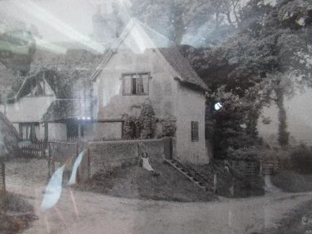

An early 20th century photo of the Old Manor, formerly known as Russell’s Farmhouse.

PROPOSAL

SUMMARY OF SCOPE OF WORKS

The proposed works to the outbuilding in the grounds of the Old Manor are straightforward and consist of:

- Change of use of the outbuilding to a 1 bed rental accommodation. This proposal does not seek to create any additional space, with the changes being internal. There are no external landscaping changes proposed.
- The addition of two windows, one conservation Velux acting as a method of escape and the other at the ground floor level which is not directly visible from the Old Manor or any neighbouring properties.

ASSESSMENT OF SIGNIFICANCE

Due to the changes being largely internal, the proposed changes to the outbuilding are not believed to present as having a significant impact on either the aesthetic, communal, evidential, or historical vales of the Old Manor or any of the three listed buildings within the vicinity (The Old Manor Barn, Horseshoe Cottage, and All Saints Church).

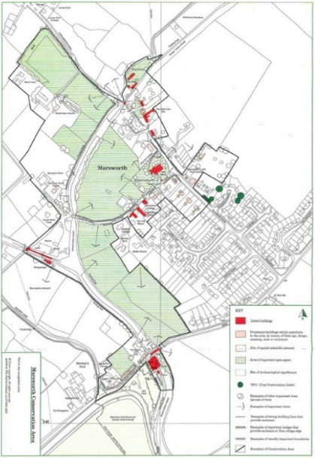
MARSWORTH CONSERVATION AREA
Marsworth’s history is described in the section above, with the map to the left outlining the conservation area.

The proposed change of use to the outbuilding are not perceived to have a detrimental effect on the aesthetic quality of the Conservation Area as defined in the Local Authority document. There Is very little change to the appearance of the outbuilding and its surrounding landscaping as it currently stands.

LISTED BUILDINGS

The proposed changes to the outbuilding at the Old Manor slight and
will therefore only have a potential impact on the building itself and its immediate neighbours – The Old Manor Barn and Horseshoe Cottage. The Old Manor Barn sits directly across from The Old Manor, but the view to Horseshoe cottage is obstructed by the Old Manor Barn and is barely visible.

To most observers of the outbuilding there will be no discernible visual change.

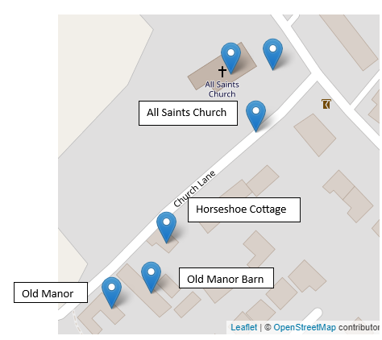

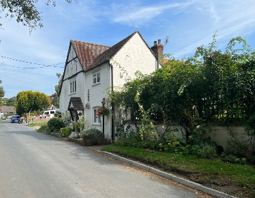

View to Horseshoe cottage from Church Lane

THE OLD MANOR

The Old Manor is situated down Church Lane and backs onto a more recent development in Lukes Lea. It was originally listed on 26th of September 1951 and was formerly known as Russell’s farmhouse, which highlights the significance. The Historic England listing (NGR: SP9193814495 ) has the following citation for the building:
“House. Late C16, extended one bay to left C17-C18, slightly altered.
Timber frame with whitewashed brick infill, the ground floor partly rebuilt in whitewashed brick. Similar plinth with some flint, partly rendered. Old tile roof, rebuilt brick chimneys between outer bays.
3 bays to left are of 1 storey with 2-storey gabled cross wing to right.
Left bay is blank, remainder have casements with diamond leading, mostly renewed, and heavy timber sills. Right bay and ground floor of second bay have 3-light casements, the upper right with a C19 Tudor wooden hoodmould. Centre bays have half-hipped eaves-line dormers with 4-light casements, the outer lights triangular. Old board door in second bay has half-hipped timber-framed porch and flanking 2-light casements. Later single storey extension to rear of cross wing is of whitewashed brick. Interior: large double-sided chimney stack between right bays; stop-chamfered spine beam in centre bays; moulded and stopped spine beam in right bay; large wind-braces. Formerly known as Russell's Farmhouse”

Under previous ownership, the Old Manor has been subject to modern development, with a significant extension to the South East elevation, undertaken in 2005.

HERITAGE IMPACT

The Old Manor barn, adjacent to the Old Manor and under separate ownership, is currently undergoing conservation works as part of Listed Building application 22/03842/ALB. The Old Manor and The Old Manor Barn are historically linked having been under the same ownership prior to 2021. It is proposed that the change of use of the outbuilding will have a negligible impact on the historic relationship between these two properties.

JUSTIFICATION FOR THE PROPOSALS

The change of use of the outbuilding will have very few visible impacts on the inclusivity of the existing Old Manor house and Old Manor barn. The proposal is being submitted from a sustainable development perspective with the intention of supporting local economic and social gains as further outlined in the supporting statement.
DESIGN

Care has been taken during the design process to ensure that the outbuilding will continue to sit harmoniously within its surroundings, with no proposed changes to the size of the building itself and with no landscaping changes. The introduction of an electric charging point has been done so to support the transition to a low carbon future.

CONCLUSION

From a heritage perspective, it is believed that the proposals are therefore in line with the NPPF - the works will cause no damage to historic fabric and will not just cause ‘less than substantial harm’ to accord with the NPPF, but will exceed this minimal requirement, as per best conservation practice set out within BS 7913: Guide for the Conservation of Historic Buildings.

