Remove young Ash Trees and Sycamore Trees - The Grange, 46 Burley Road, Langham, LE15 7HY

We would like to carry out the following works to continue to maintain and enhance the area and habitat of this piece of land which lies alongside the Langham Brook within the village conservation area. We have taken advice from a tree surgeon who has closely inspected the trees suggested the following works would be appropriate given their current state and the proximity to three other large trees.

- Fell Ash Trees (T1) – This clump of young multi stemmed self-seeded Ash Trees are growing very close together alongside the boundary. They are also growing at an angle towards the neighbouring property.

- Fell Elderberry Tree (T2) – This tree is in very poor health and is growing extremely close to the boundary fence with the neighbouring property.

After removal of this clump of trees a replacement Alder tree would be planted. This tree will thrive in waterside habitat and will help to stabilise the bank. The current Hawthorn to the left of the trees will be able to grow up will also help provide more stability to the bank.

- Fell young sycamore trees (T3). These two young trees are growing out of the bank and are unstable. There is already a very large multi stemmed sycamore within approximately 5 m of these trees. We would like to replace these with an Alder. To the right of these trees we intend to plant Hazel as well as some Basket Willow.

Location of the trees

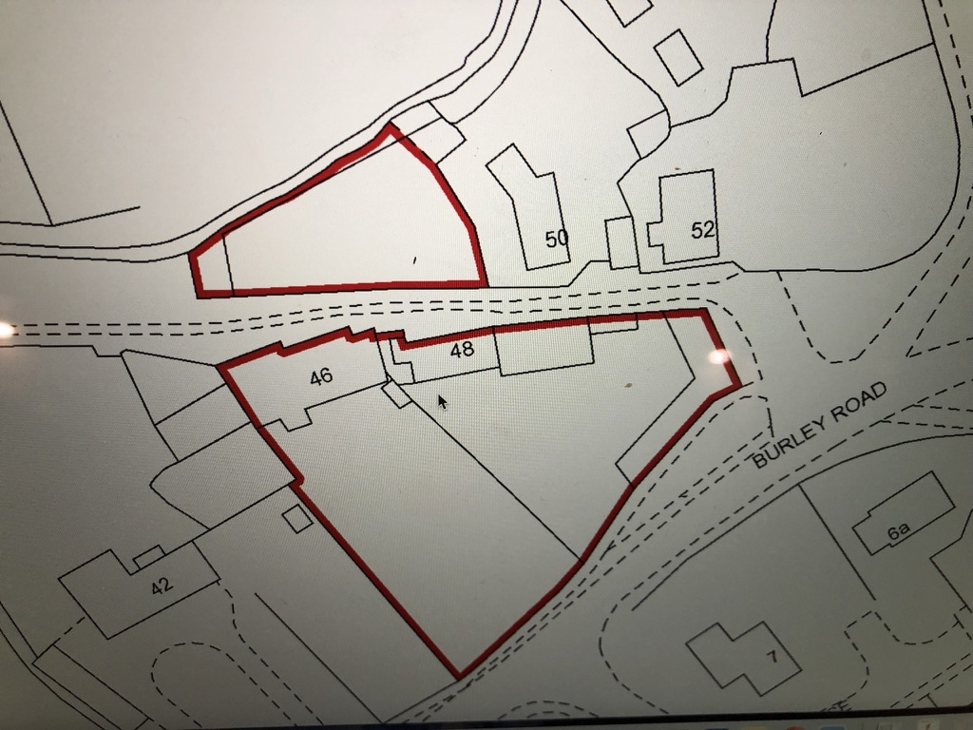
1

T1& T2
T3 & T4

Photographs of the trees

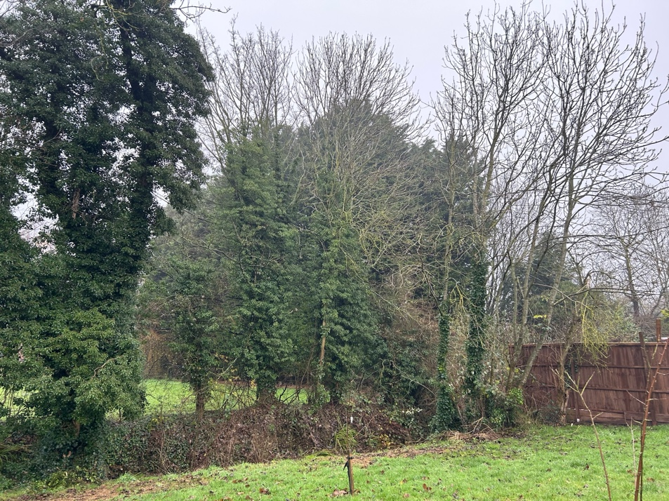
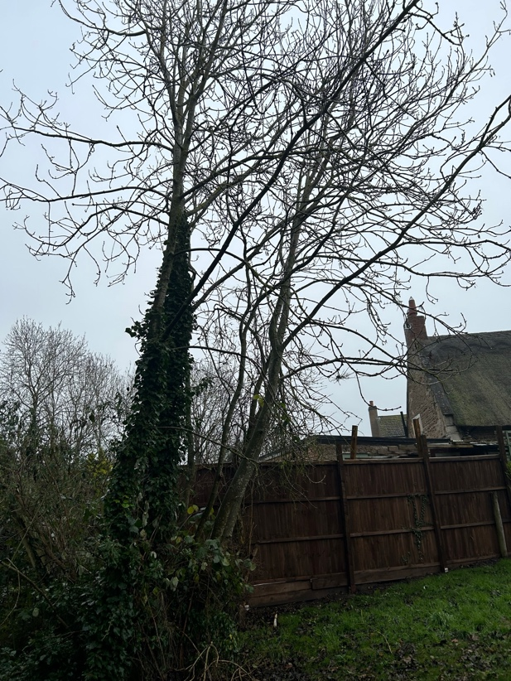
- Ash Trees

- Elderberry

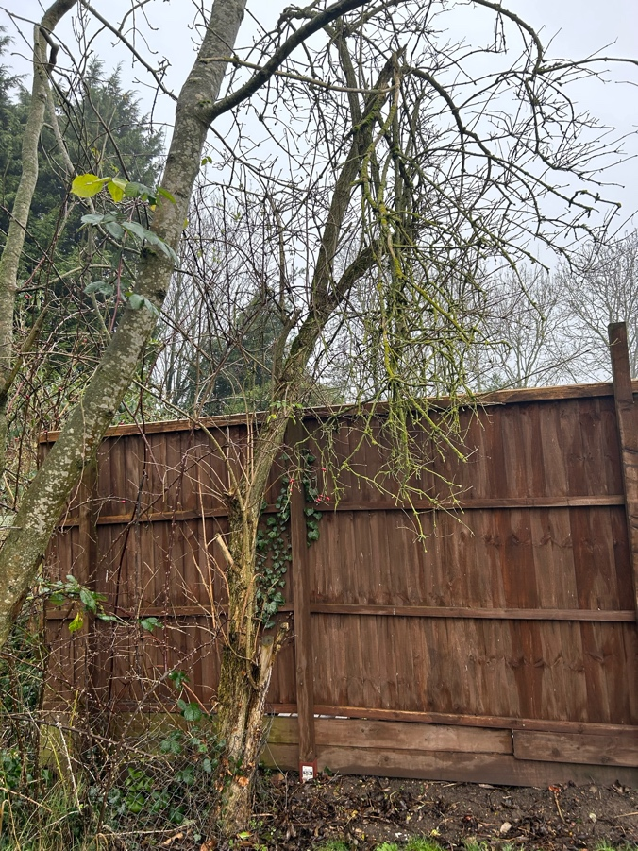

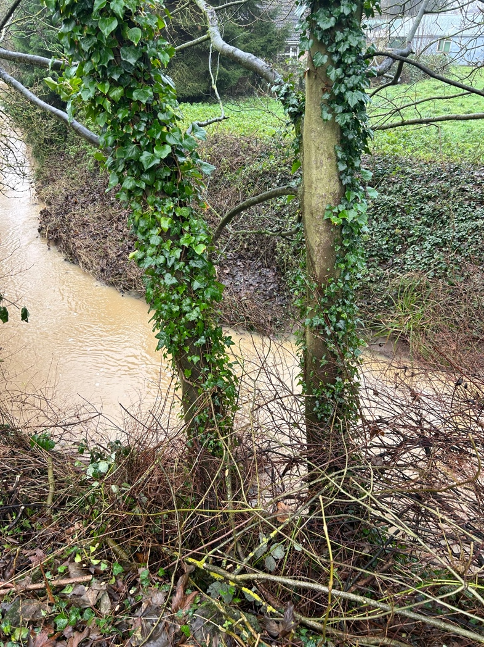
- Sycamore Trees
