2024 Tree Works Required at Kenilworth Castle, Castle Road, Kenilworth CV8 1NG

Job No | Tree & Works Required
1634 | Fraxinus excelsior  Ash dieback symptoms. Poor condition and form, with visible fungal fruiting bodies. Lean bias over footpath. Historically topped with old fungal bracket evident on primary leader in crown. Tree removal advised due to condition and expected irreversible decline.  Mature tree, poor condition.
1632 | Acer pseudoplatanus  Significant basal decay approximately 50% of flare with moderate compensatory growth. Targets include main gate to castle and footpaths on all sides. Heavy reduction of approximately 50% in height recommended to suitable growth points (height, and sides balanced). Epicormic growth not to be removed.  Mature tree, fair condition.
1635 | Fraxinus excelsior  High use target area with row of declining Ash trees (x3). Historic limb failure and fungal bracket noted in NW tree, likely innonotus hispidus at approximately 12m above ground level over footpath. Removal of subject limb recommended. Severance of ivy at base advised to facilitate future inspection.  Mature trees, fair condition.
1636 | Fraxinus excelsior  3 x stem tree with included bark unions at base. Lean bias over residential property. Ash Dieback and decline expected. Tree removal to ground level advised.  Mature tree, fair condition, high risk
1038 | Fagus sylvatica  Advanced basal decay, cambium/sapwood defective as confirmed by acoustic and resistograph micro-drill test: E and S tested, shows 8-10cm sound wood only. Lean bias over carpark and on man-made banking. Fluting at base, irreversible decline at base despite healthy crown. Proactive intervention via tree removal recommended as mode and direction of failure foreseeable.

Tree Location Plans

Trees 1632 and 1636
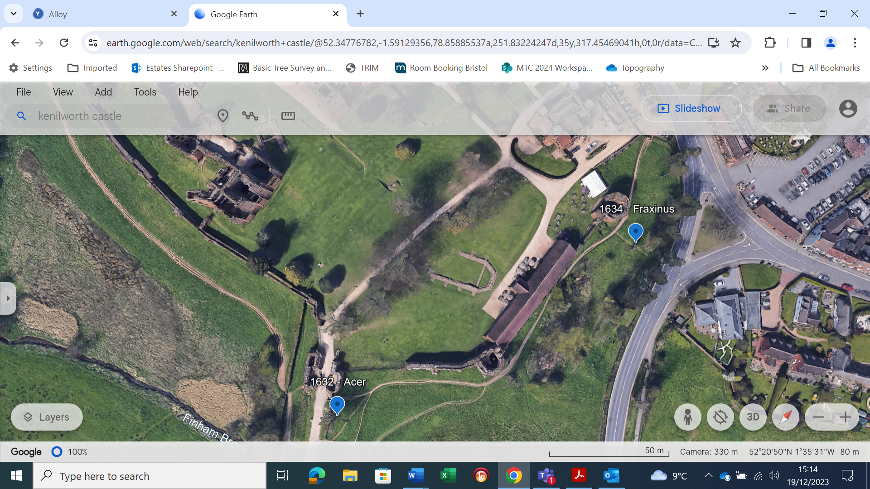

Tree 1635
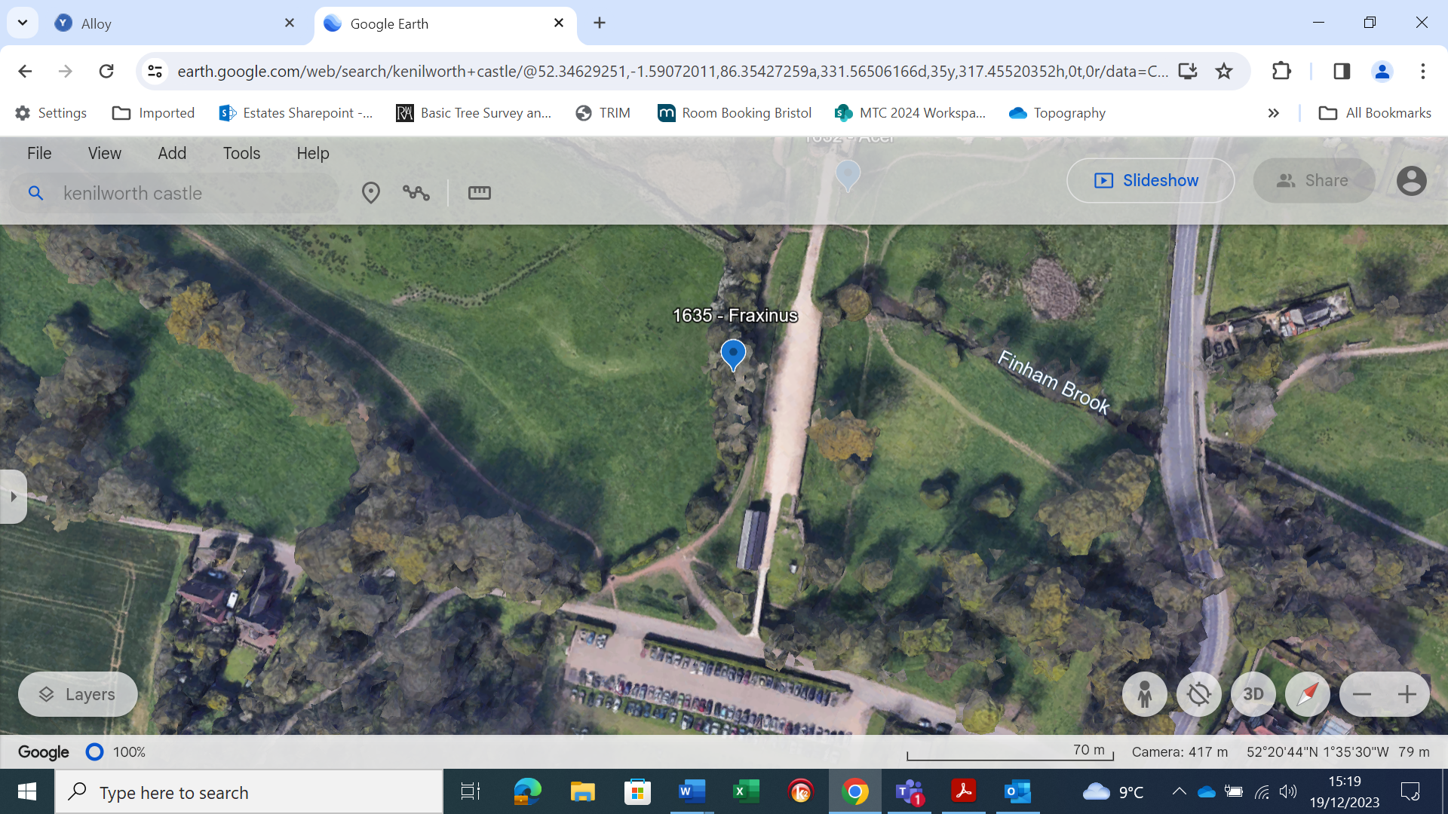

Trees 1038 and 1636
