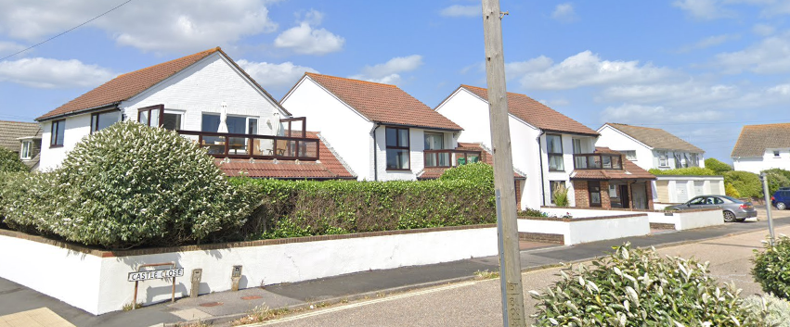
Existing street scene

Polruan Saltaire

