Dear Sir/Madam,
Dover District Council
Dover District Council, Dover District Council,Planning Department,White Cliffs Business Park,Dover,CT16 3PJ
Mail ID: supportassistants@dover.gov.uk
Contact Number: 01304872486
Our ref:
OGEA11804653
Title: – BT intends to install fixed line broadband electronic communications apparatus nearly 11 Millais Road,Dover, Kent,Dover,CT16 2LW.
Under The Electronic Communications Code (Conditions and restrictions) (Amendment) Regulations 2017, I hereby give you notice under Regulation 5 informing you of our intention to install 1 Pole at the above location.
I enclose a copy of the plan indicating the approximate position for the proposed apparatus.

Should you require further information about the above works, please do not hesitate to contact me.
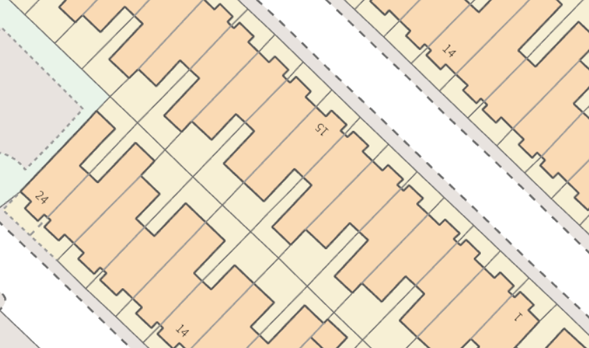
Approximate Grid ref: - 631229 142302
Yours faithfuly,

