Dear Sir/Madam,
Chorley Borough Council
Chorley Borough Council,
Chorley Borough Council,
Planning Services, Civic Offices,
Union Street, Chorley,
PR7 1AL
Our ref:
OGEA75469523
Title:– BT intends to install fixed line broadband electronic communications apparatus Near 538 Preston Road,Clayton Le Woods,Chorley, Lancashire,Chorley,PR6 7EB
Under The Electronic Communications Code (Conditions and restrictions) (Amendment) Regulations 2017, I hereby give you notice under Regulation 5 informing you of our intention to install 1 new pole required at the above location.
I enclose a copy of the plan indicating the approximate position for the proposed apparatus.
` 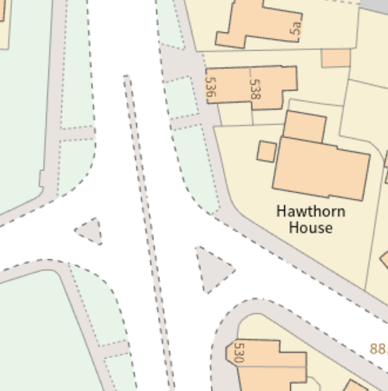
Approximate Grid ref:-
357872,423333

Should you require further information about the above works, please do not hesitate to contact me.
Yours faithfully,

