12 Hobart Drive, Hythe, SO45 6FH
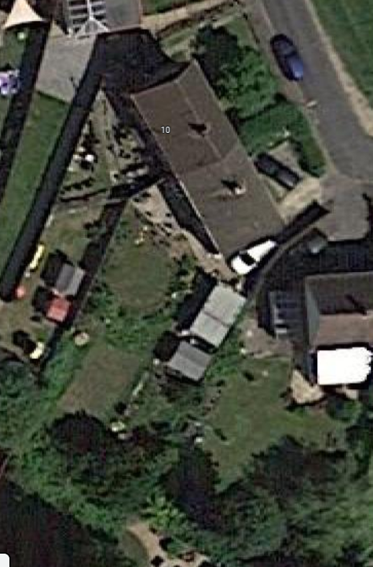

- Site
  - The application site contains a semi- detached property and is located within area of Hythe.
Application Site

- Site & Planning History
  - New Forest District Council website shows 0 planning history for the application site.

- Proposal
  - The proposal is to demolish the existing garage and shed and replace it with a larger garage, a dark room for the current owner to use along with a utility and w/c.
  - The material used will be block and cladding and the windows and doors to be brown UPVC. The roof will be flat made from EPDM to minimize the impact to the neighbours.
  - The proposed scheme will replace an old and tired looking garage with a more robust and new building.

