Application for Walnut Tree Cottage
Work to tree in conservation area

Approximate tree loaction………………………..

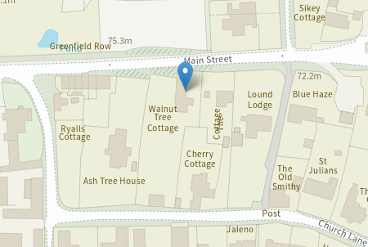

The upper branches are now rubbing against the tiles ( of our Listed Building ), and have broken two already. They also rub against the windows in the middle bedroom which are very thin and liable to crack. The lower branches make access to the house slightly difficult…particularly if you’re tall !
The proposal is to raise the crown to 5 metres.
Prune top branches all round by approximately 7 metres to give 2 clear metres gap to the building and roof in particular.
Thin by 20%.

