Planning and Heritage Statement

4 & 5 The Square, Sedgefield TS21 2AB

Replacement of roof coverings on both properties

Planning Approval
(Retrospective)

CONTENTS

PLANNING STATEMENT

P.1.00 - Introduction and Existing Site
P.2.00 - The Application

HERITAGE STATEMENT

H.1.00 - Introduction
H.2.00 - Development Proposals
H.3.00 - Policy Context
H.4.00 - Listed Buildings
H.5.00 - Impact on the setting of the Heritage Assets
H.6.00 - Conclusion

Appendices
A - EMAIL CORRESPONDENCE WITH PLANNING DEPARTMENT
B - EMAIL CORRESPONDENCE WITH DESIGN AND CONSERVATION
C – Introduction
D - Introduction

PLANNING STATEMENT

Introduction & Existing Dwelling

    - This statement has been prepared on behalf of the Client, Mr. Peter Wren,
in support of a Householder Planning Application submitted to Durham County Council, for the replacement of roof coverings on both properties, 4 & 5 The Square, Sedgefield TS21 2AB.

    - The properties are located in the town centre of Sedgefield, surrounded by public open space, with the main High Street located less than 100 yards to the north.

    - Situated centrally within the existing terrace known as “The Square”, due to its unique layout.
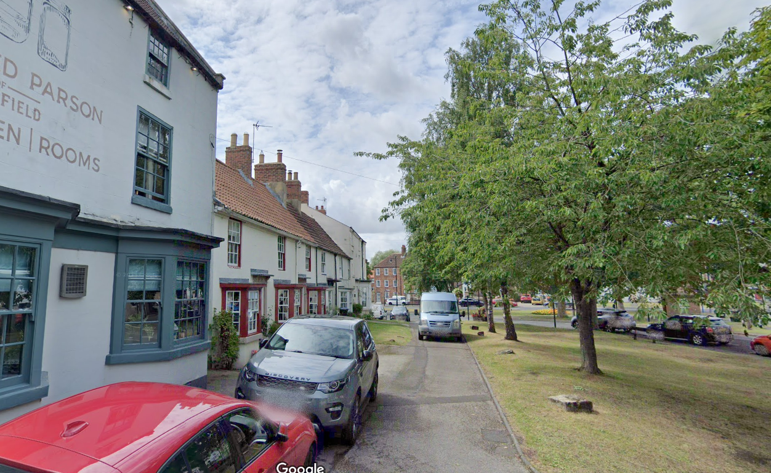
No.4 & 5 The Square
Image P.1.01 Existing Front Elevations

    - Vehicular access to The Square is from the existing road “West End” which leads to the existing perimeter road around The Square, where car parking is available to residents and visitors. The Square is very accessible by foot, with footpaths leading to it from public areas to the north, east, south and west.

The Application

    - The application being submitted is for Planning and Conservation Permission Retrospective to undertake replacement of roof coverings on both properties. None of the proposals look to extend the dwelling beyond its existing building lines.

    - Advice on the proposed scheme was sought via email, with a written e-mail response received from planning officer Mrs. Hilary Sperring: A copy of this correspondence is enclosed with this Planning Application package. See appendix A.

    - Unfortunately, the application wasn’t progressed at that time. However, during recent bad weather, the tenants in No5 reported water leaking in through the roof. This is primarily where the roof of number 5 meets the wall of (the taller) No 6 The Square. On investigation our roofer reported that, in addition to the obvious leaks reported by the tenants, there is other water ingress, the underfelt has failed in several places and is generally life expired. The roof was Installed at least 50 years ago.

His strong recommendation is that any repair focused solely on known leaks would be very short term and that the correct solution is that the contiguous front roofs of 4 and 5 [facing on to The Square] be stripped; any necessary repairs made to roof structure, modern membrane be installed across both properties, lead flashing to side and around the chimney stacks and the tiles then put back.

    - With particular reference to Conservation, approval is sought for works to the following areas of the existing dwelling.
      - All roof coverings (front and rear) – to allow the existing roof Re-roof with pantiles similar to those on many adjacent properties. New roof tiles are a rustic coloured Sandtoft double pantile, with a smooth face finish. Existing tiles from the front elevation were recycled and reused on the rear elevation of the main roofs.
      - No change to roof profile or ridge height
      - Lead flashing replacing mortar to be used at the junction on 5 & 6, and around the chimney stack between 4&5.
      - Fascia boards to be replaced as defective. Existing (black plastic) guttering to be replaced like-for-like.

Further correspondence was also sought from the Design and Conservation team, a copy of this correspondence is also enclosed, see appendix B.

    - It is believed that the re-roofing of the properties is sensitive to its existing location within the Conservation Area, and will not adversely affect the surrounding locality, but enhance it. See photos of the new roof coverings in appendix C.

    - With reference to Ecology in particular possible bat roosts. I didn’t have any preliminary bat surveys carried out as I wasn’t aware if the need for one at the time. However, the loft space in both properties is in use as storage and there has never been any sighting of bat activity in either loft space. Also, during the works there was no reported sightings of bats or droppings to indicate the loft space had been any kind of bat roosting area.

HERITAGE STATEMENT

    - Introductions

This heritage statement has been prepared to accompany an application for the replacement of roof coverings on both properties, 4 & 5 The Square, Sedgefield TS21 2AB. The statement has been prepared to assess the significance of architectural history, character and history of the site and its immediate surroundings and to consider the proposals in this context. While neither 4 & 5 The Square are listed building, it is located within the conservation area of Sedgefield.

H.2.00 Development Proposals

The replacement of all roof coverings on both properties, 4 & 5 The Square, Sedgefield TS21 2AB.

H.3.00 Policy Context

This statement seeks to assess the potential impact of the development proposals on the special interest of the surrounding listed building and adjacent conservation area. The assessment in this statement extends primarily to assess the impact of the development proposals on the setting of the listed buildings and the character and appearance of the conservation area.

H.4.00 Listed Buildings

There are 5 Statutorily Listed Buildings in this Character Area.
Details of the listed buildings are given below.
Name / Grade
The White House, 34 and 36 North End II
3 and 5 North End II
Hardwick Arms, 1 North End II
Magistrates Court House (Manor House) II*
Gate Piers, 10 Metres East Of Magistrate's Court House (Manor House)

H.5.00 Impact on the setting of the Heritage Assets

There are a variety of different roof coverings currently in the conservation area.
See photos in appendix D attached.

H.6.00 Conclusion

The proposed works would take place in an area which has some historic interest.
However, the proposal would not have any direct negative impact on the historic
heritage of the area.

