Application for the discharge of a condition relating to planning approval No 2023/0129. Agricultural building at Fold Head Farm, Hallfold, Whitworth OL12 8XL

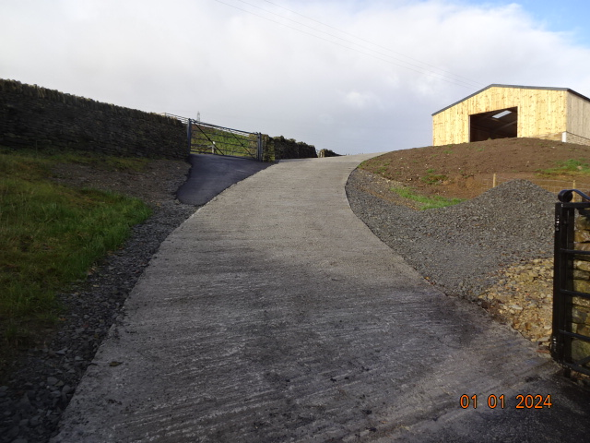

H | P
D | A

January 2024
Prepared by Hartley Planning and Development Associates Ltd
The above application was approved on 3 July 2023 subject to the following condition and for which application is now made for its discharge: -
3. Once the development has been substantially completed, but prior to the first use of the building hereby permitted, a post-construction survey of the condition of Hall Street/Bridleway ref. BW1405112 shall be submitted to and approved in writing by the Local Planning Authority. The survey must consist of:
- A plan showing the location of all defects identified;
- A written and (clearly dated) photographic record of all defects with corresponding location references accompanied by a description of the extent of the assessed area and a record of the date, time and weather conditions at the time of the survey.
Prior to first use of the building, Hall Street/Bridleway ref. BW1405112 shall be re-instated to a condition no worse than it was immediately prior to the commencement of works to the satisfaction of the Local Planning Authority. The condition of Hall Street/Bridleway ref. BW1405112 has been shown in the approved photographic record comprising 14 photos and plan ref. MH220623.B.
Prior to the planning decision, photographs were taken of the lane at identifiable locations and shown on a plan and forwarded to the local planning authority which responded by email dated 23 June 2023 that ‘I’m satisfied that the photographic record provided discounts the need to include a pre-commencement condition’.
The agricultural building has been substantially completed such that there is no requirement for heavy construction delivery vehicles to now use the lane.
The following photographs compare the lane as at June 2023 (ie prior to the start of construction) and as at 1 January 2024 when its use for construction purposes has been completed. A plan showing where the pre- construction photographs were taken is submitted separately. The post construction photographs are taken from the same places.
The post construction photographs have been taken after several days of rain, sometimes heavy. They were taken about mid-day and when there were further showers

Site number | Pre construction photos(June 2023) | Post construction photos (1 Jan 2024)
1 | 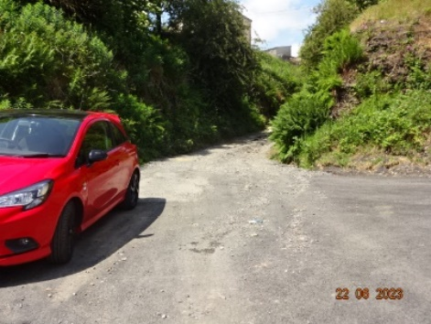 | 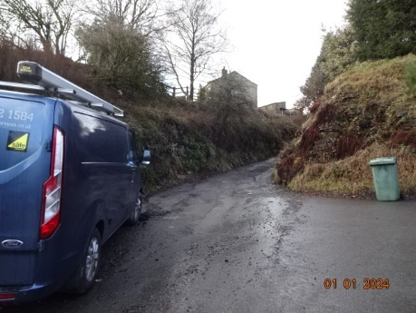
2 | 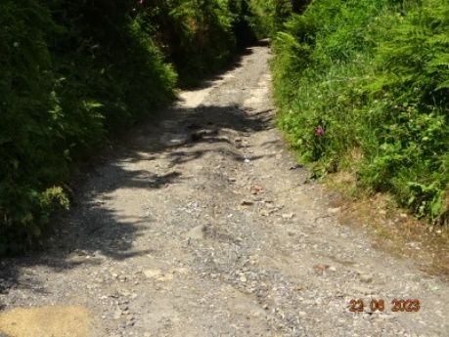 | 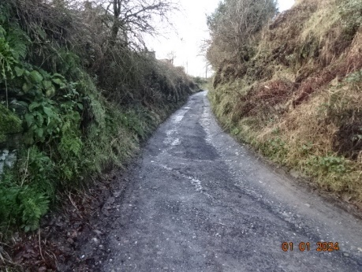
3 | 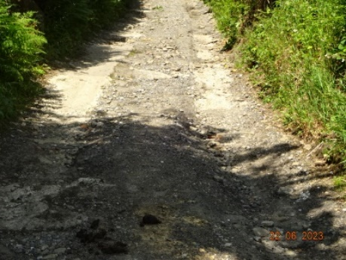 | 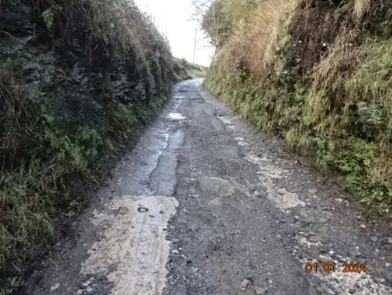
4 | 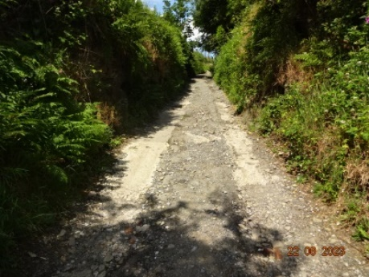
5 | 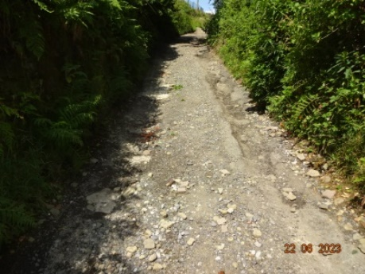 | 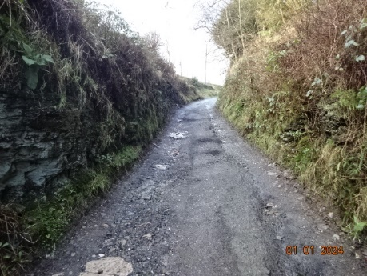
6 | 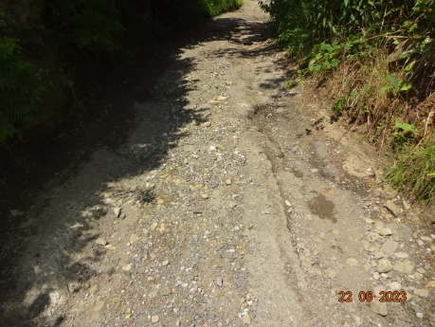
7 | 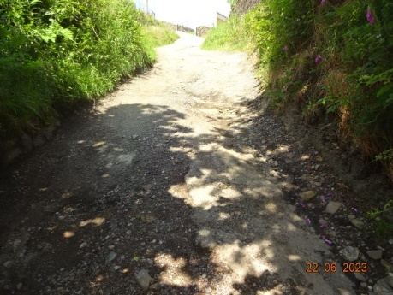 | 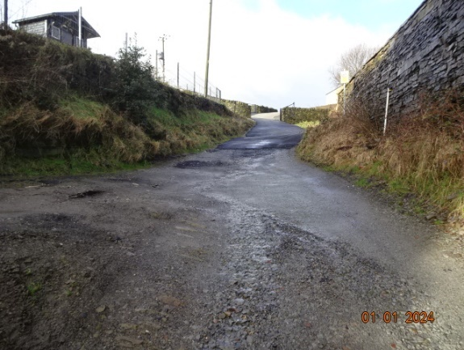
8 | 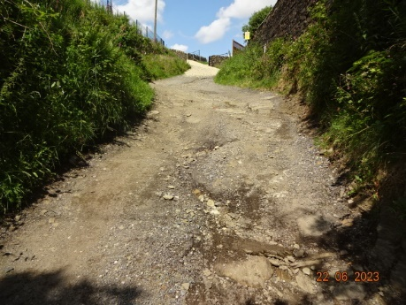
9 | 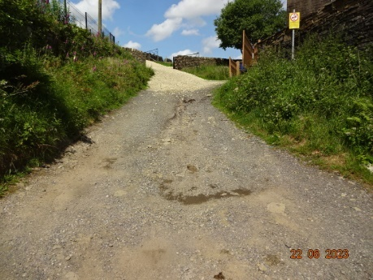 | 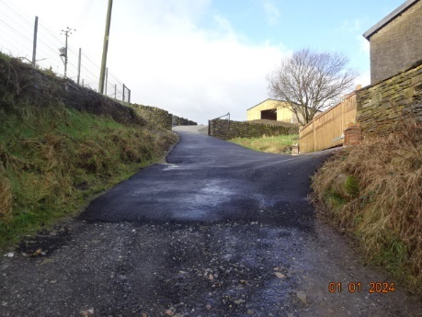
10 | 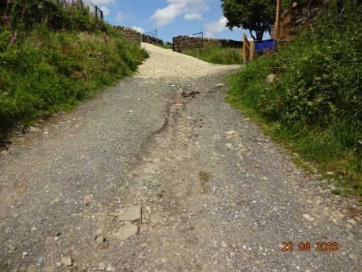
11 | 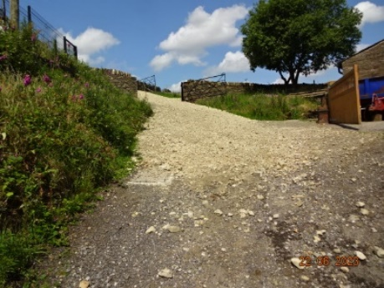
12 | 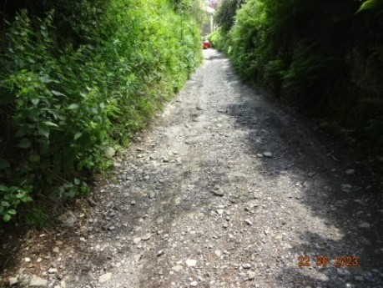 | 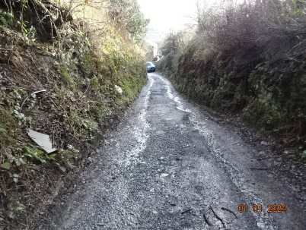
13 | 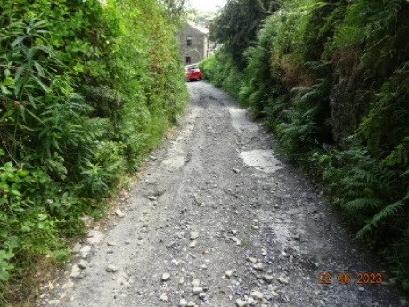
14 | 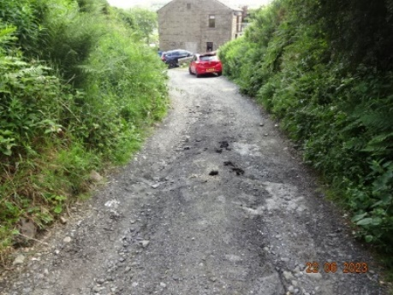 | 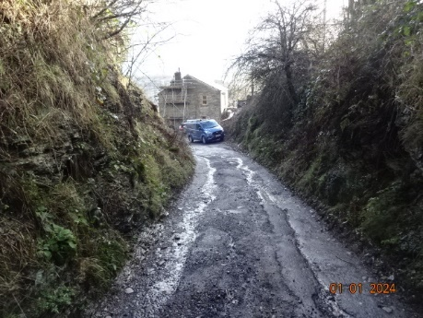

The reason for the condition is ‘to ensure that any damage to the highway sustained throughout the development process can be identified and subsequently remedied, at the expense of the developer’.
The ‘before and after’ photographs indicate that the condition has been met. The lane is in no worse a position than prior to construction work, and indeed, especially at its northern end in the vicinity of Fold Head Farm, the surface has been much improved. Elsewhere on the lane, potholes have been filled, even though these were not caused by construction traffic.

