Planning Statement : 11 Lowfield Road
Current Situation
For a number of decades 11 Lowfield Road has been used as an HMO for 7 tenants. Once licensing came into force, the then landlord changed to short term lets as the property no longer complied with the revised regulations.
Since purchasing the property in 2020 we have thoroughly refurbished the house: going back to brick, replacing gas/ electric, removing stud walls to increase room sizes and adding ensuite bathrooms. Although there was already a bedroom on the second floor, we have opened up the remainder of the loft making a large 27 sqm room. The property has been finished to a very high specification, all rooms are now ensuite and there is a very large, fully featured kitchen and snug area. Our aim is to provide good quality accommodation without compromise for older, professional tenants.
The HMO licence for 11 Lowfield Road was granted in June and covers up to 8 tenants on the condition that we have planning permission to do so. We currently have 6 tenants, all professionals aged up to 55 (many NHS). We would now like permission to use the 7th bedroom.
Impact
We believe the extra tenant (or couple) will have very little impact on both the property and the local environment. There is a well appointed ensuite room currently unoccupied in the house.
Because of the excellent access to public transport, few HMO tenants have cars however for those that do, this end of Lowfield Road has plentiful on road parking due to the large apartments opposite having their own car parks. Indeed the road has recently catered for parking for the mass vaccination campaign carried out at Lowfield Surgery.

Work Required:
No work will be required to the property other than the provision of bike storage in the (locked) garden. For this we propose the lockable Cycle Pod units, each which can take 4 cycles.
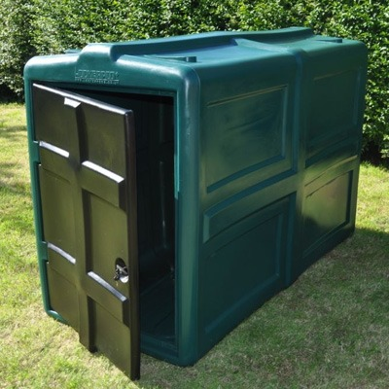

The Property
Photos of the property below:

