Proposal for the window replacement

We want to replace the windows with exact like for like, that is:

- 2 wooden casements to be fitted into the existing stone mullion frame.
- Each one to be able to be opened. Each to have a central baton across the middle.
- Each one to have the existing window furniture re-used – black hammered iron monkey tail design, or exact replacement if the joiner advises that the existing one is no longer fit for purpose.
- Single glazed glass.

I am currently awaiting quotations from two local joiners/window suppliers.

Photo below of the existing window casements which we are intending to match exactly.

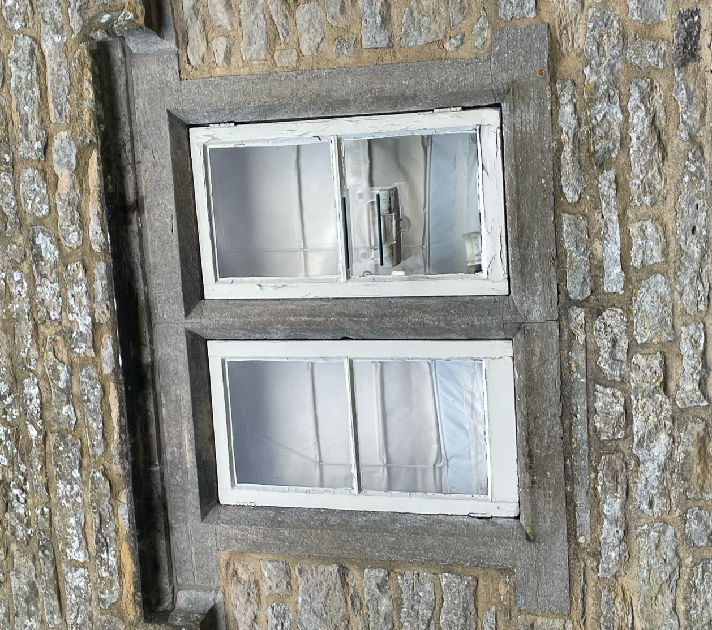

NB I think this is all covered in the Design and Access Statement but I had an email saying that I hadn’t submitted details of the proposed new casements.

