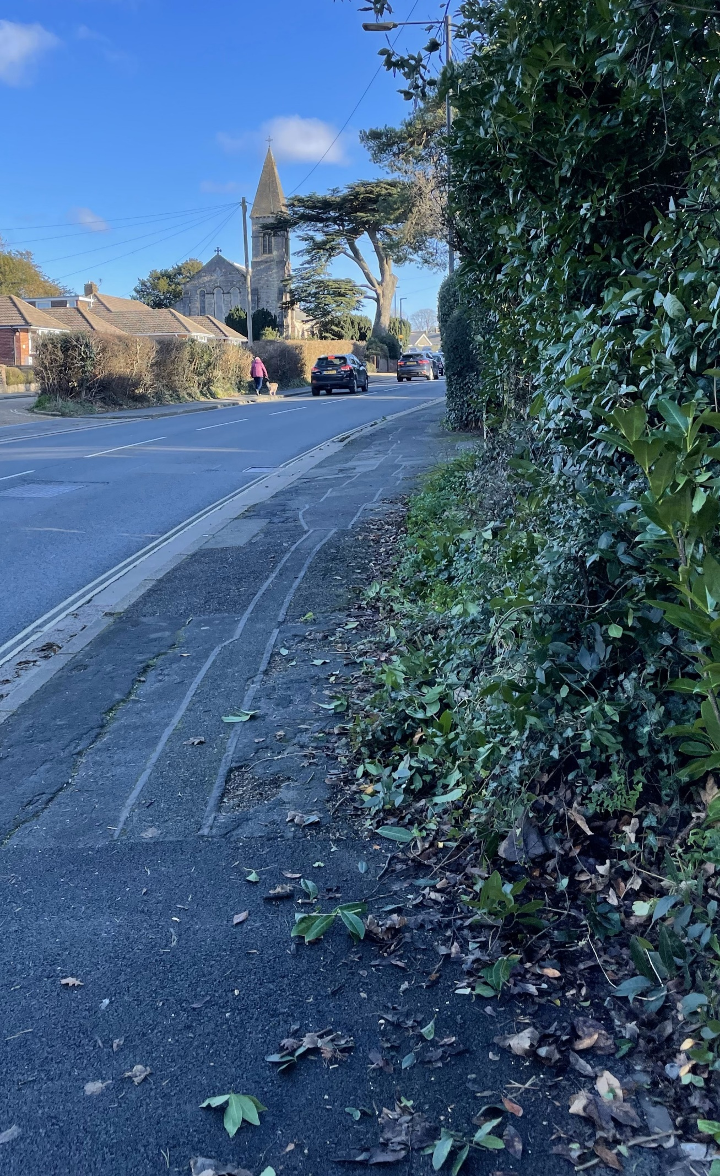

A

B



Visibility splay looking East up Staplers road Viewed from position B

A = 43 m x 1 m from curb

B = 2m in from curb middle of the new drive



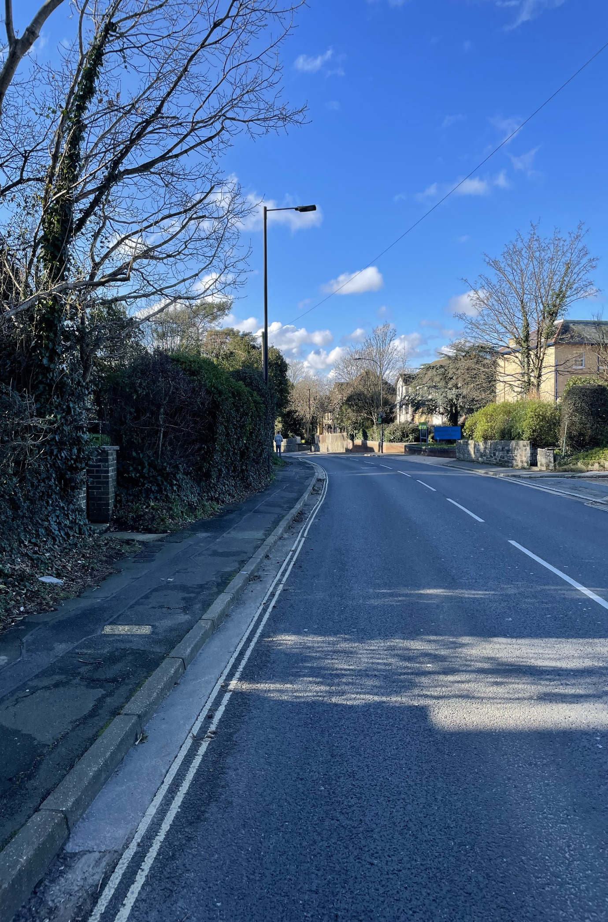

**B**

A

Visibility splay east viewed from position A

A = 43 m x 1 m from curb

B = 2m in from curb middle of the new drive

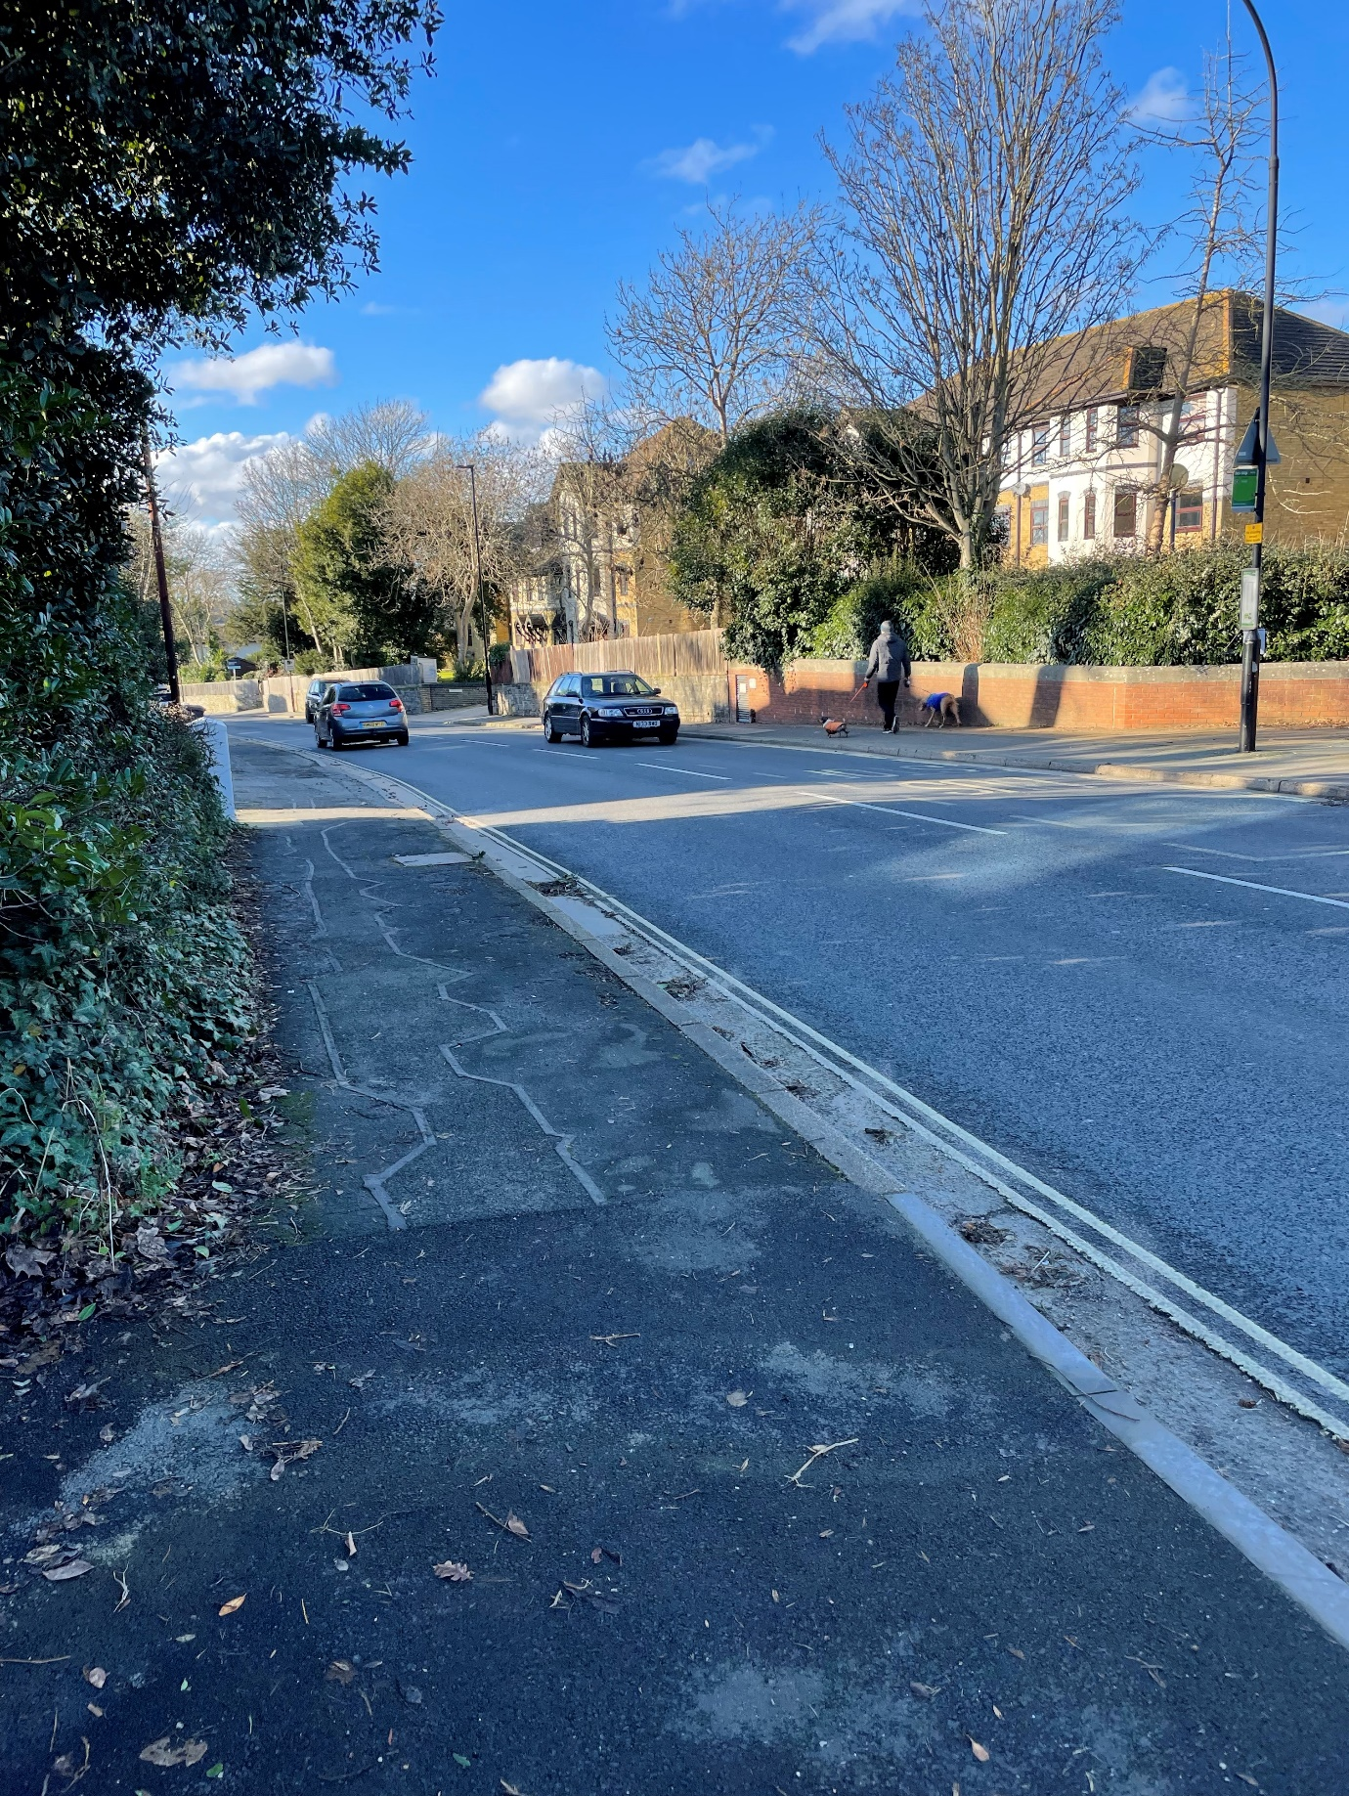

C

Visibility splay west down staplers rd viewed from position A

A = 43 m x 1 m from mid line of the road

B = 2m in from curb middle of the new drive

A