14 Cavendish Crescent North – Discharge of Conditions

Condition 1: Garage door.

Given that the existing garage door opening dimension remains the same, we now plan to retain the existing door for the purposes of this project. It is functionally fine and simple in appearance. It will be cleaned and repainted in black just to freshen it up. The timber surrounds will be removed as a new lintol runs over the door in the agreed proposals with a brickwork parapet detail.

Condition 2: Facing brickwork.

We will endeavour to match the facing brickwork to the existing roadside wall (in face, size and bond) so that it is consistent and in harmony with this using reclaimed bricks which we will either source locally or reclaim on site from the internal garage walls which are being removed and are built of a very similar brick. The photo below shows the existing external brick wall which we will match:
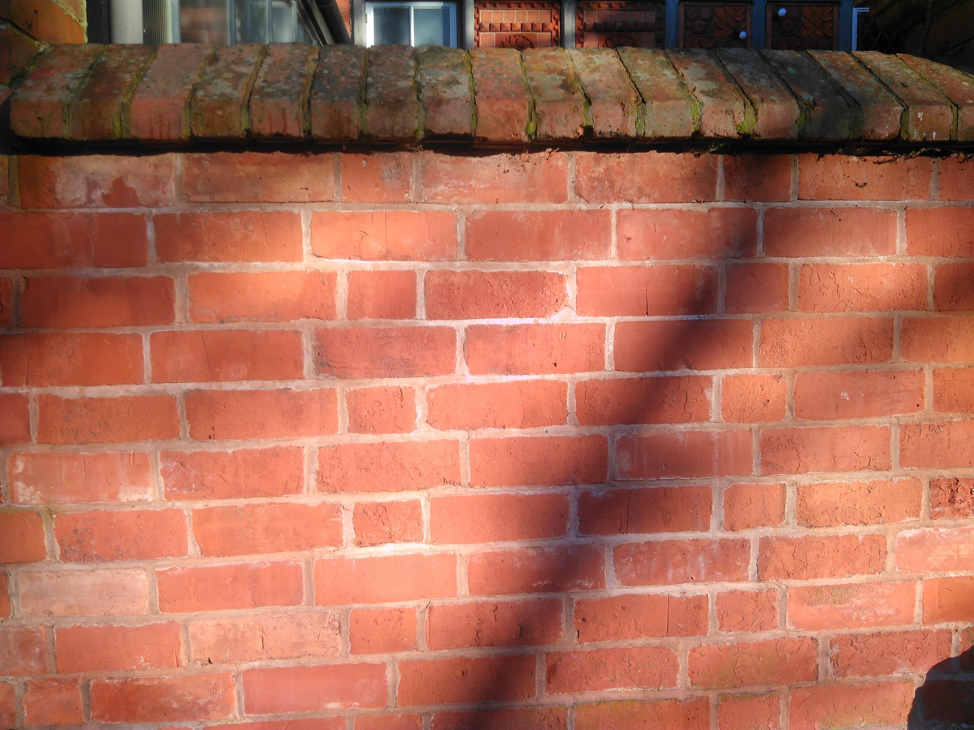

We have repaired and rebuilt several similar walls in The Park in recent years sourcing matching reclaimed brick which have been very successful.

The capping bricks used for the parapet above the garage door will also be to match those existing on the wall as pictured. Also reclaimed from a local source.

The existing facing brickwork around and above the pedestrian door which is not currently matched in course or type will be removed and replaced to achieve a consistent finish and the whole repointed to match. See image below. The theshold for the pedestrian door is being raised to the same level as the garage floor and a new brick lintol detail added over this door as part of the agreed works.

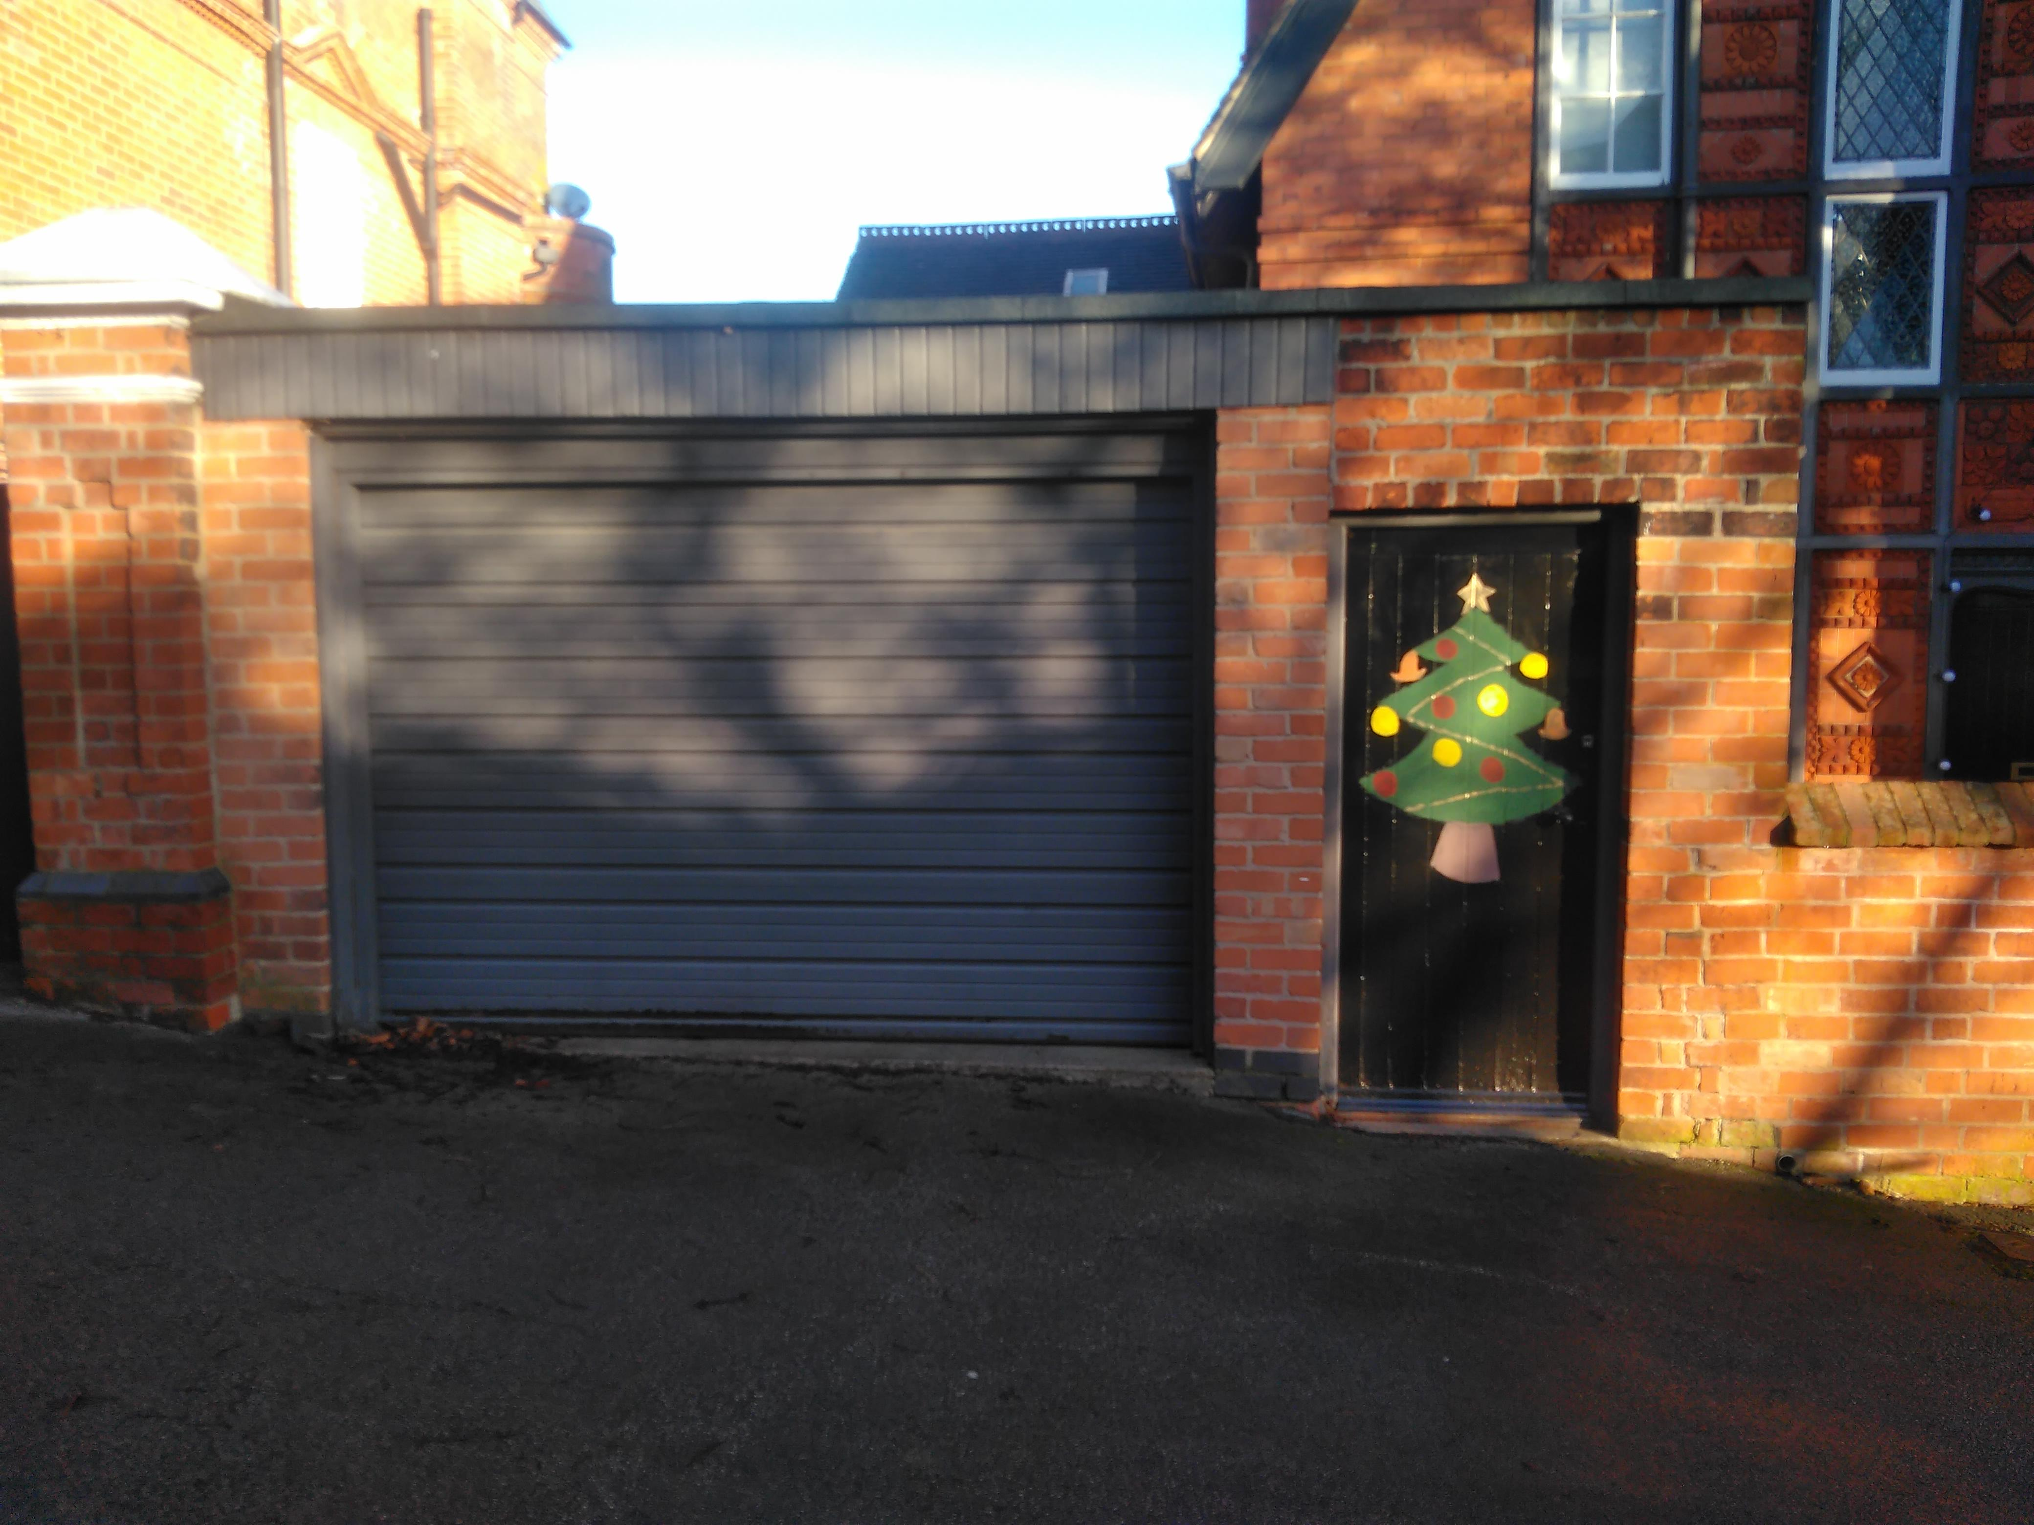
image of existing arrangement:

I trust that this information will be acceptable in terms of meeting the conditions which apply to this project.

