SIMON ANGELL
ARCHITECTURAL AND PLANNING CONSULTANT
ORCHARD COTTAGE ASHFORD CARBONELL SHROPSHIRE SY8 4BX
TELEPHONE : 01584831424
Mobile : 07855864403
Website : simonangellarchitectural.yolasite.com
Email: simonangell49@gmail.com

DESIGN AND ACCESS STATEMENT / HIA

RE: NEW BALCONY / GARAGE CONVERSION AND SOLAR PANEL SYSTEM AT 18 TEMESIDE LUDLOW SY8 1PD - LISTED BUILDING

REFERENCE 632/23

JANUARY 2024

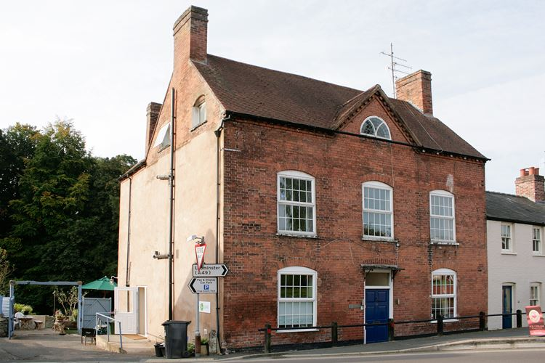

North Elevation

INTRODUCTION

This application is for a proposed balcony / conversion of the garage and solar panel system at 18 Temeside, Ludlow ( Grade 2 Listed ). The proposal also includes the replacement of existing white upvc windows with new timber windows as shown on the drawings along with increased opening depths and arches over the existing southern garage windows, installation of Velux conservation roof window (to provide more natural light).

Appearance - The only changes in appearance will be the galvanised steel balcony, solar panel system, replacement and revised window openings and a single roof light. All of these alterations and additions are at the rear of the property and will not be seen by public.The replacement of upvc windows will enhance the listed building.

HERITAGE IMPACT STATEMENT

LISTING

SO5174 TEMESIDE 825-1/1/469 No.18 15/04/54
GV II
House. Late C18/early C19. Brick; C20 plain tile roof; brick end stacks. Symmetrical 2-storeys and attic; 3-window range: C20 horizontal casements, in original moulded cases, under segmental arches; brick modillion eaves with central pediment containing semi-circular light with radial lead glazing, under semi-circular brick arch. Central entrance: C20, 6-panel door and overlight, with simple hood, in altered opening under segmental arch; flanked by C20 casements in original frames, under segmental arches. Right returned side has two C20 lights under segmental arches, in gable; C20 entrance under timber lintel. Wing to rear with brick end stack.
The proposed balcony is sited at the rear of the building and tucked behind the lower first floor pitched roof. It has little impact upon the listed building especially considering that it is largely hidden from public view.

Replacing Upvc windows with timber on a listed building is always a positive improvement.

The conversion of the garage does not have any negative impact upon the listed building

